**CSE3002- INTERNET AND WEB PROGRAMMING**

**J Component Report**

*Submitted to*

**Pr. Rajiv Vincent**

**School of Computer Science and Engineering**



**TABLE OF CONTENTS**

|  |  |  |
| --- | --- | --- |
| **Ch. No** | **Chapter** | **Page Number** |
| 1 | Title with Team Details | 3 |
| 2 | Acknowledgement | 3 |
| 3 | Abstract | 4 |
| 4 | Introduction | 4 |
| 5 | Related Work | 5-6 |
| 6 | Proposed Work | 6 |
| 7 | Code Snippets | 7-54 |
| 8 | Screenshots | 55-65 |
| 9 | Conclusion and Future Work | 66 |
| 10 | Video and Code Link | 66 |

**TITLE OF PROJECT**

MUN-LOG

**TEAM MEMBERS**

SHIVAM KUMAR (19BCE1098)

SAGNIK SANYAL (19BCE1489)

ADITYA MISHRA (19BCE1528)

**ACKNOWLEDGEMENT**

We wish to express our sincere thanks and deep sense of gratitude to our project guide, **Pr. Rajiv Vincent,** School of Computer Science and Engineering for his consistent encouragement and valuable guidance offered to us throughout the course of the project work.

**ABSTRACT**

We have designed a fully functional website with numerous features in which people can register their complain to the Municipality of the city regarding bad road conditions, be it about manhole, pothole, cleanliness or anything regarding improving road conditions in their respective area.

Municipality can further verify the received complaint and take legal action on that. They can also update the status of the complaint which will keep notifying user/people about their complaint.

**INTRODUCTION**

India is said to be the fastest developing countries today only after China. Although India is doing exceptionally well in fields like education, industrialization and fashion there are still certain areas where the country is lagging behind.

Since roads indirectly contribute to the economic growth of the country it is extremely essential that the roads are well laid out and strong. India is home to several bad roads be it the metropolitans, the cities or the villages.

We as a team, came up with a little solution to overcome this problem and designed a website in which user can register his/her complain just by locating the area on the map that is given in our website. User can either search the location or can move the pointer over the map for the area he/she needs to register the complaint. Municipality can further verify and takes action on that complaint and keep the users updated over that. Municipality can also post notices regarding any construction or something like that being held in a particular area.

**RELATED WORK**

We researched on various topics like map implementation, using API keys, etc that are explained below.

We used “MapmyIndia” Interactive Map API for our project which helped us to search, locate our current, pin point any other location by dragging/clicking.

The Interactive Maps JavaScript API based on Leaflet JS helps render and display map tiles while customizing the map's look and feel on mobile or web browser. Leaflet is the leading open-source JavaScript library for mobile-friendly interactive maps i.e. easy to use & high on performance. It is a collection of classes and functions that can be used to implement a host of map features.

Features

* 1. **Map Markers (Pushpins)**:

Point to any location using default pushpin behaviours and provide it your own style to make it look more tailored for your application. Note: Have a look at the Plug-ins section to find out what makes it cooler.

* 1. **Circles:**

Show instant radial areas of inter

* **Controls**:

Because we understand the use cases with a map we provide the below out of the box controls that can be turned off or on based on your requirement and because we care, we provide you to override our controls outlook by providing your own styles or CSS so that you can move them or customize them completely. Controls include:

Helps to provide zoom in and zoom out functionality to the map by default.

* 1. **Map Layer Control**:

Allows to change the map view from Road to hybrid and visive. Also allows to show traffic layer on map.

* 1. **Current Location Control**:

Scopes the Map to the viewer.s current location. **Note:** The location settings must be turned on and must allow the site to fetch the location for this control to work.

* 1. **The Search Control**:

With MapmyIndia.s interactive map API you get MapmyIndia quick search built in out of the box. The search control is placed in the top left corner by default although you can style it or move it as per your UI. This control provides quick search via a name, address, eLoc (or Place_Id) with built in autosuggest.

**PROPOSED WORK:**

To construct a website featuring Google Maps where the customer can pinpoint the area of complaint and file a complaint to the municipality.

The municipality will appoint a worker to complete the work and the user will be informed when the worker is appointed and also when the work is completed.

**CODE SNIPPETS:**

**PHP Files**

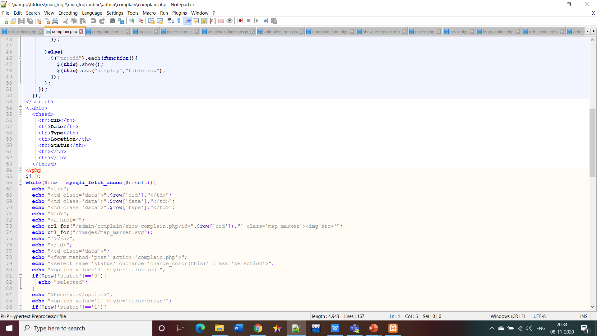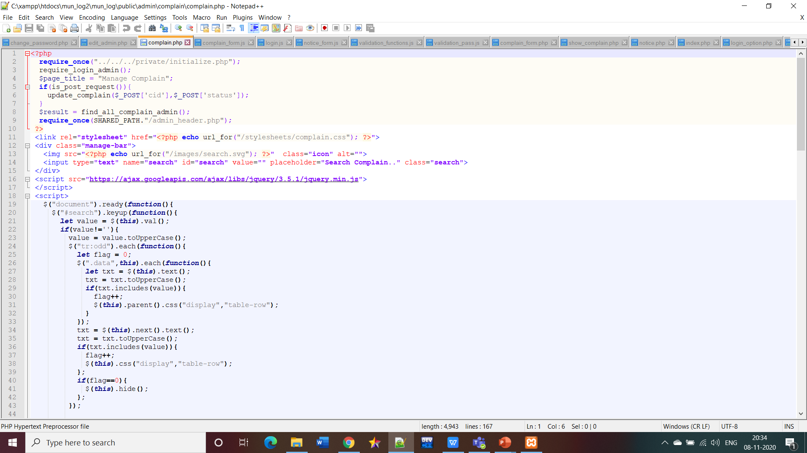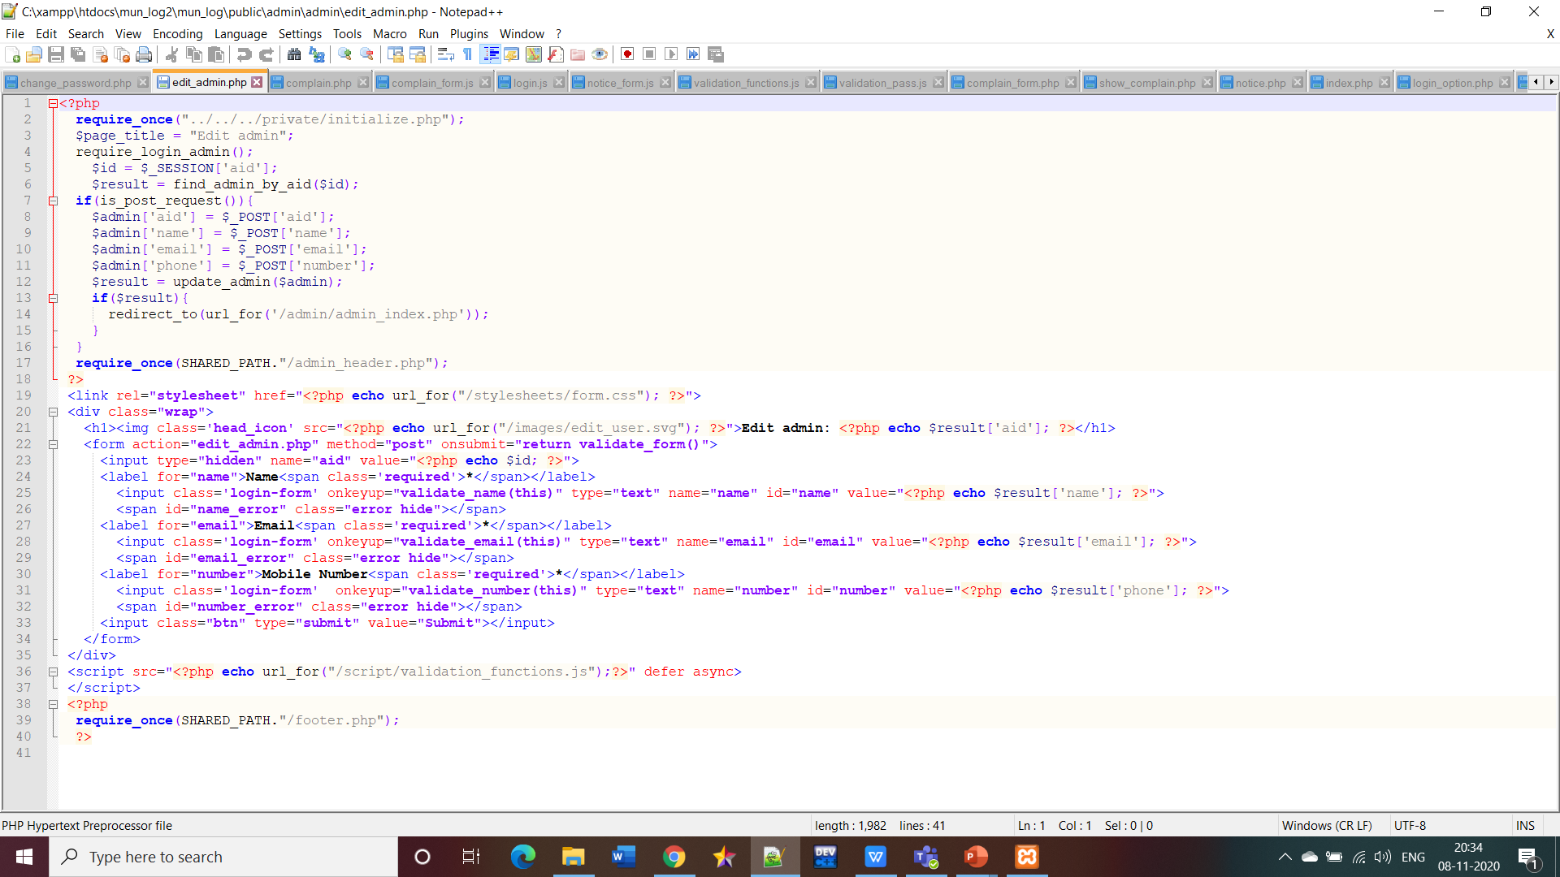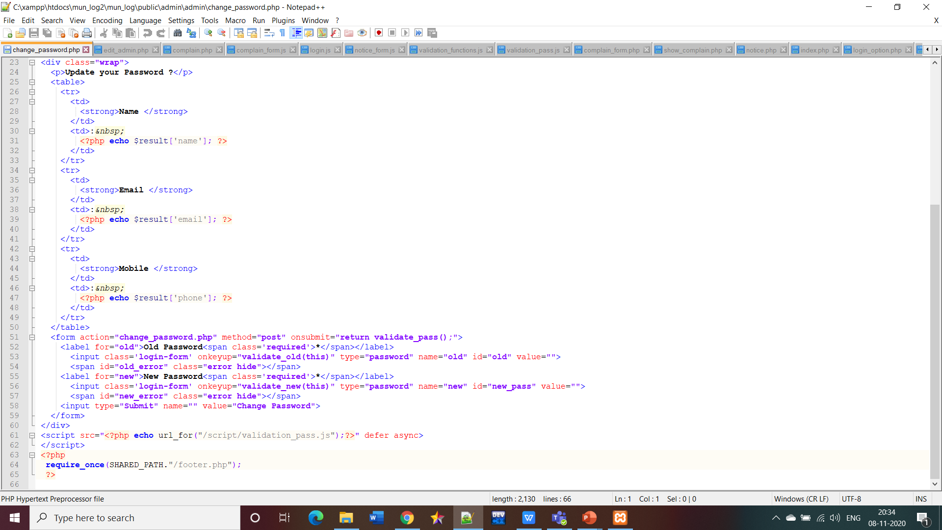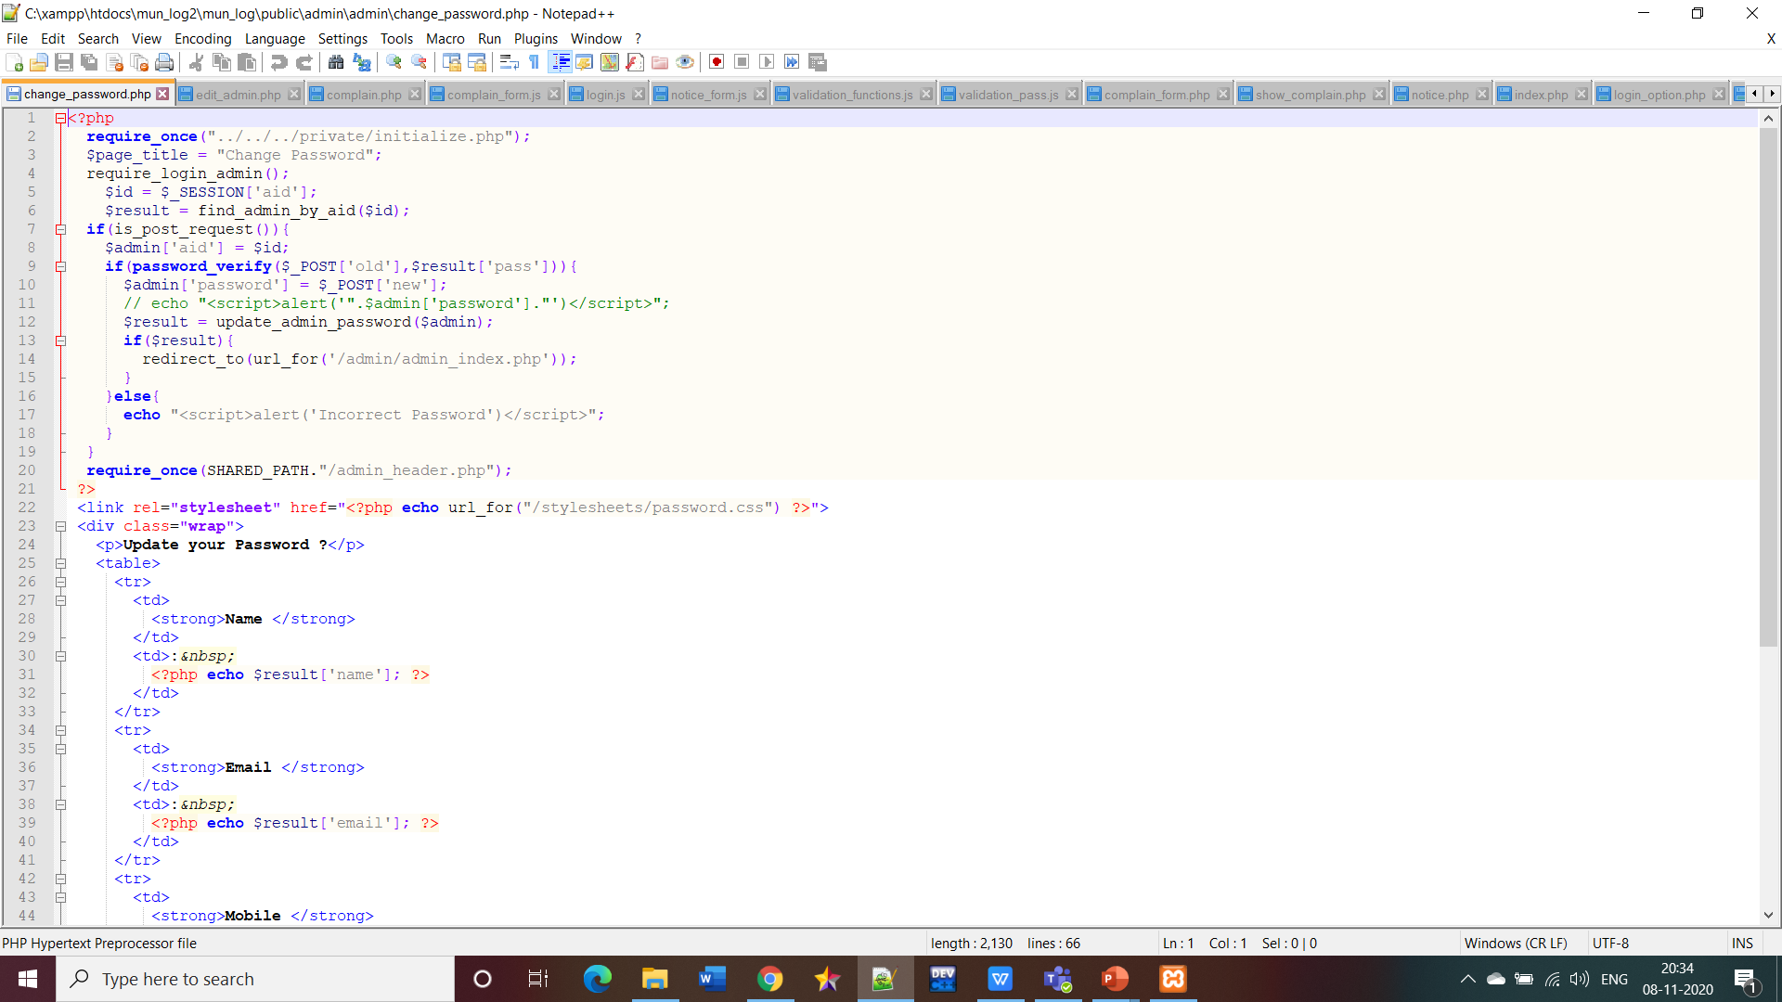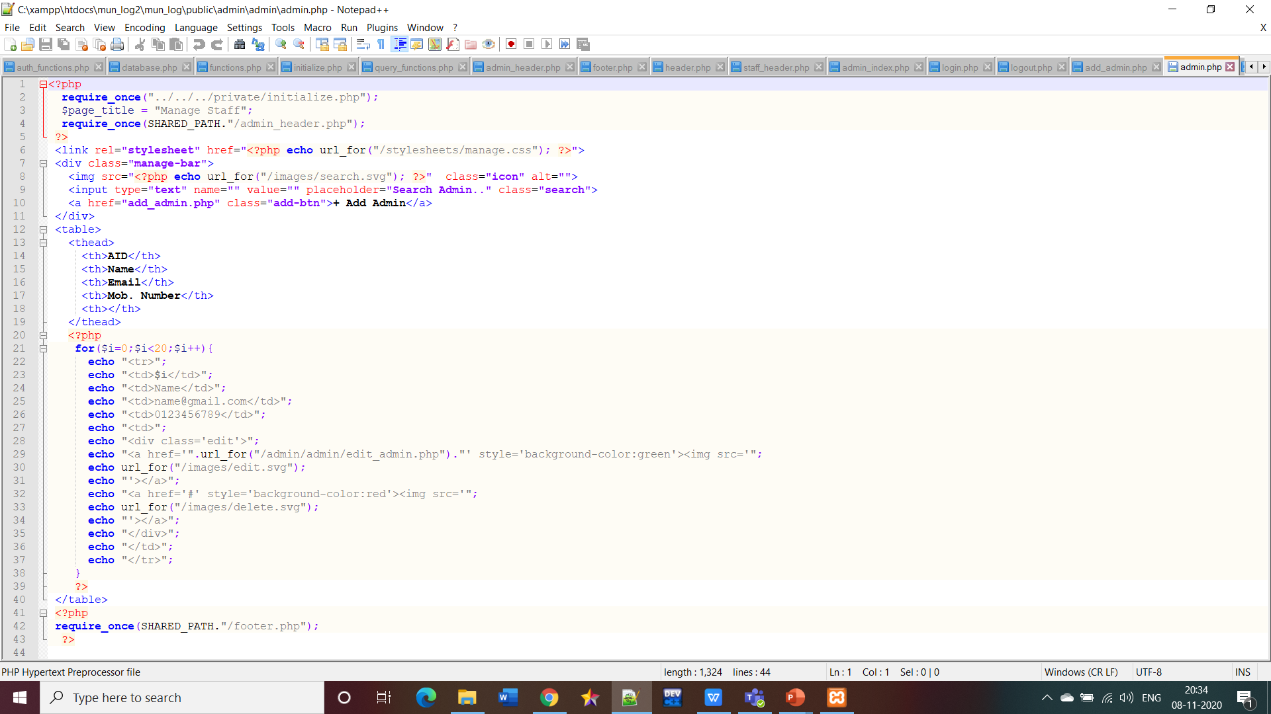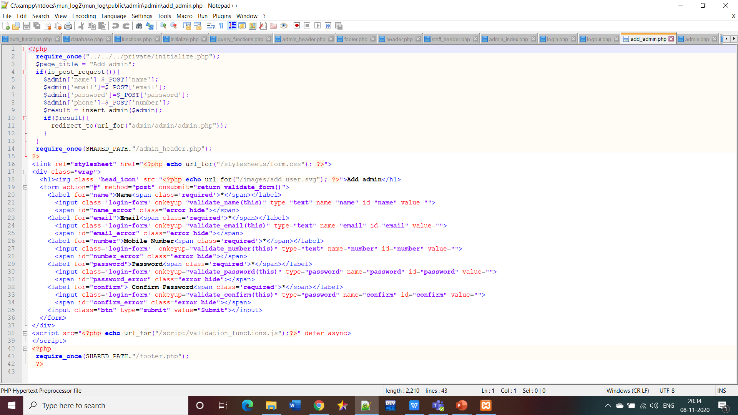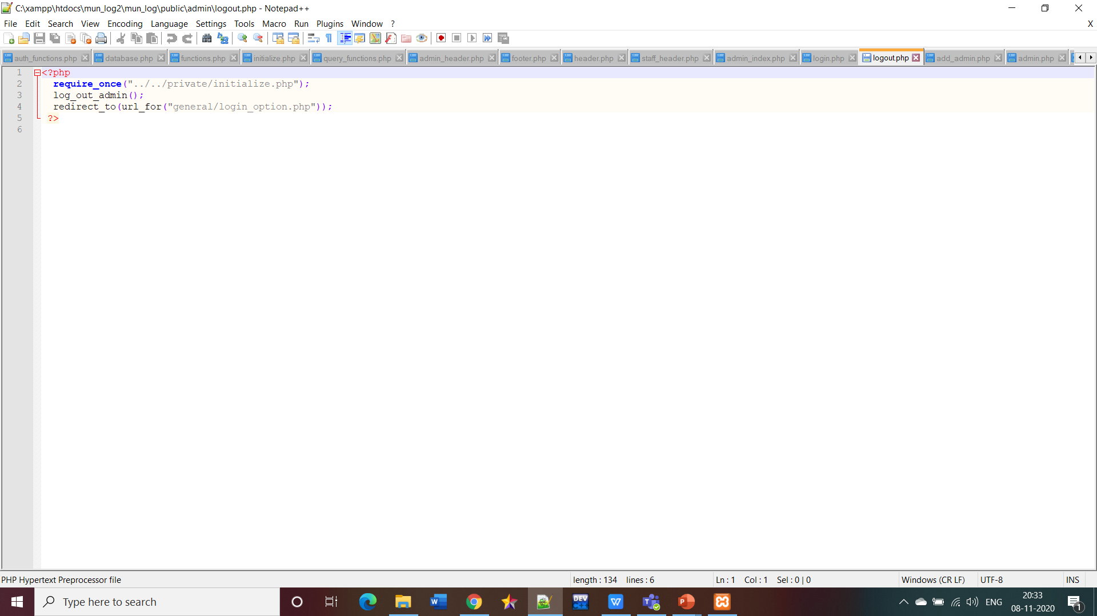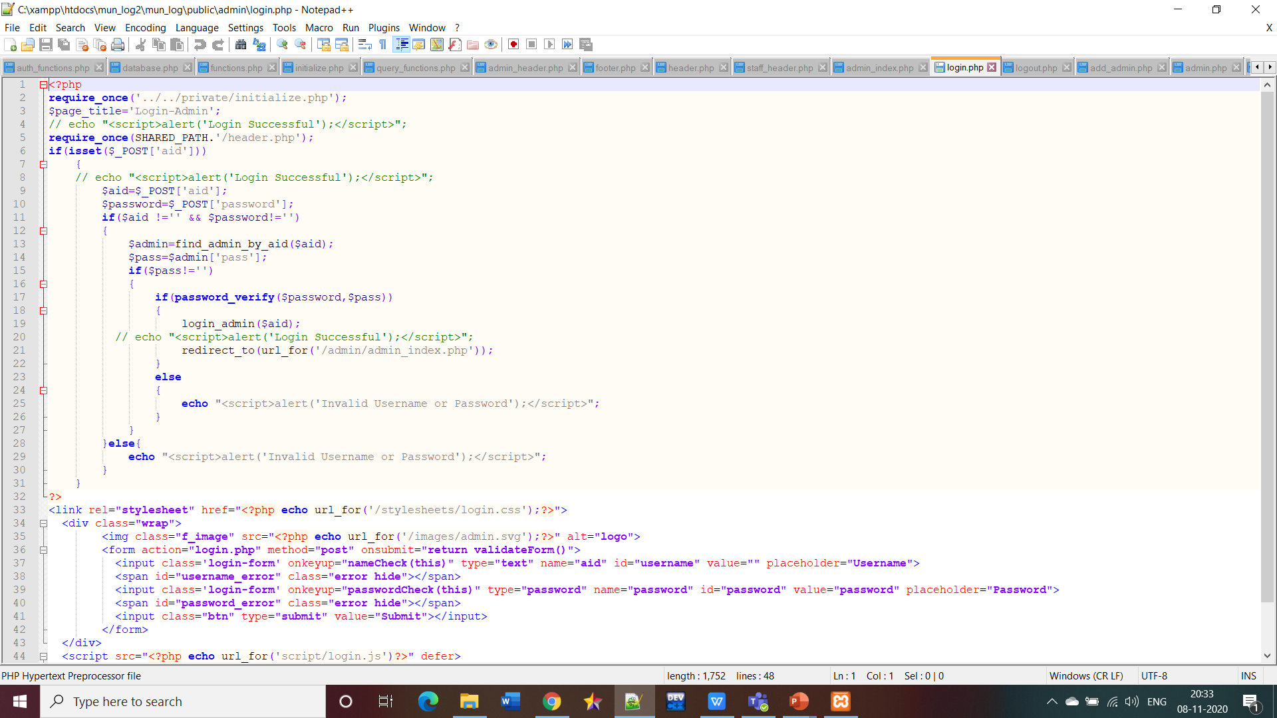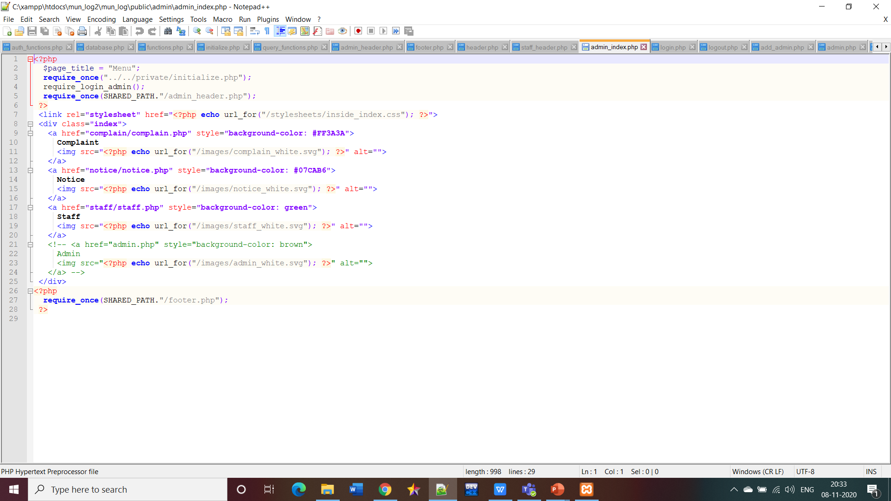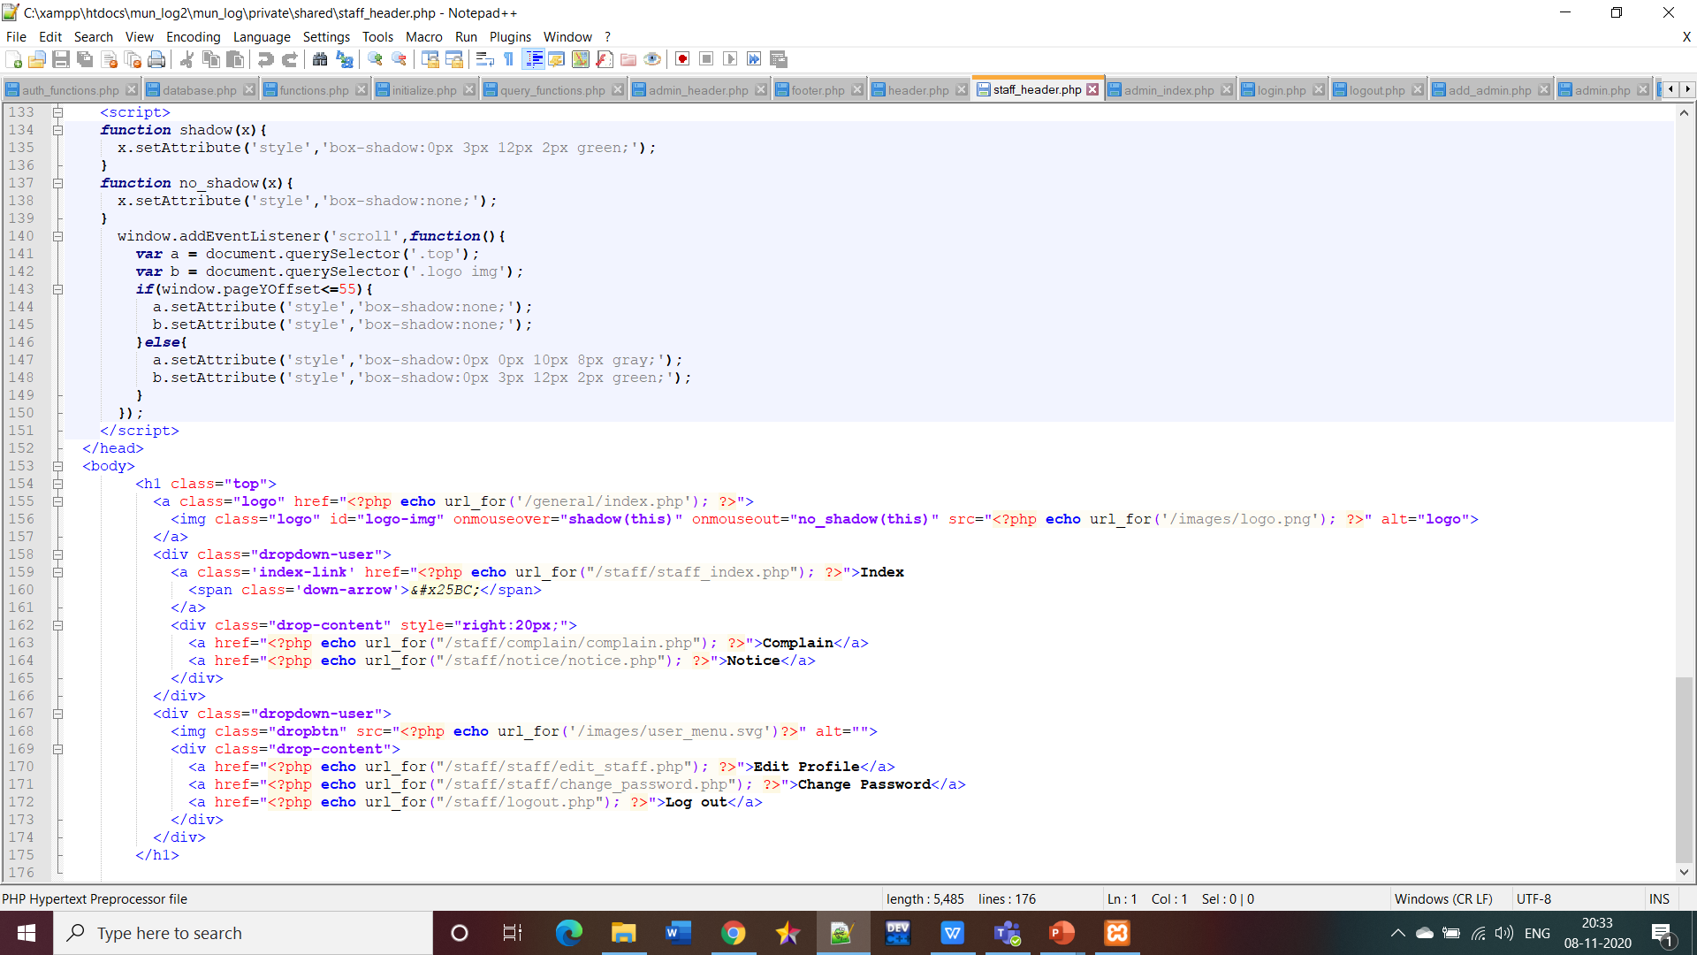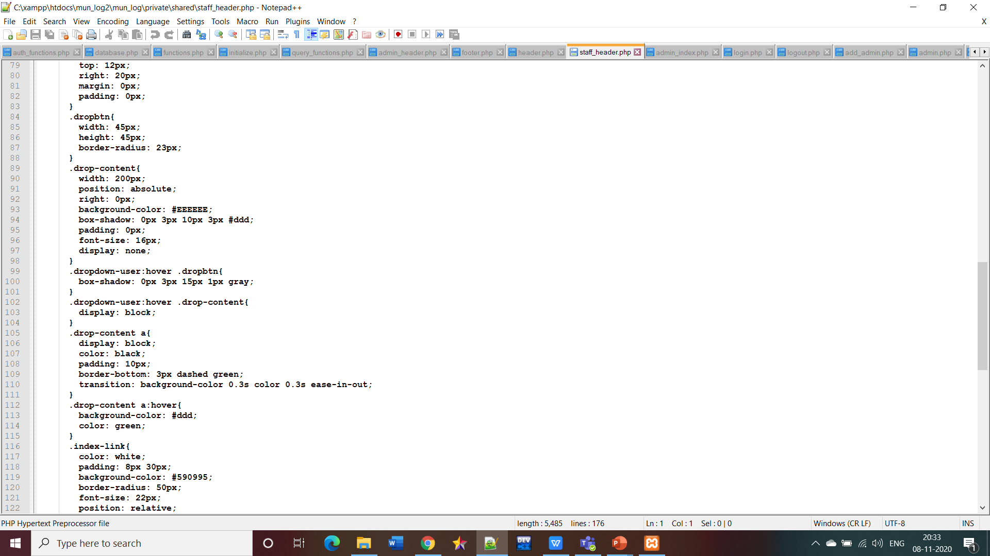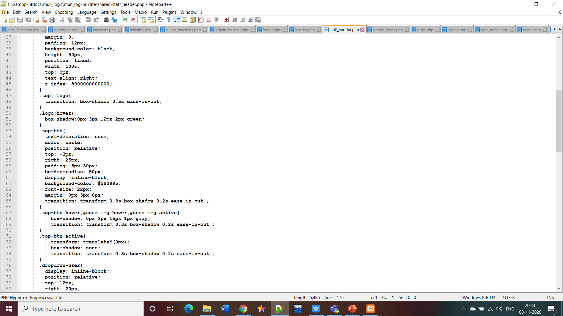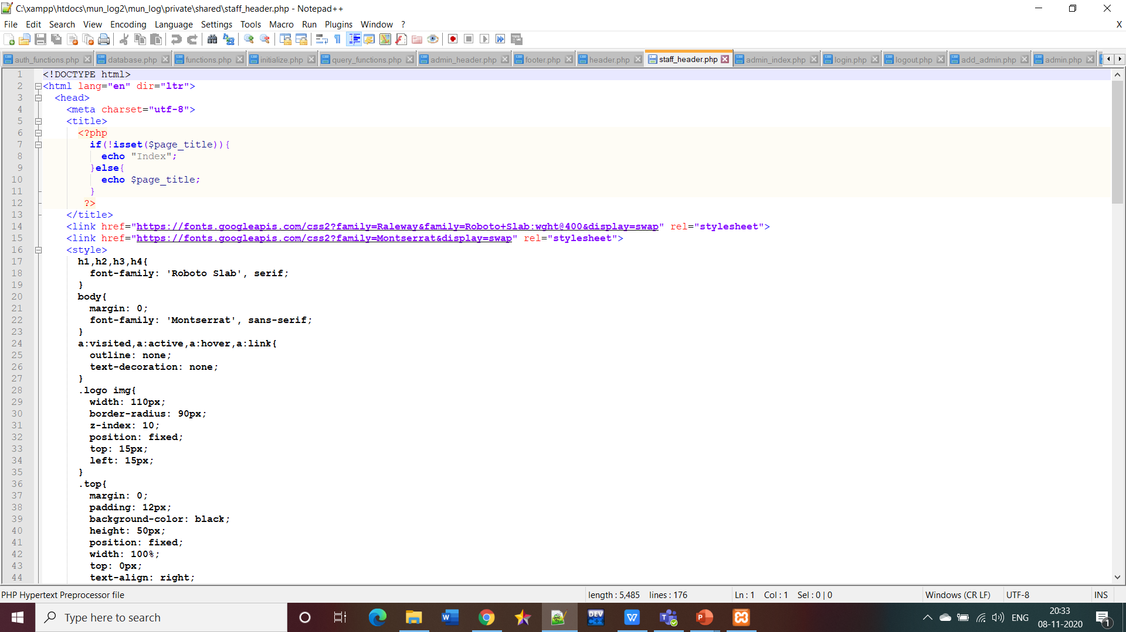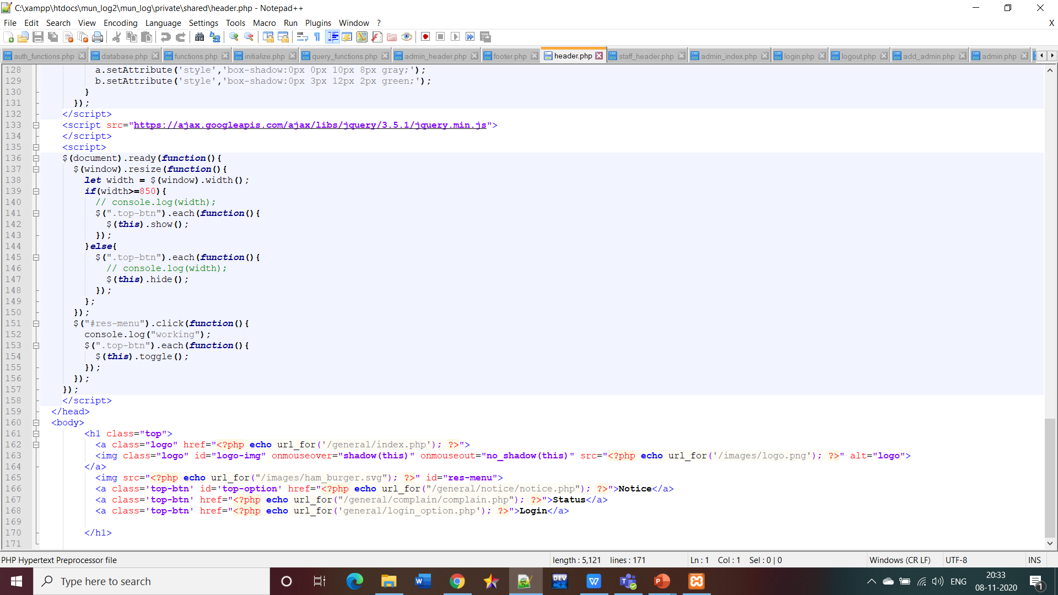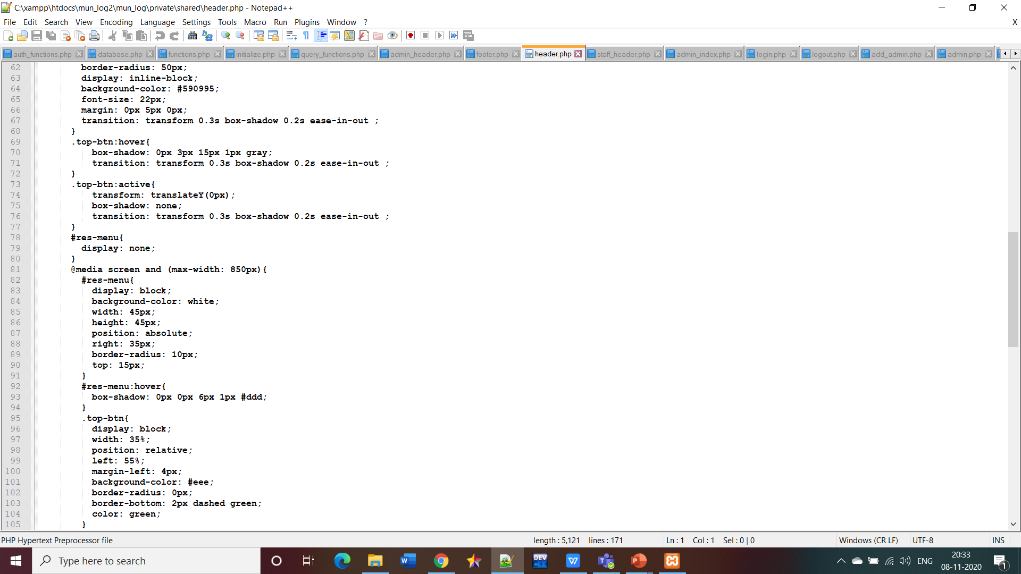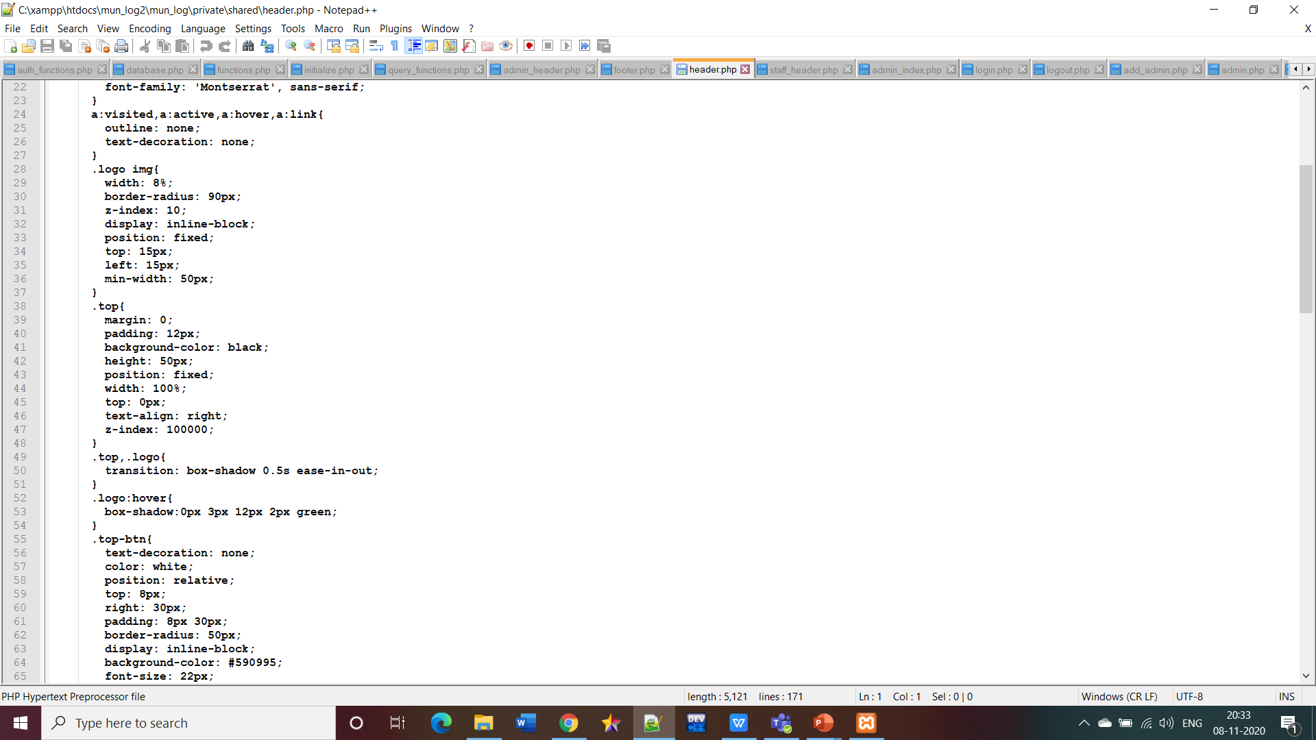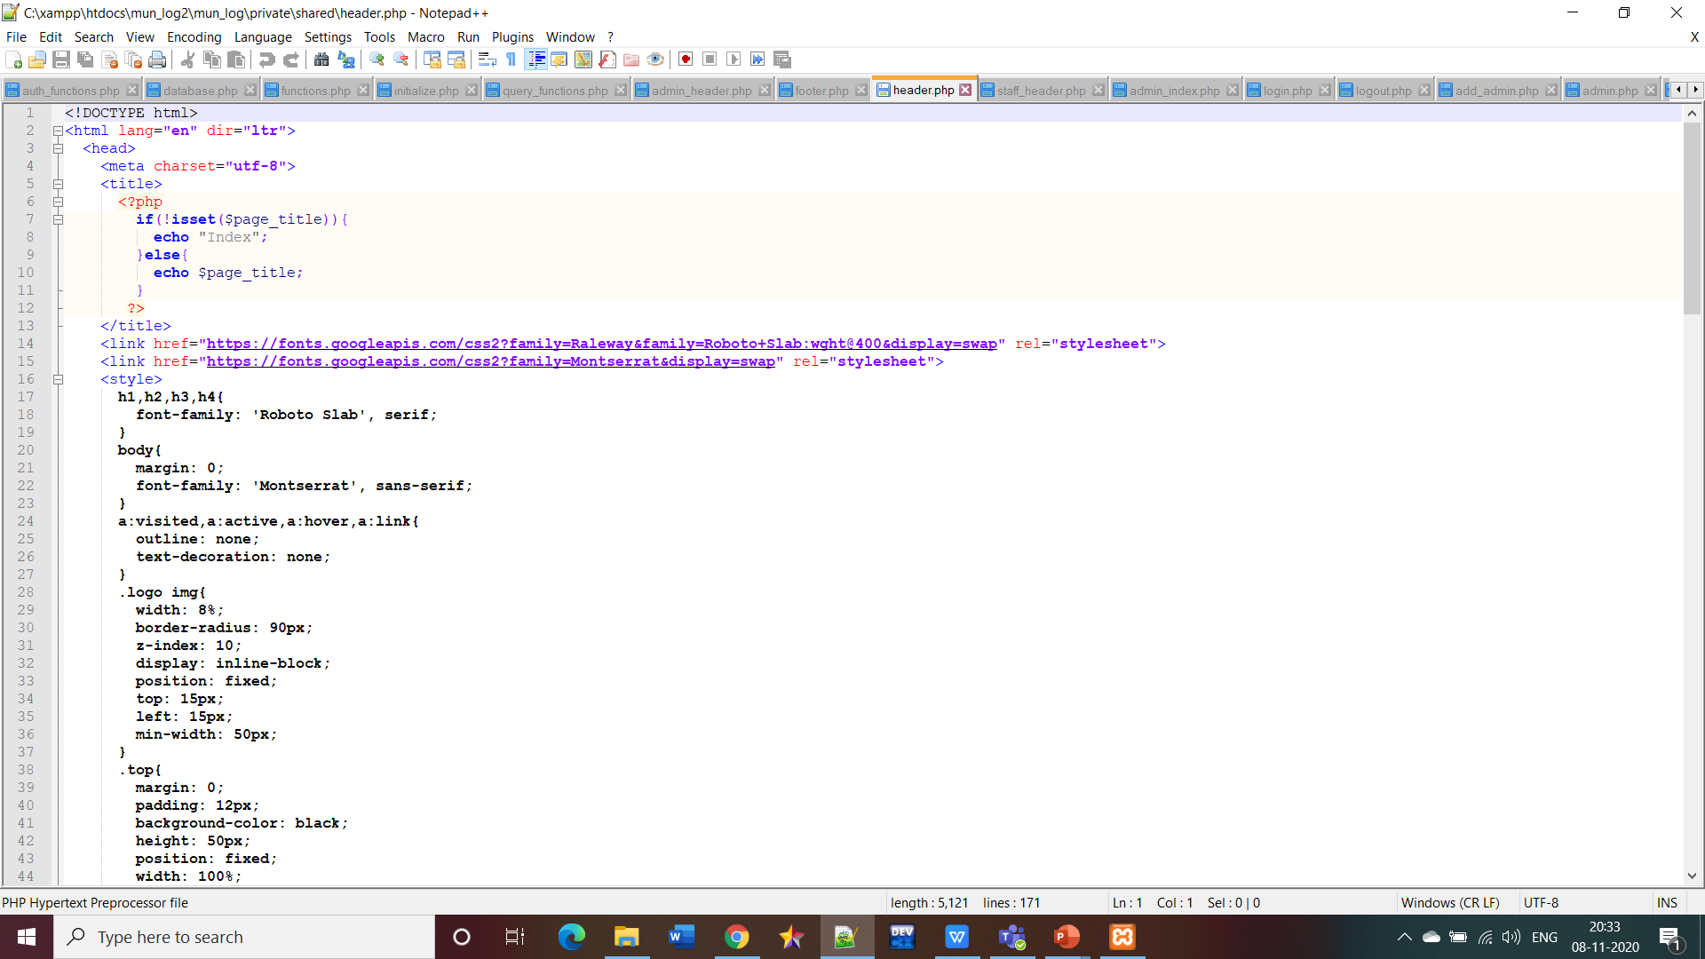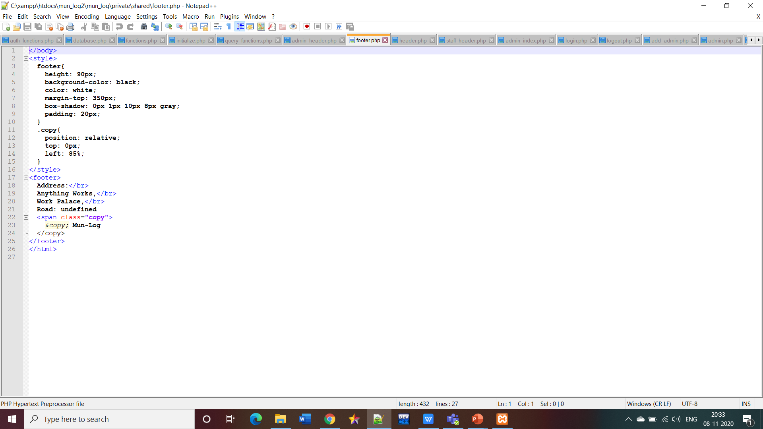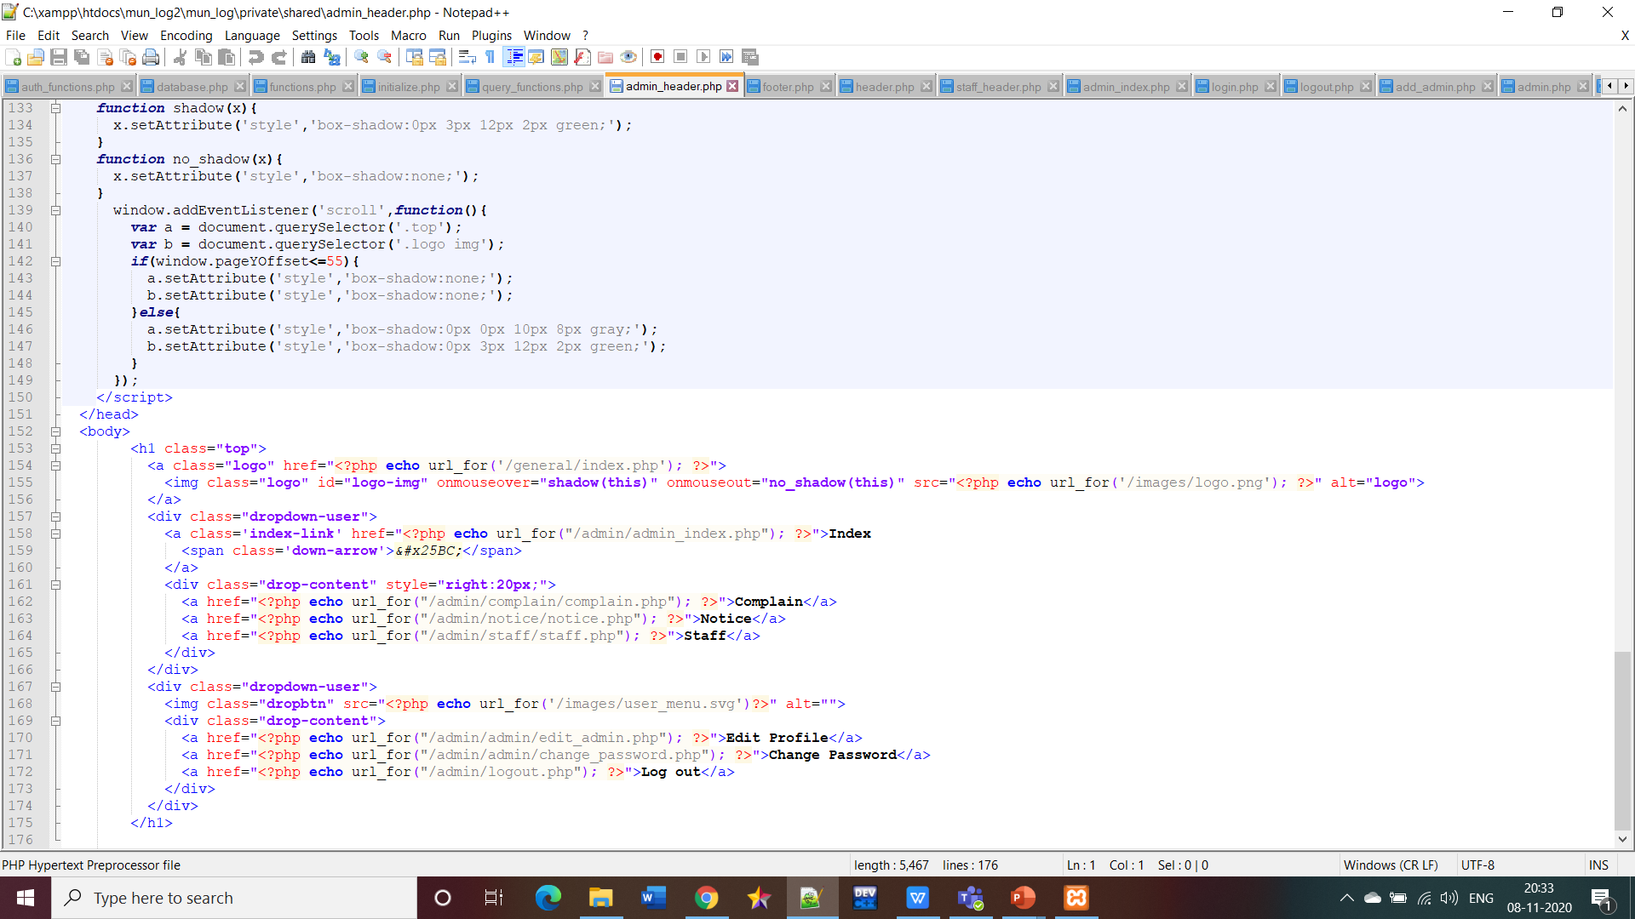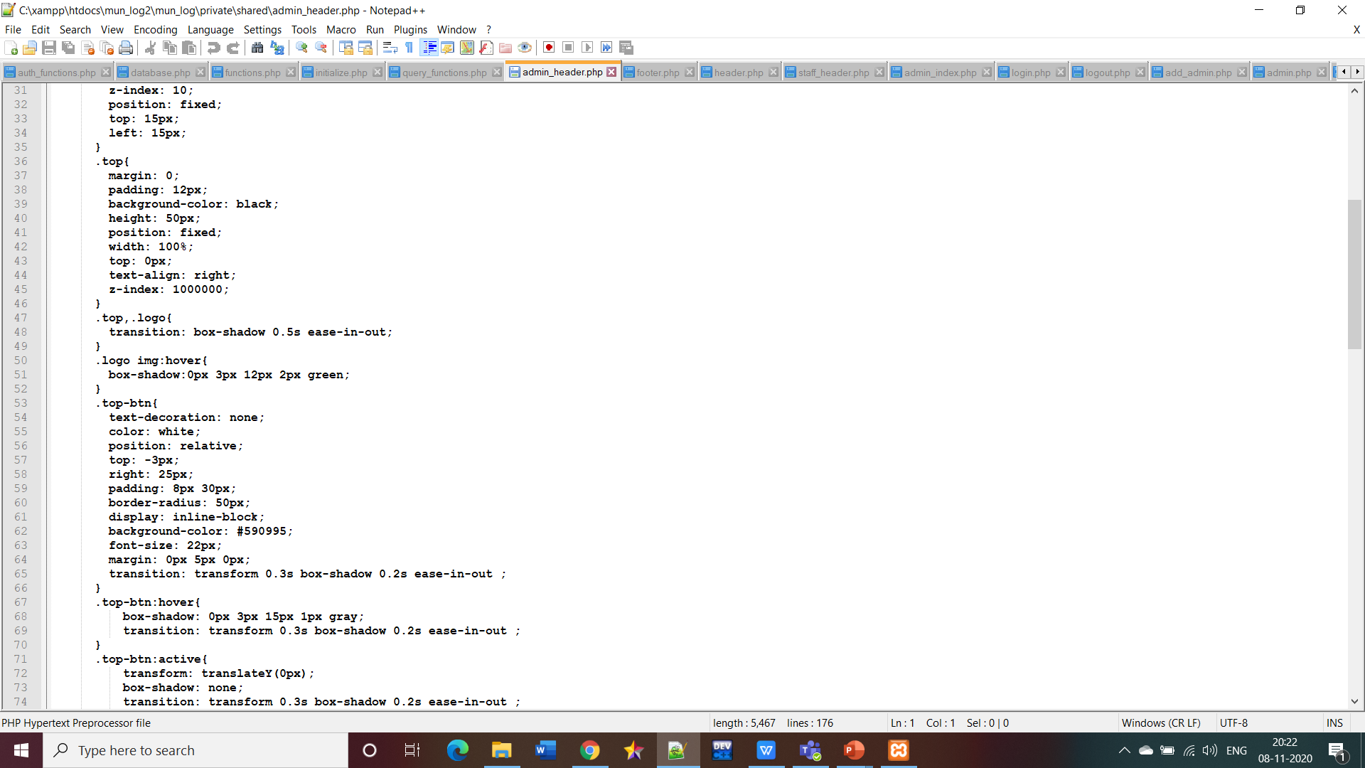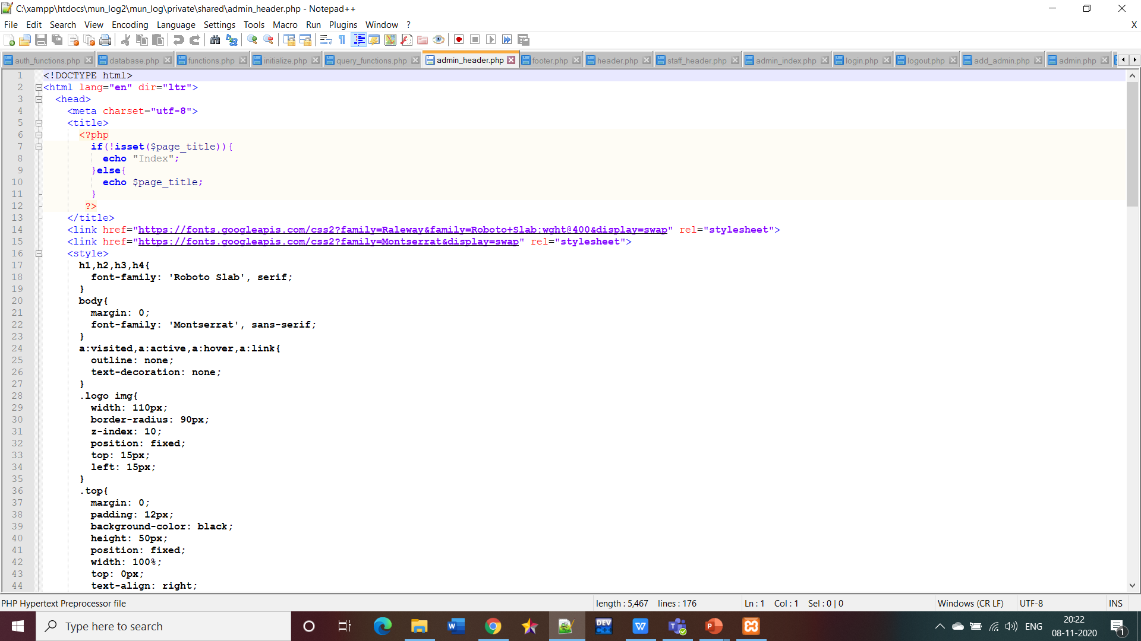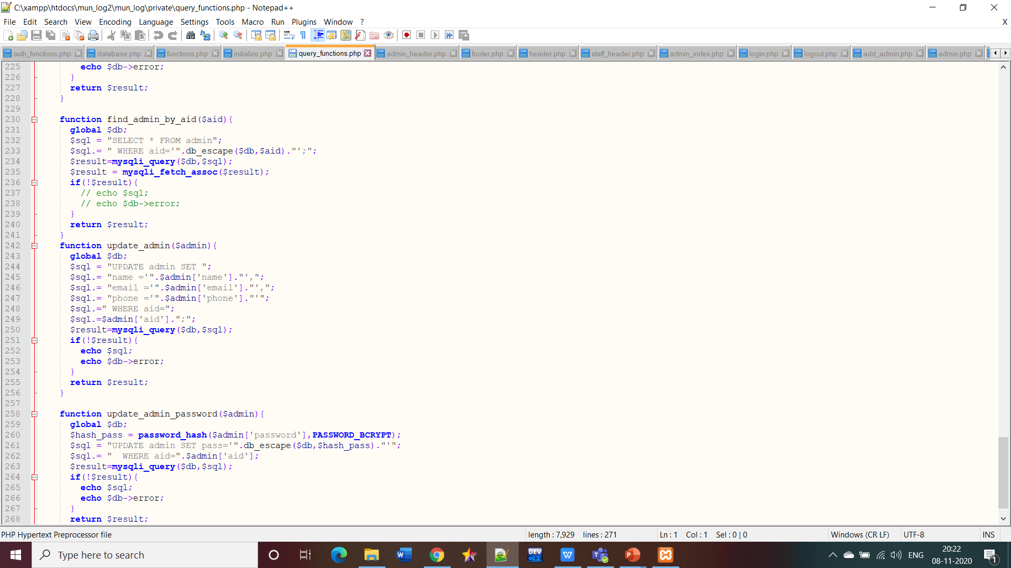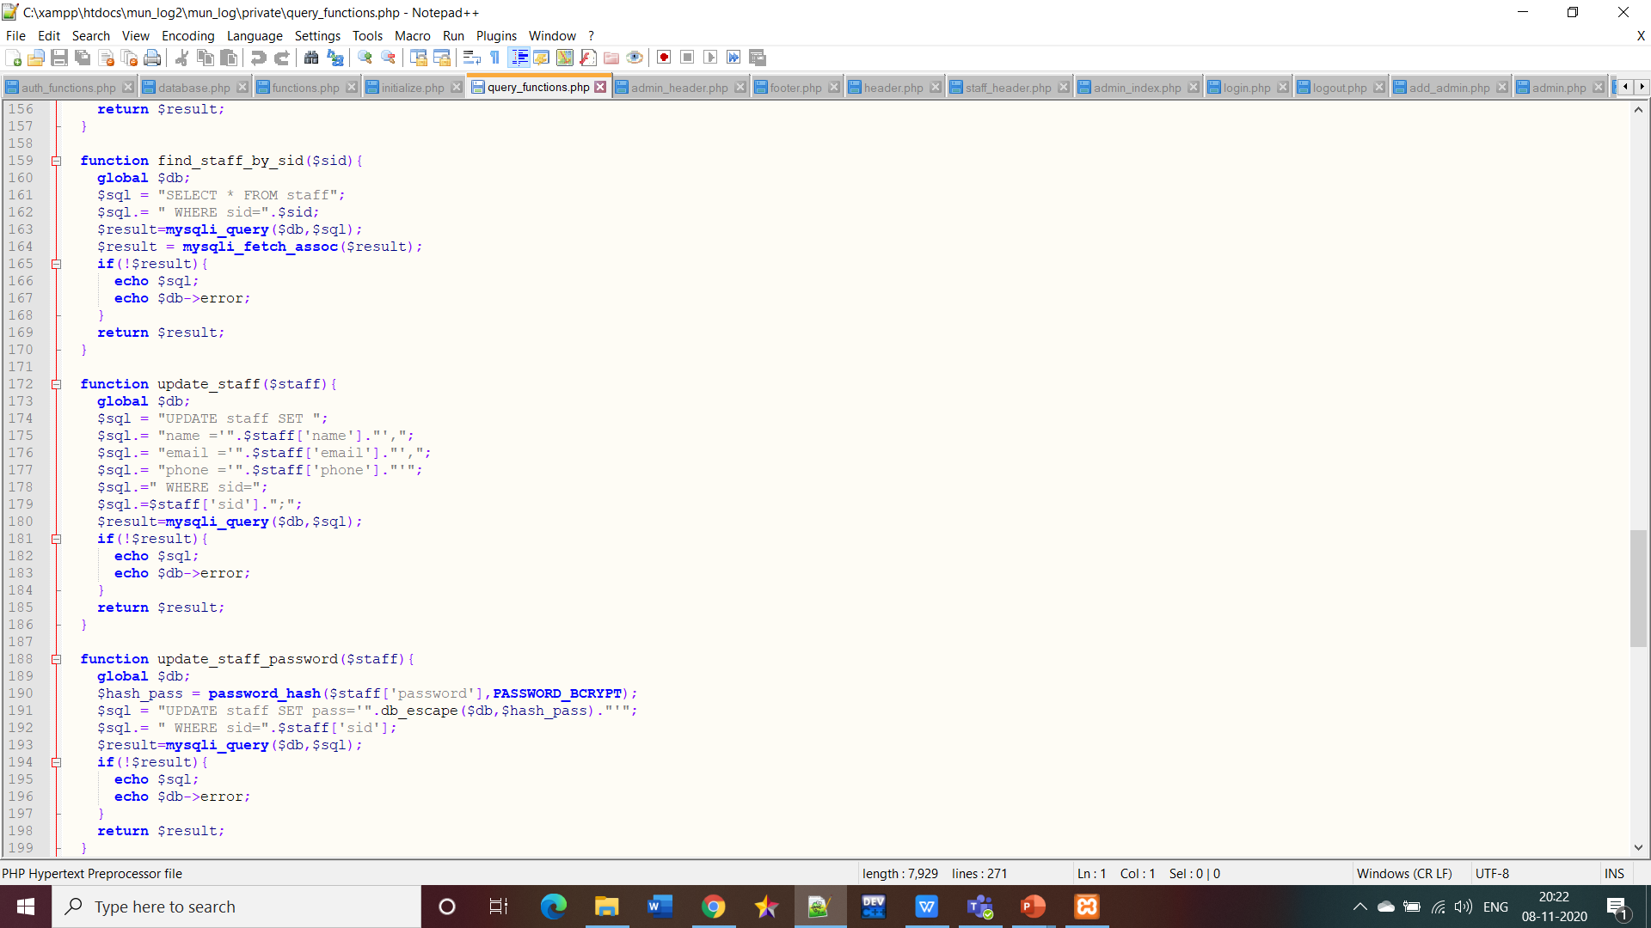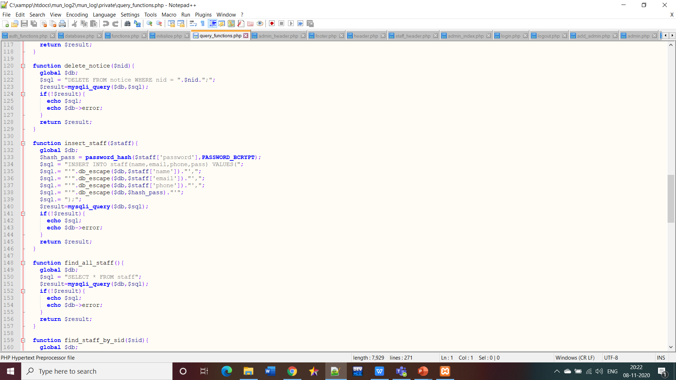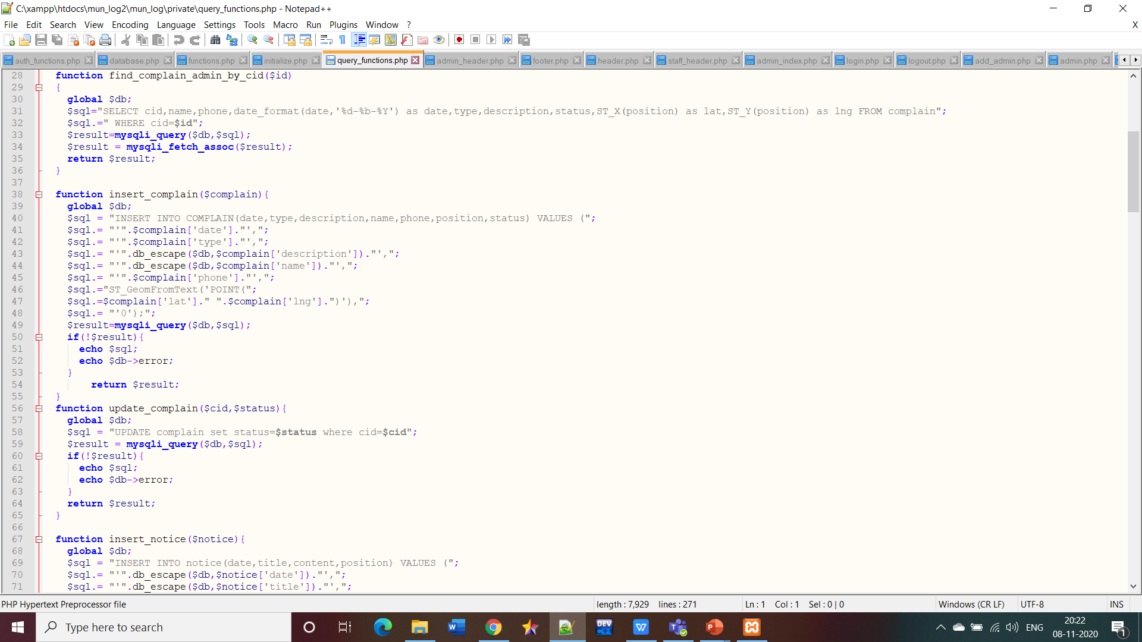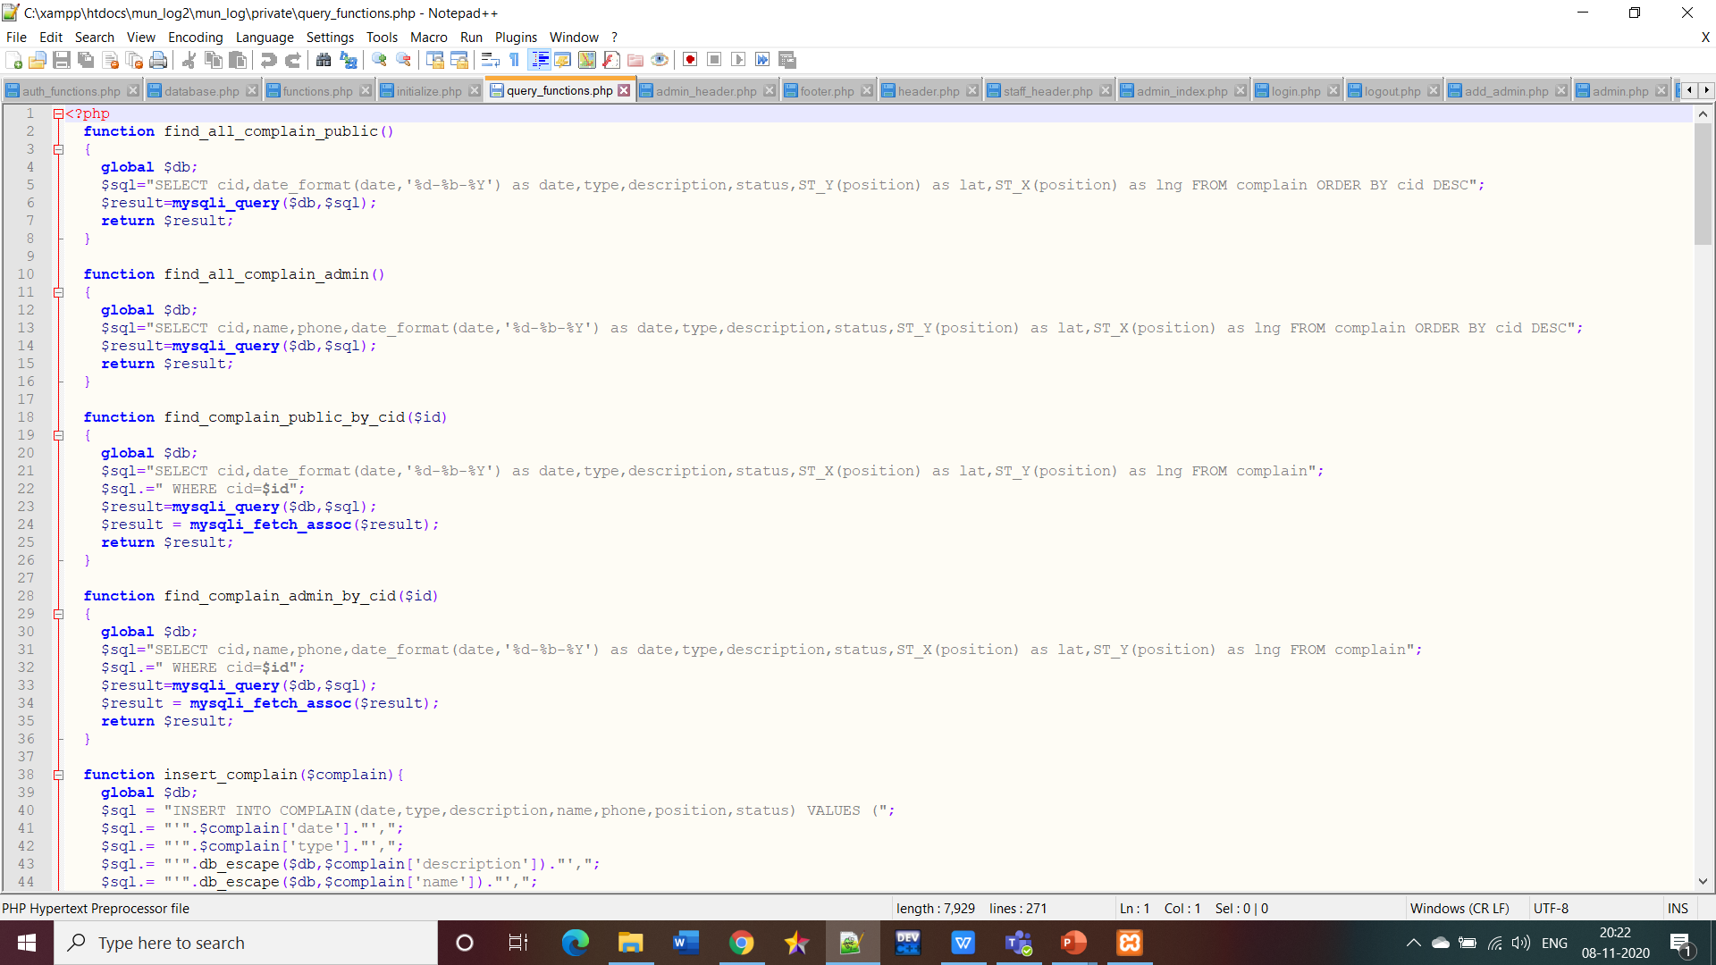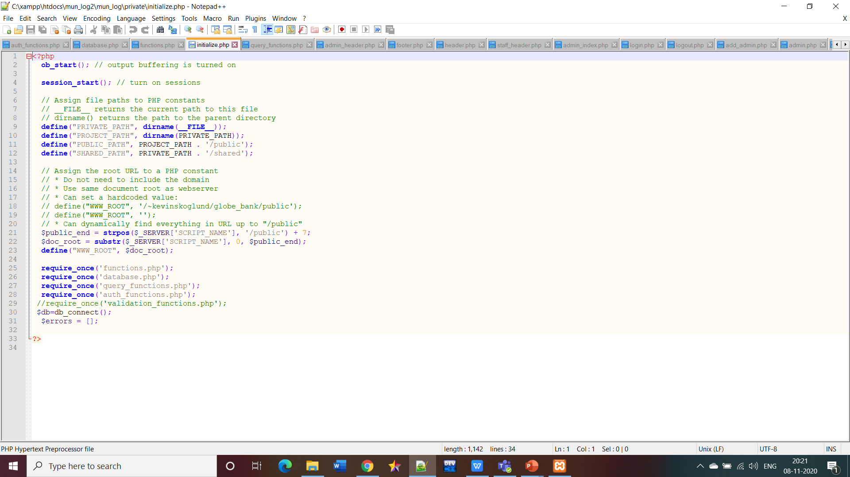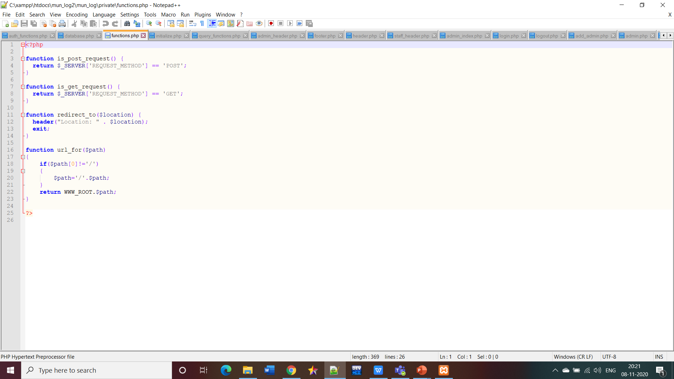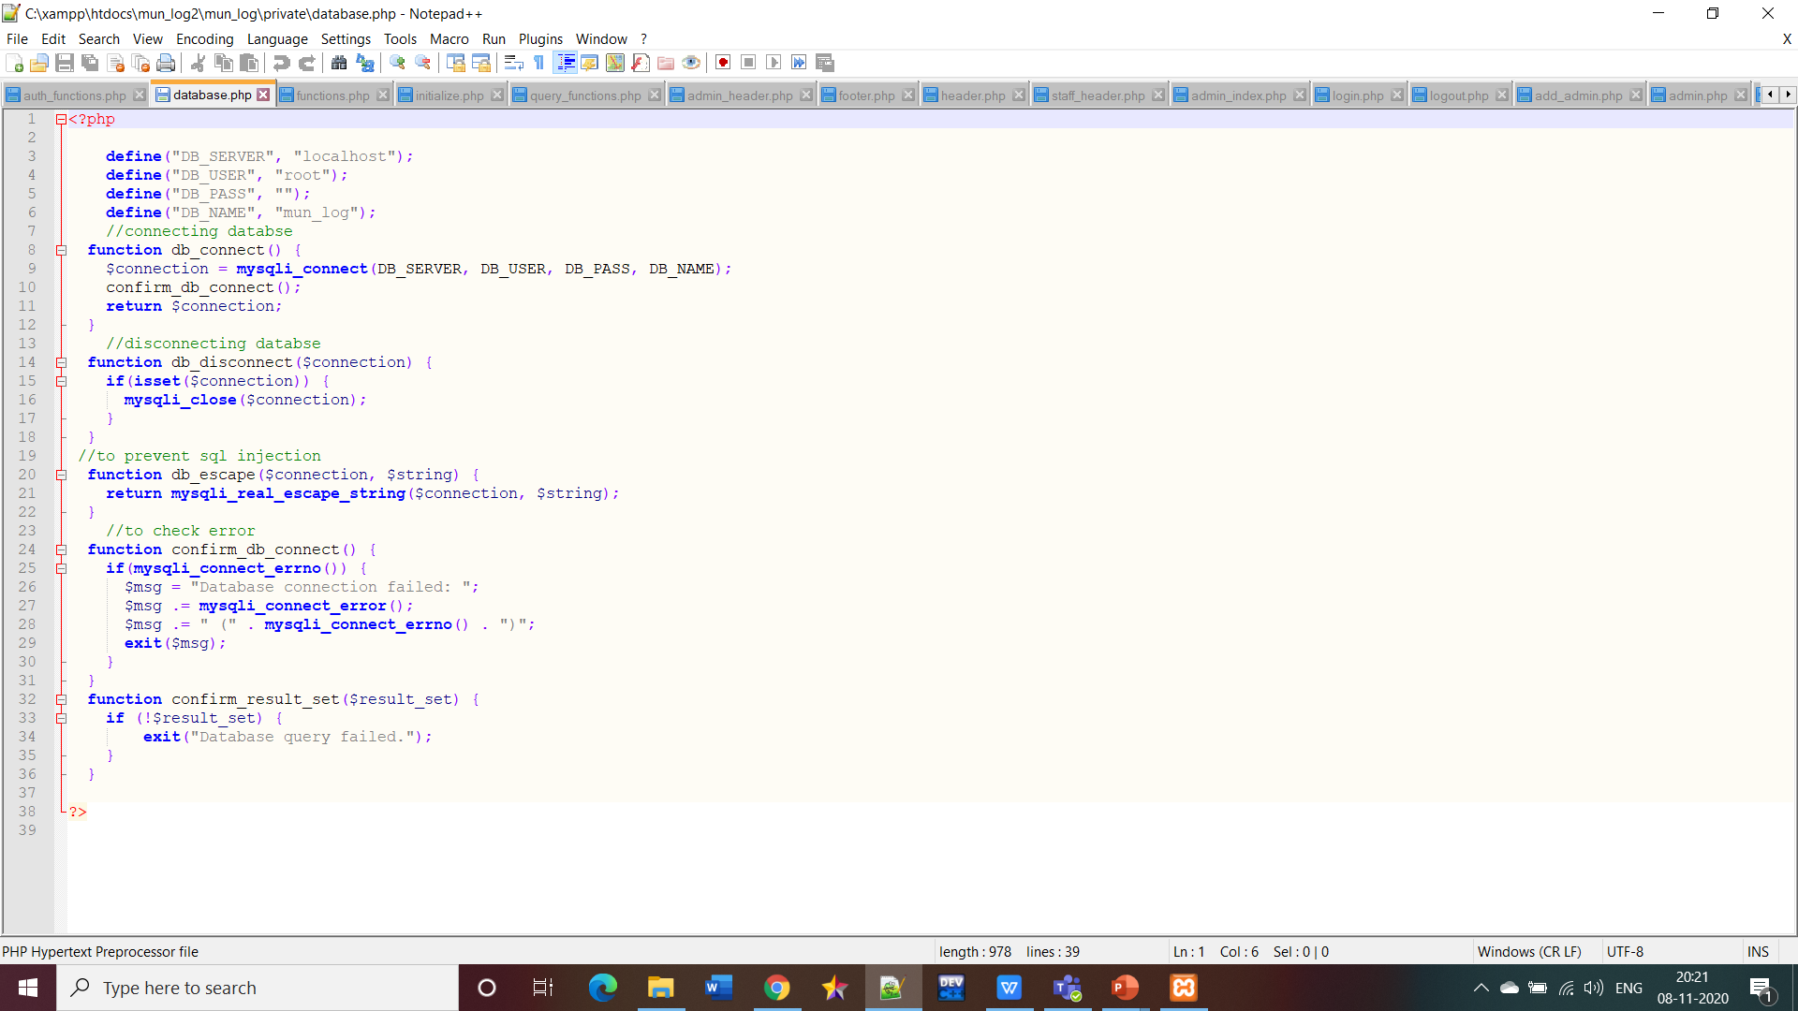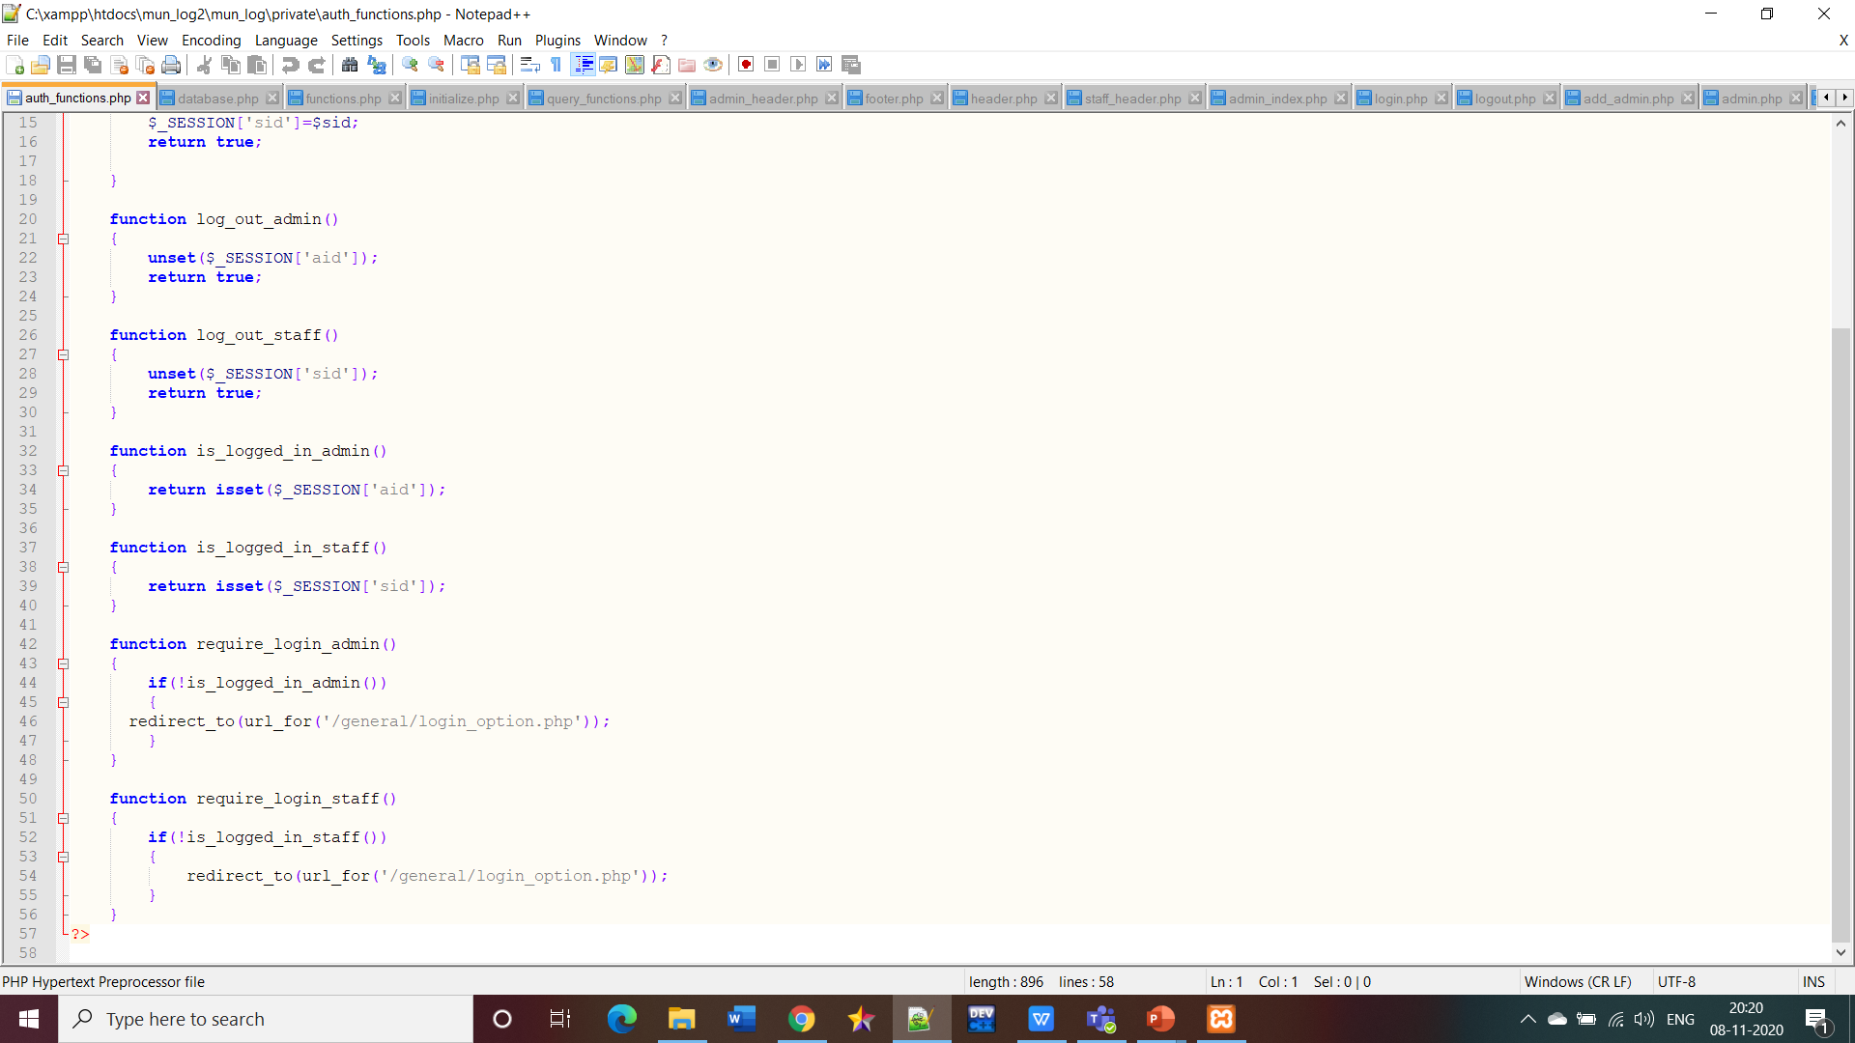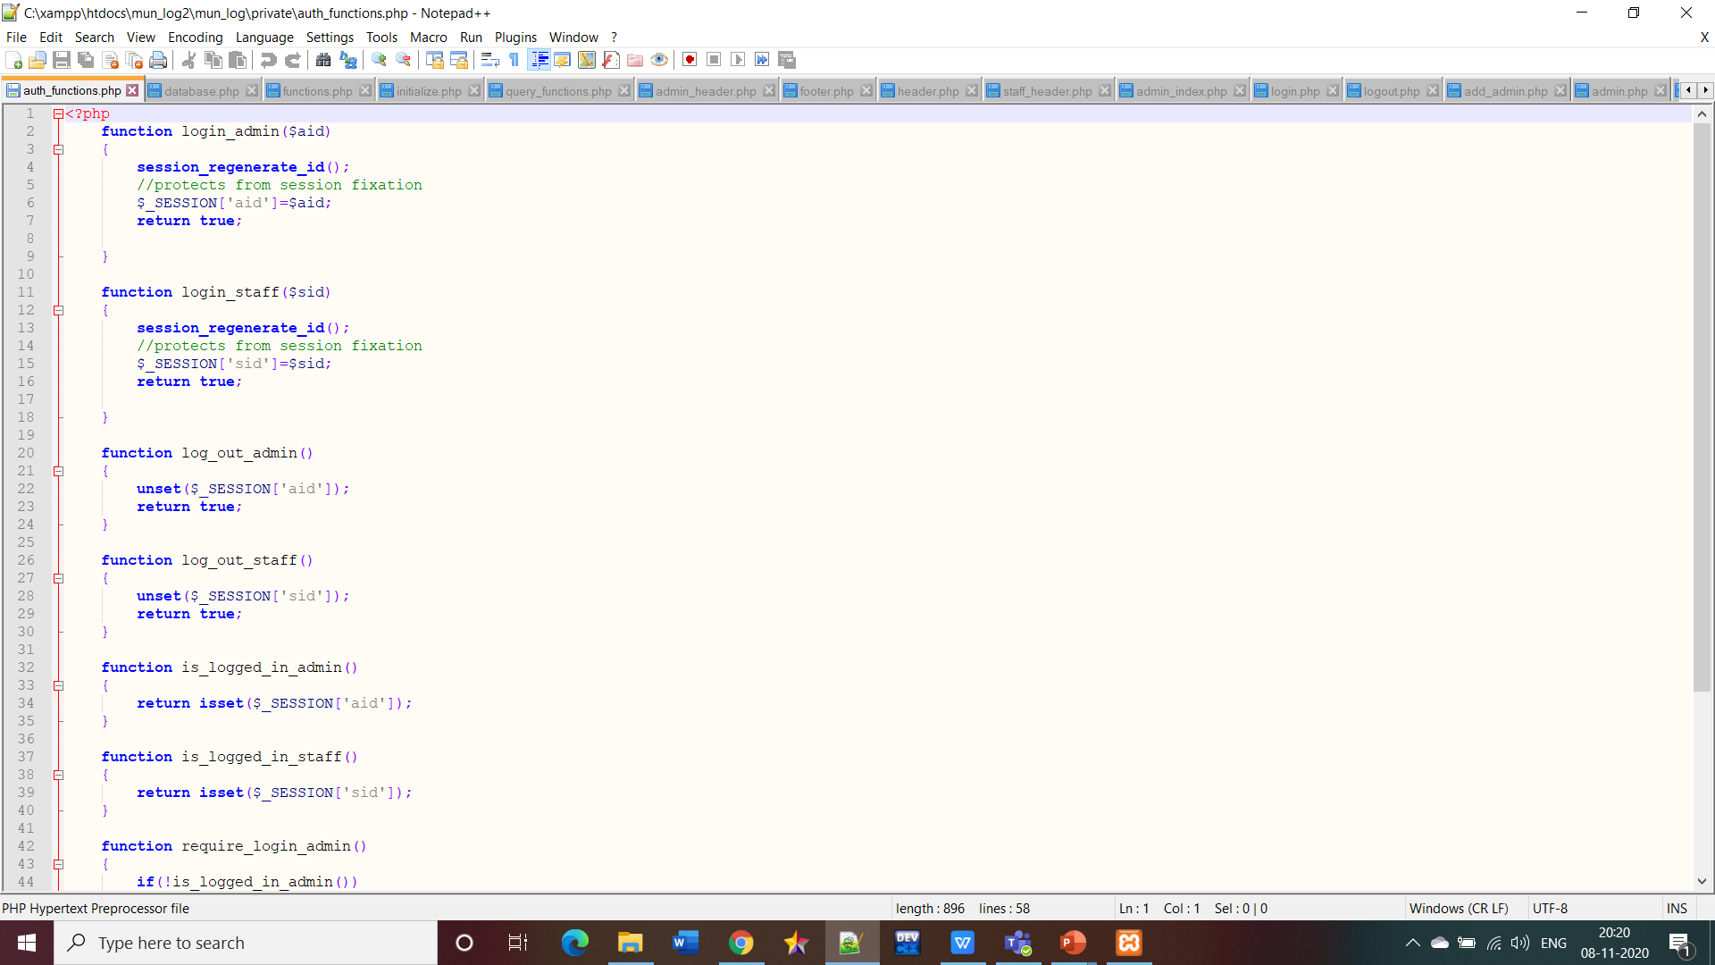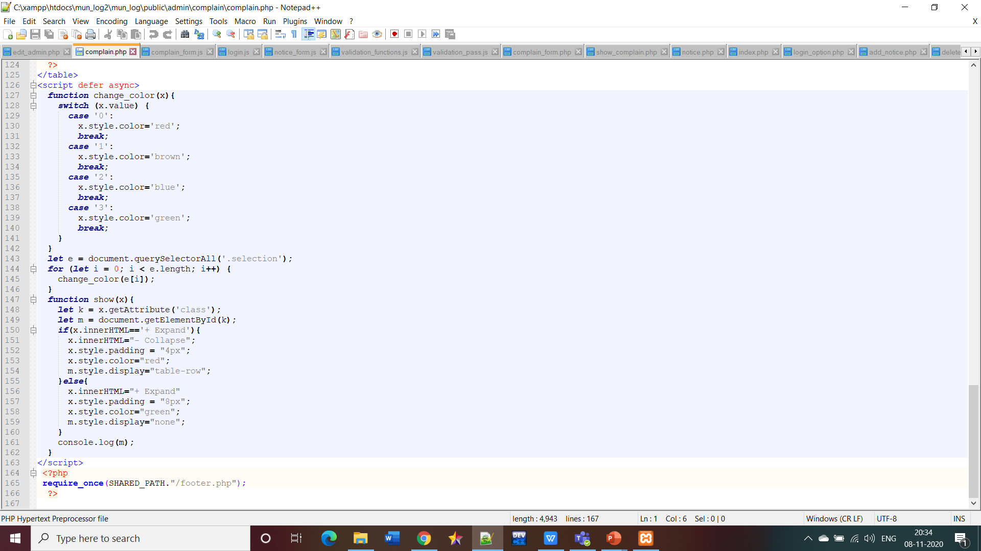

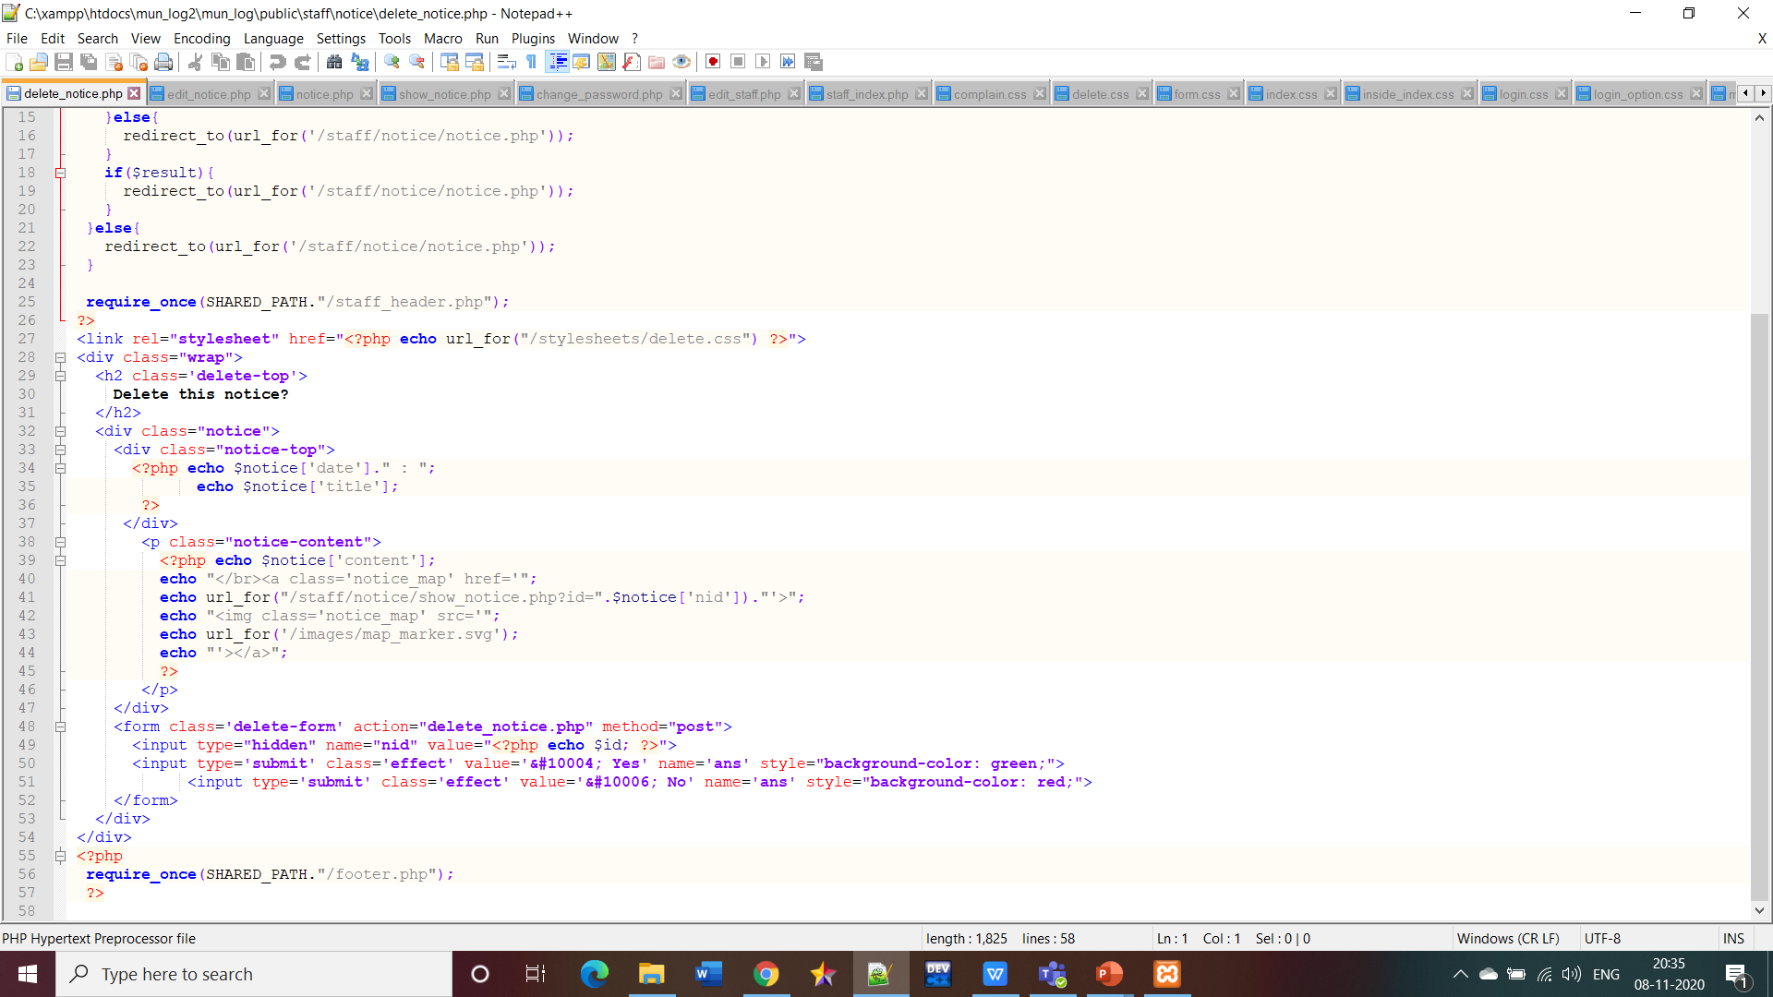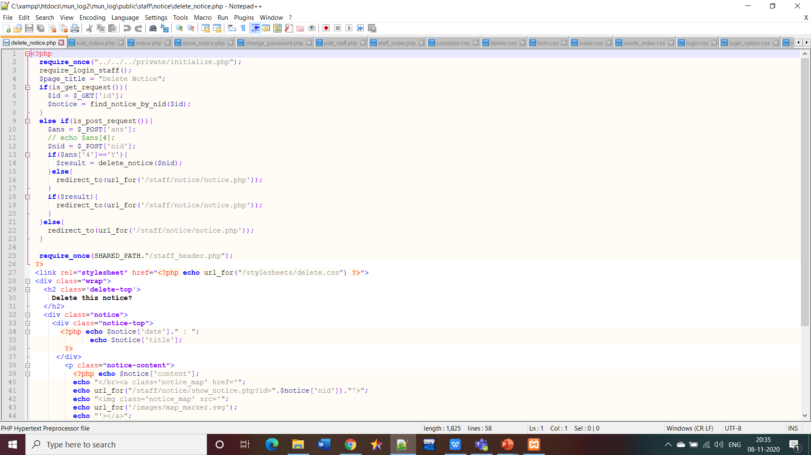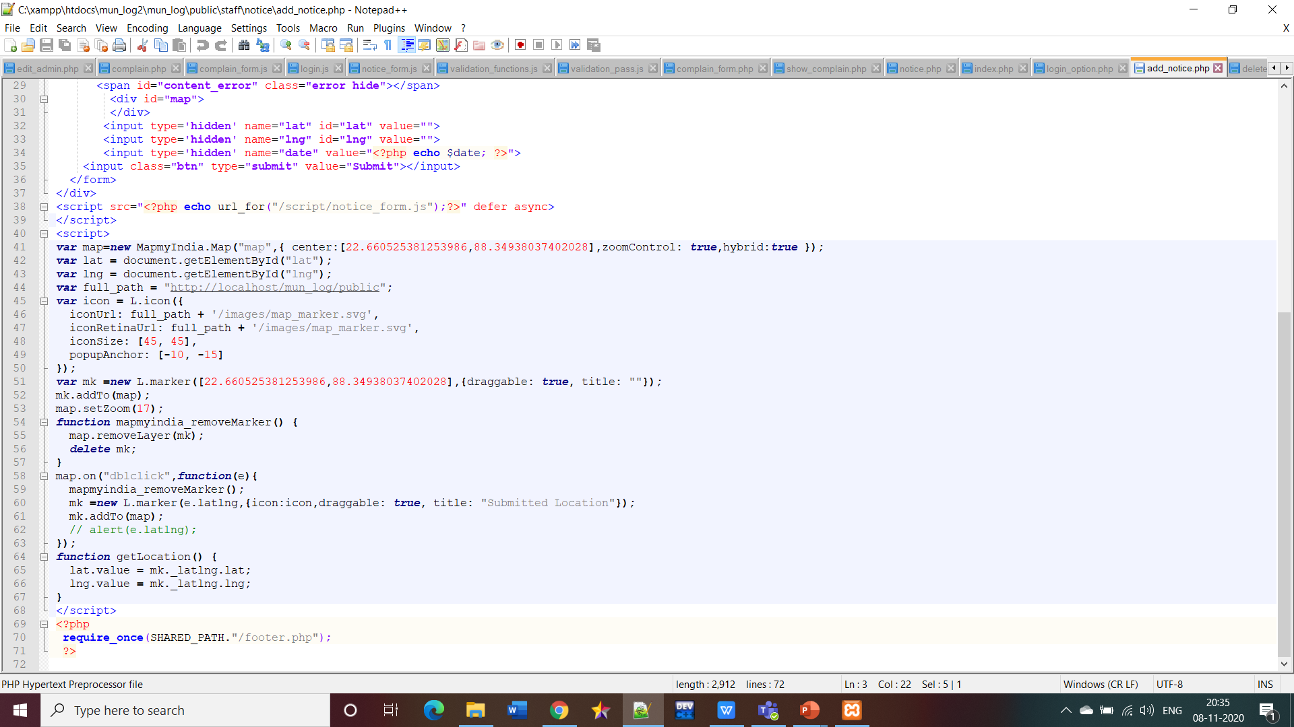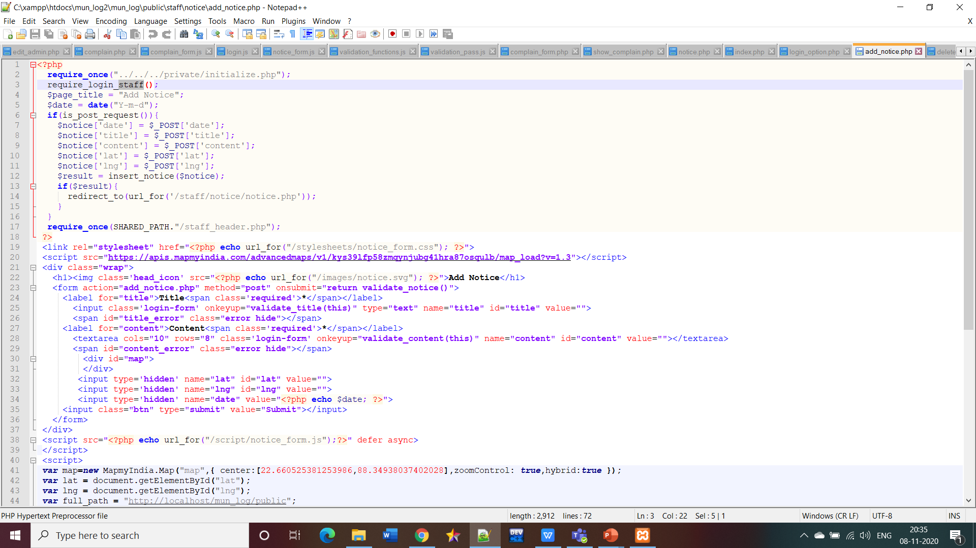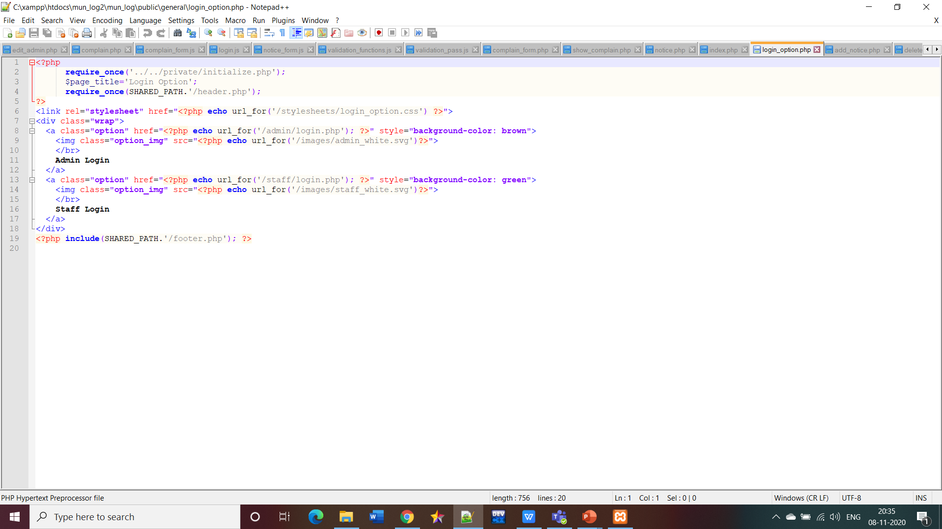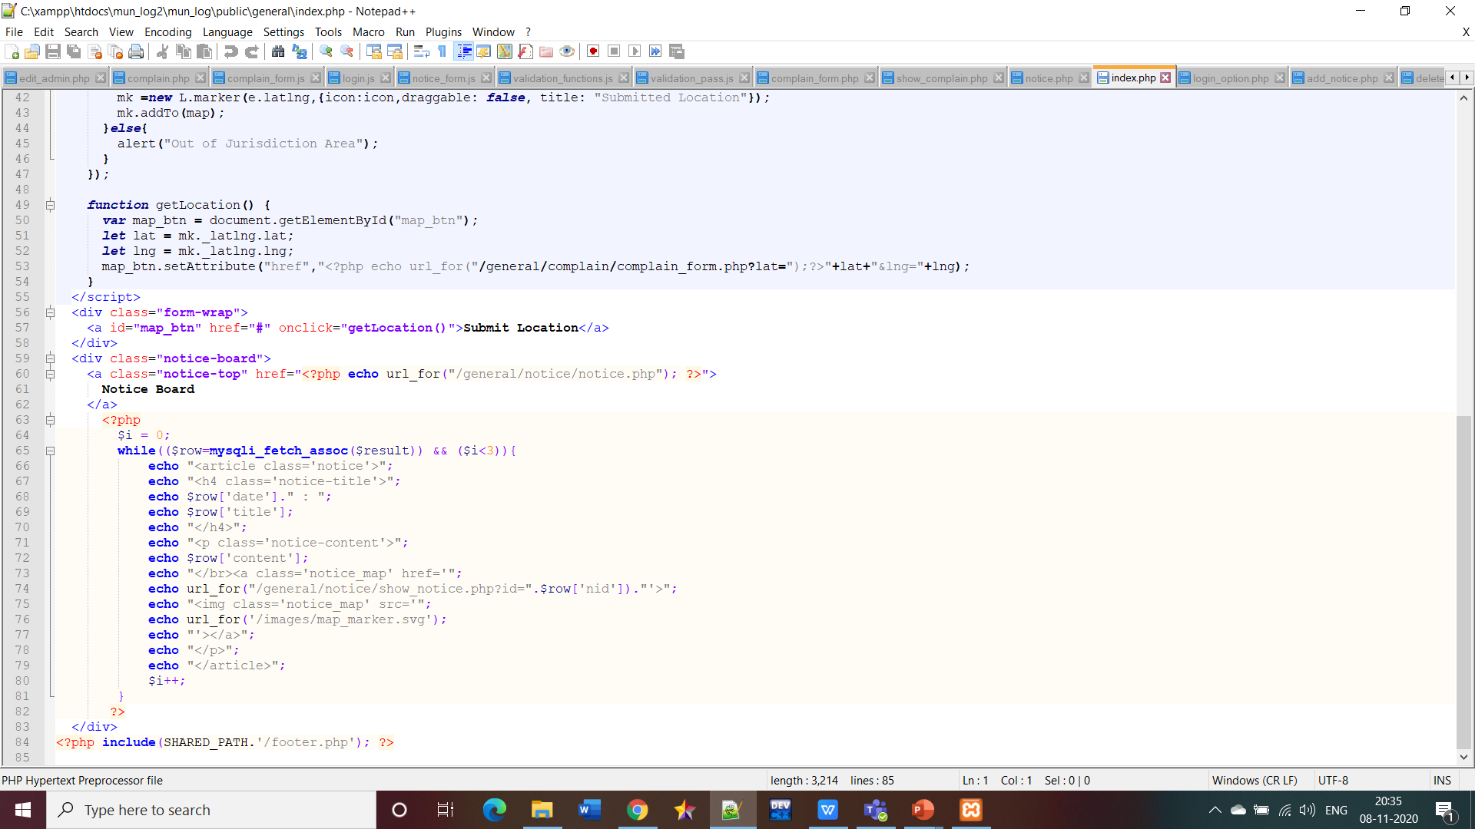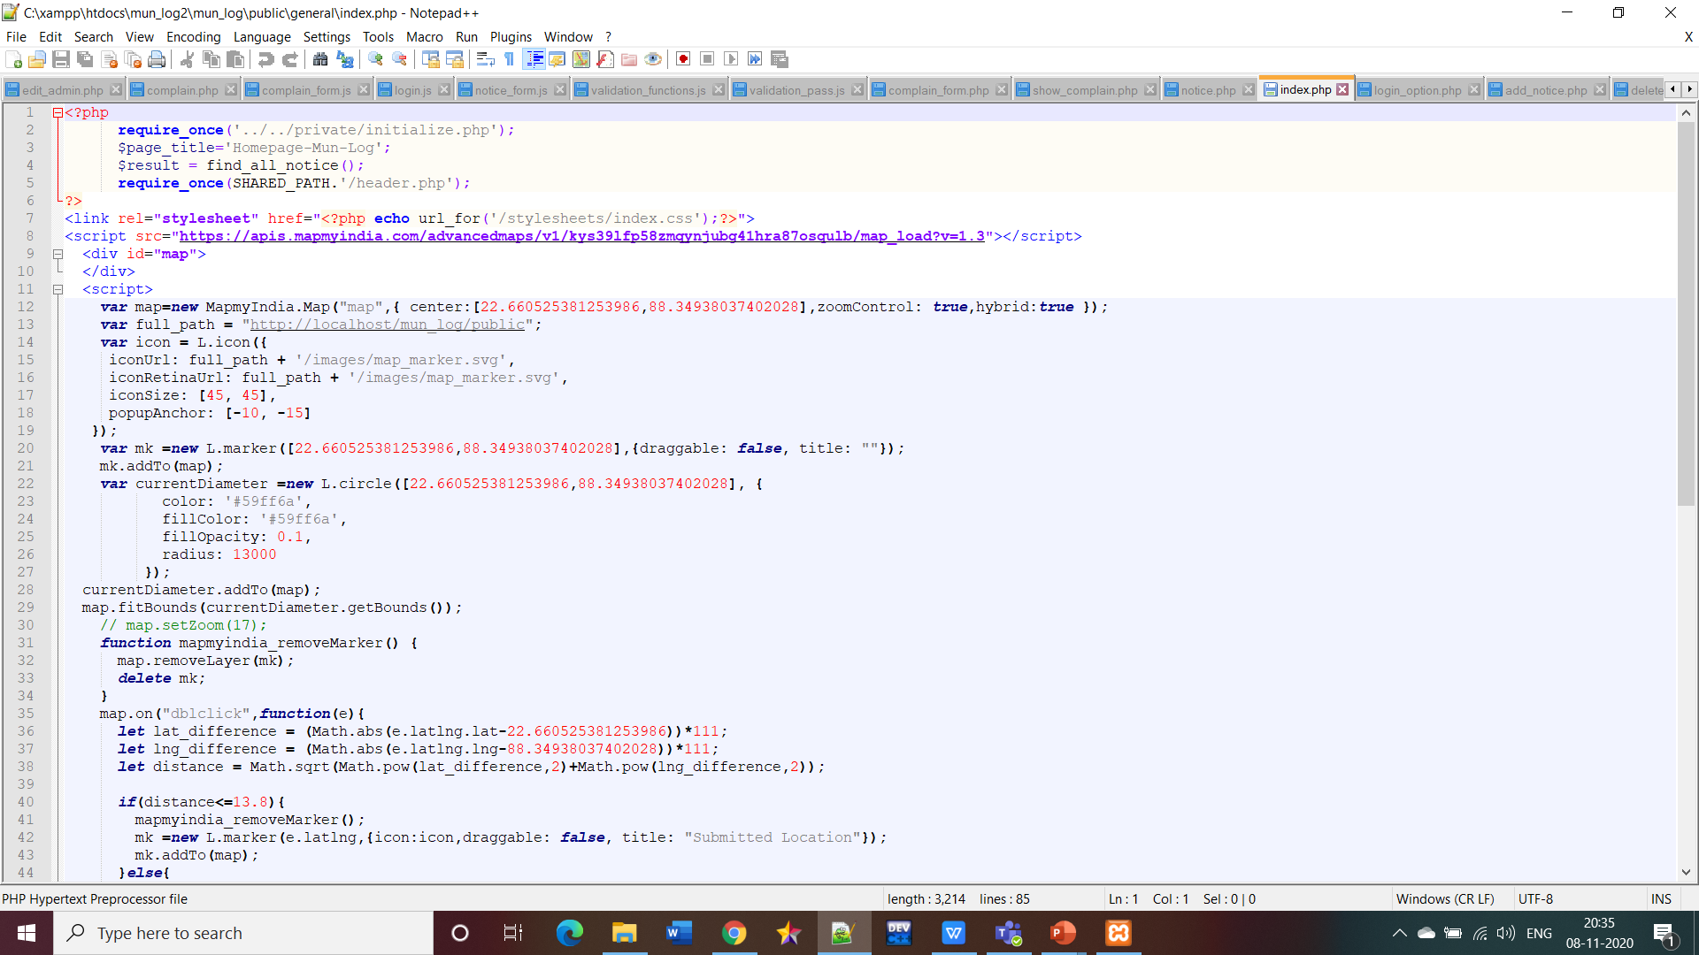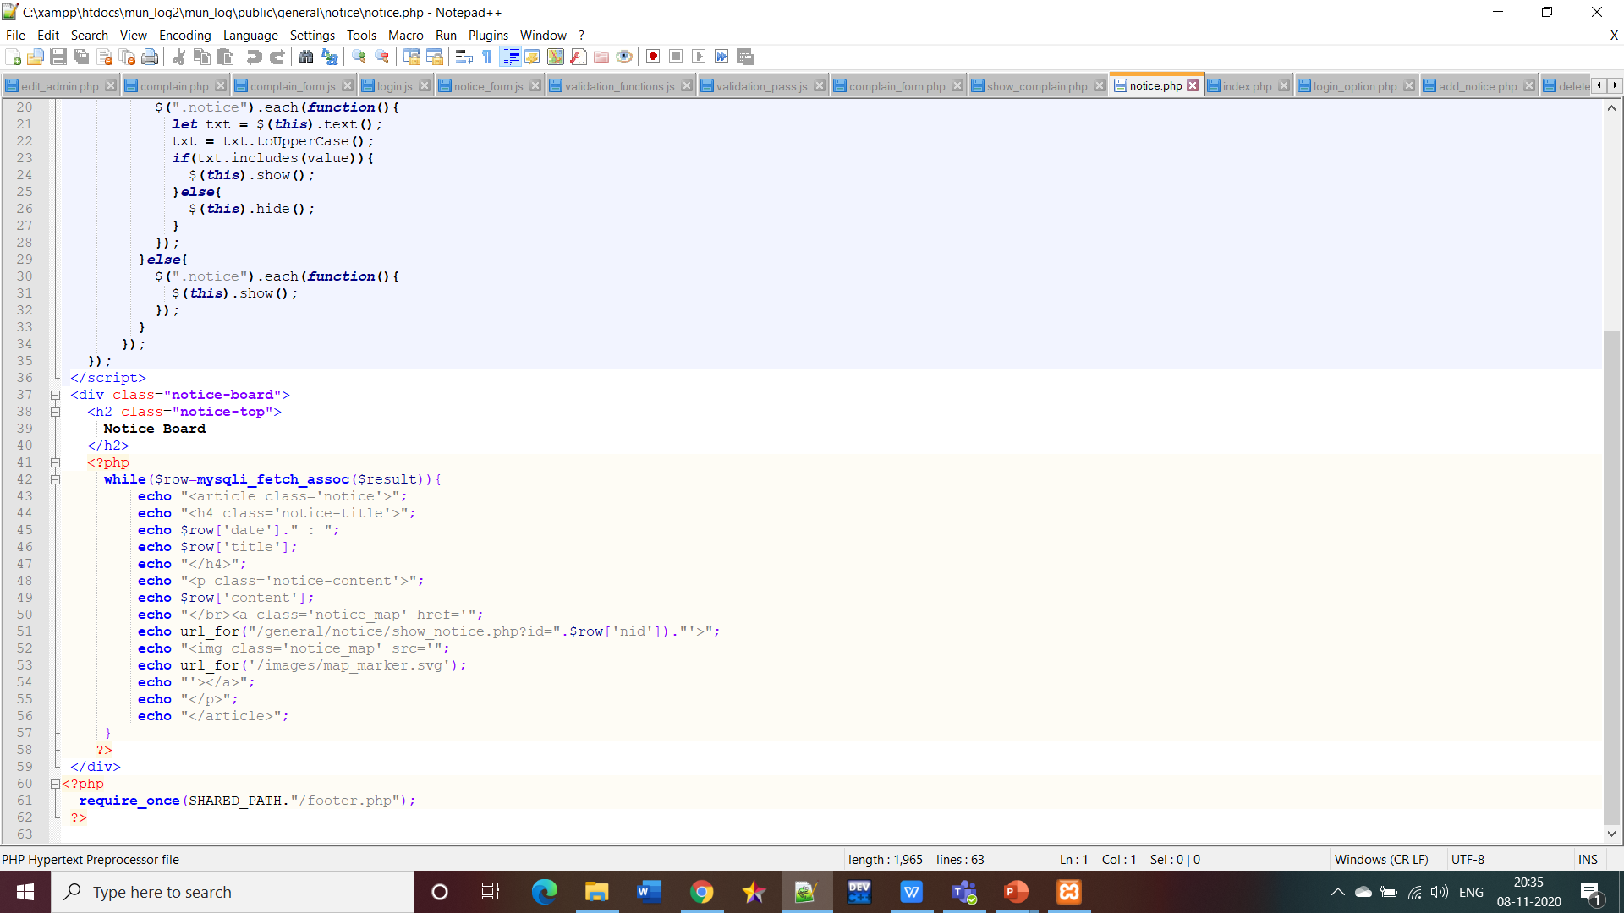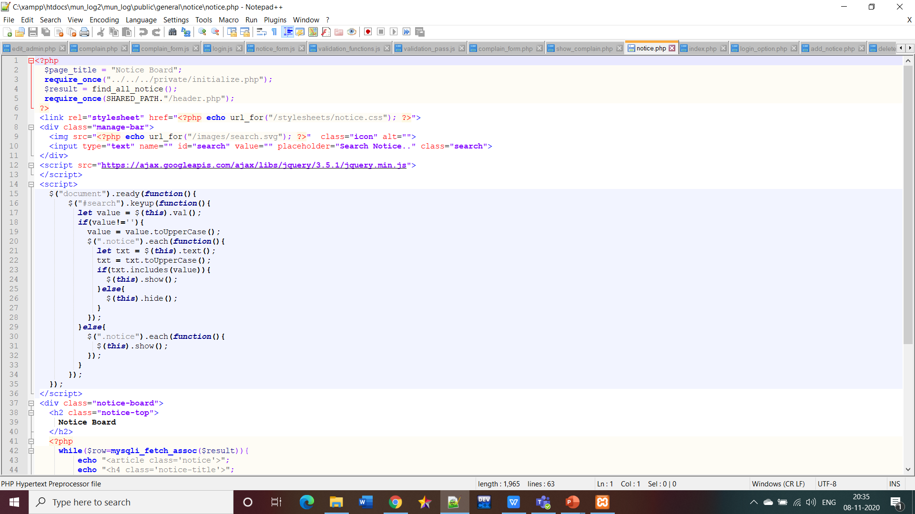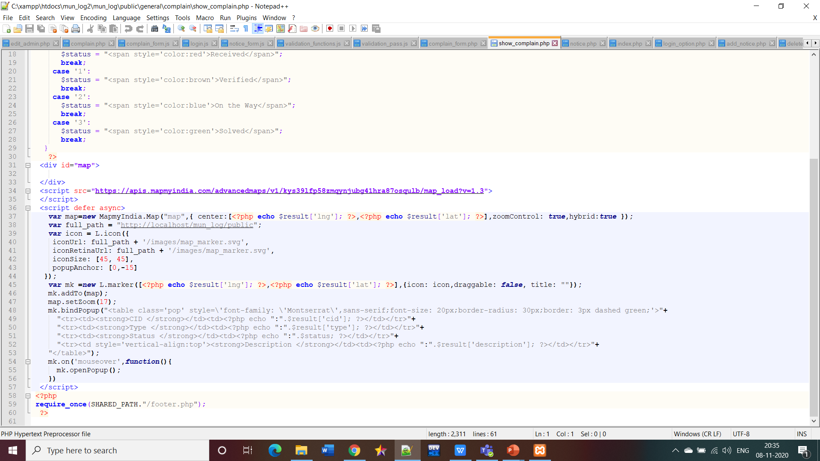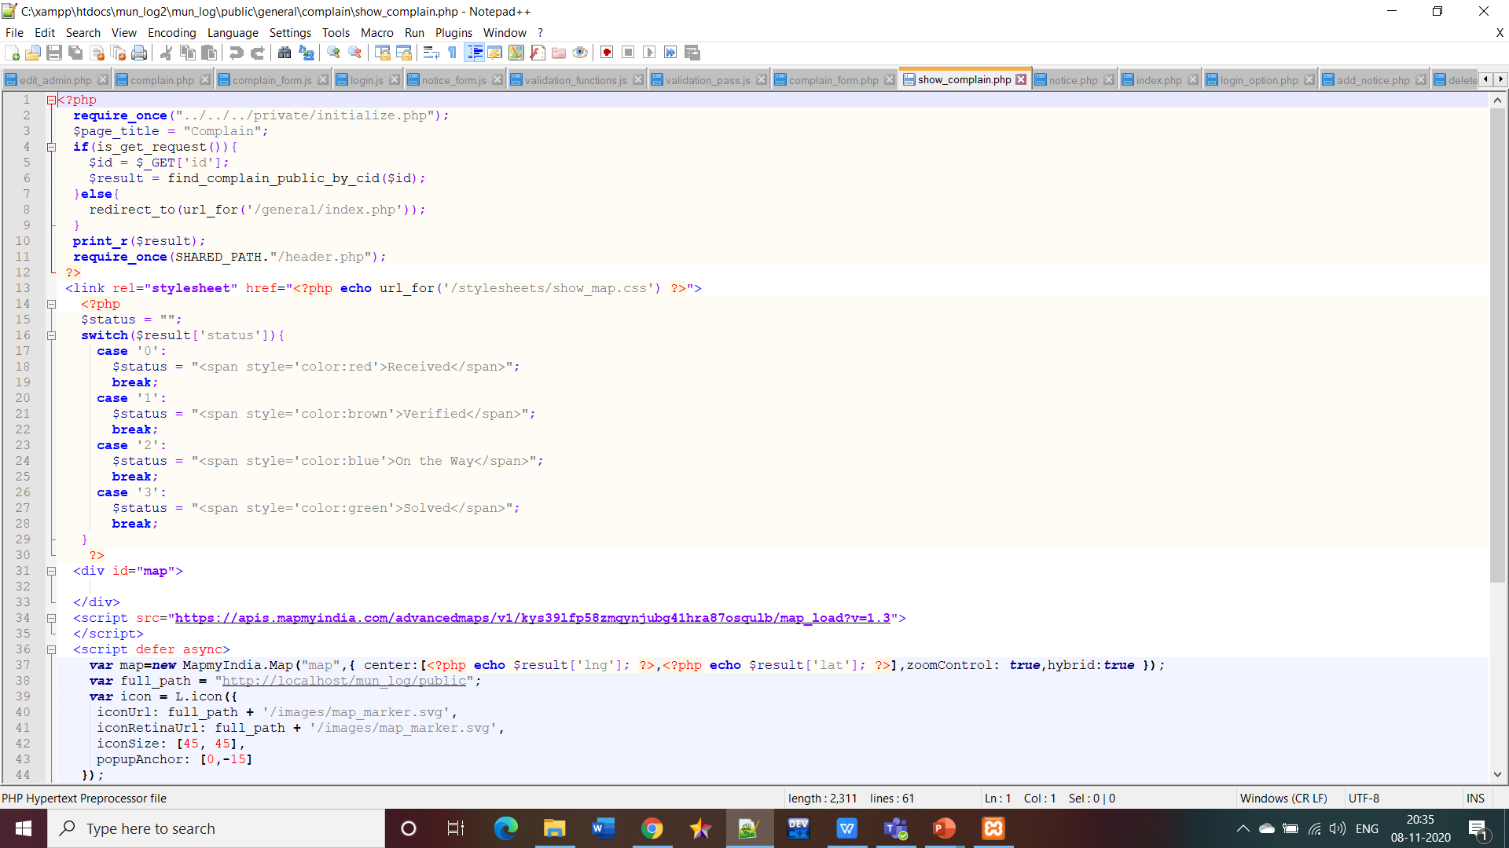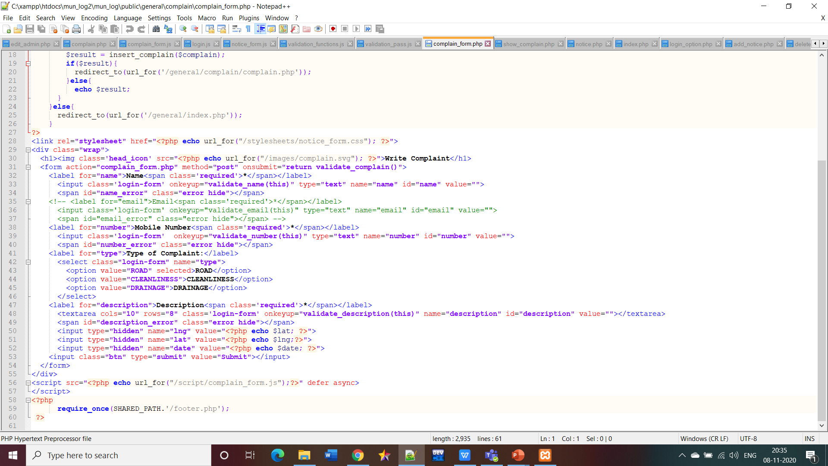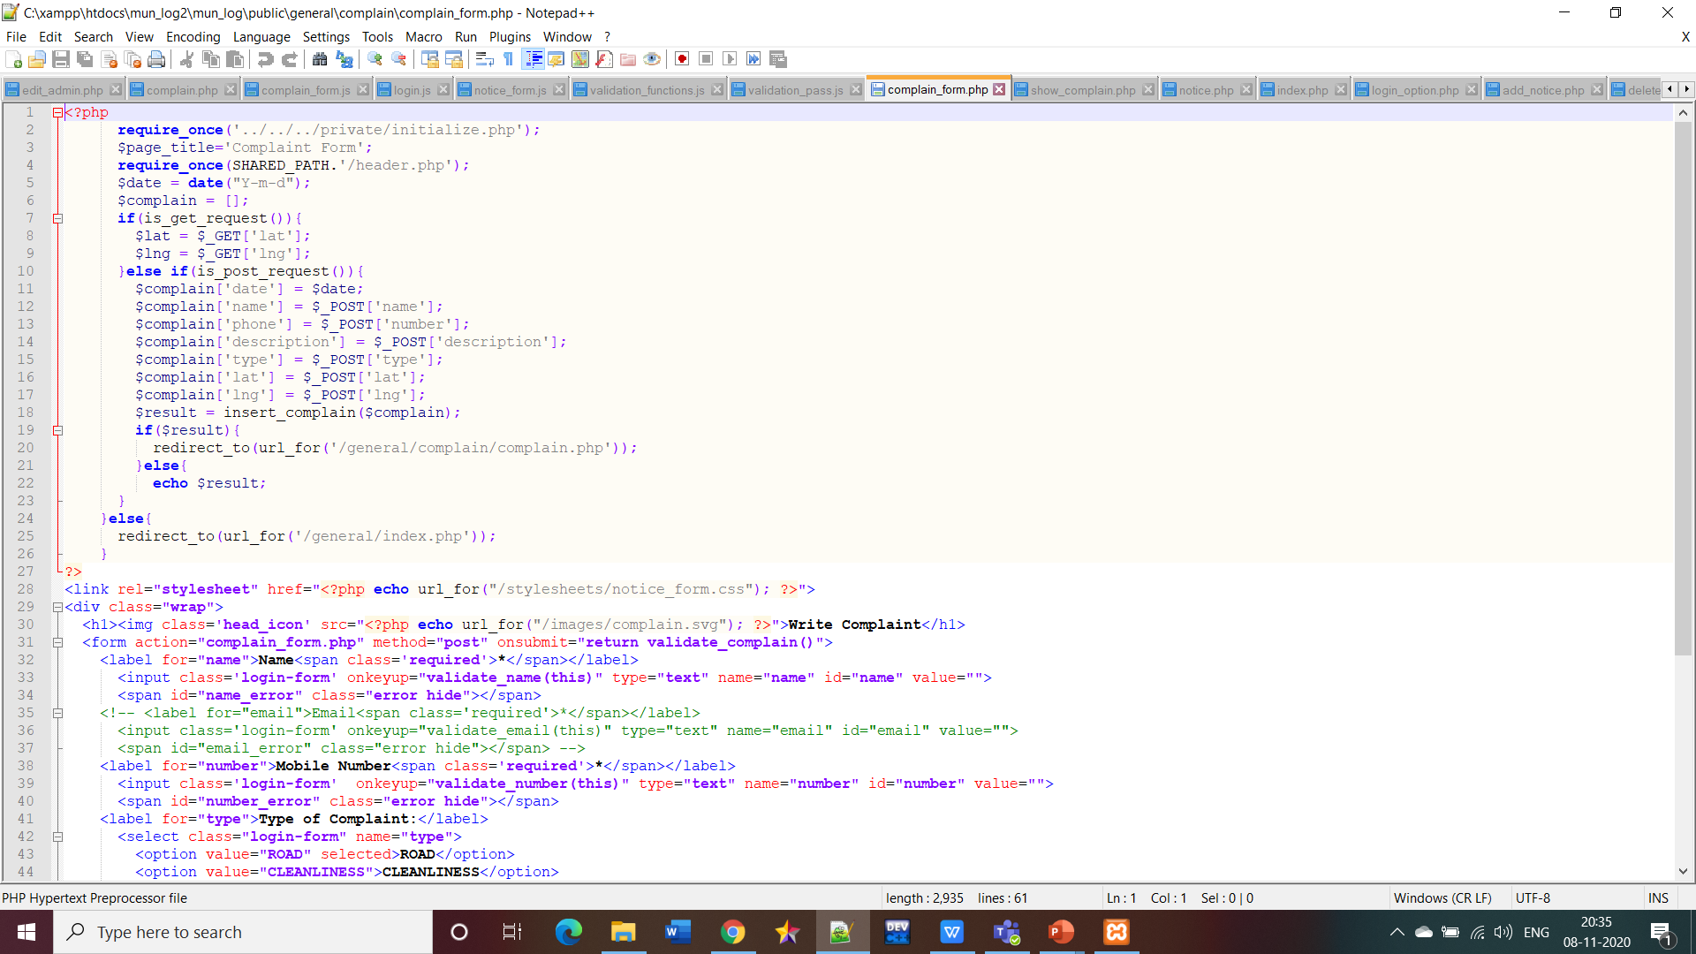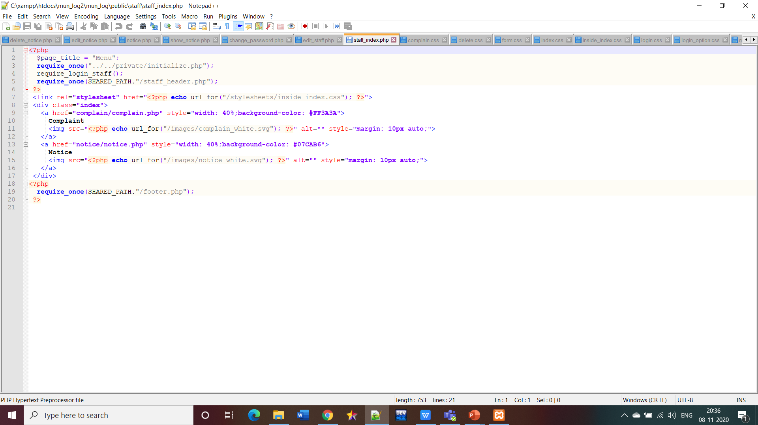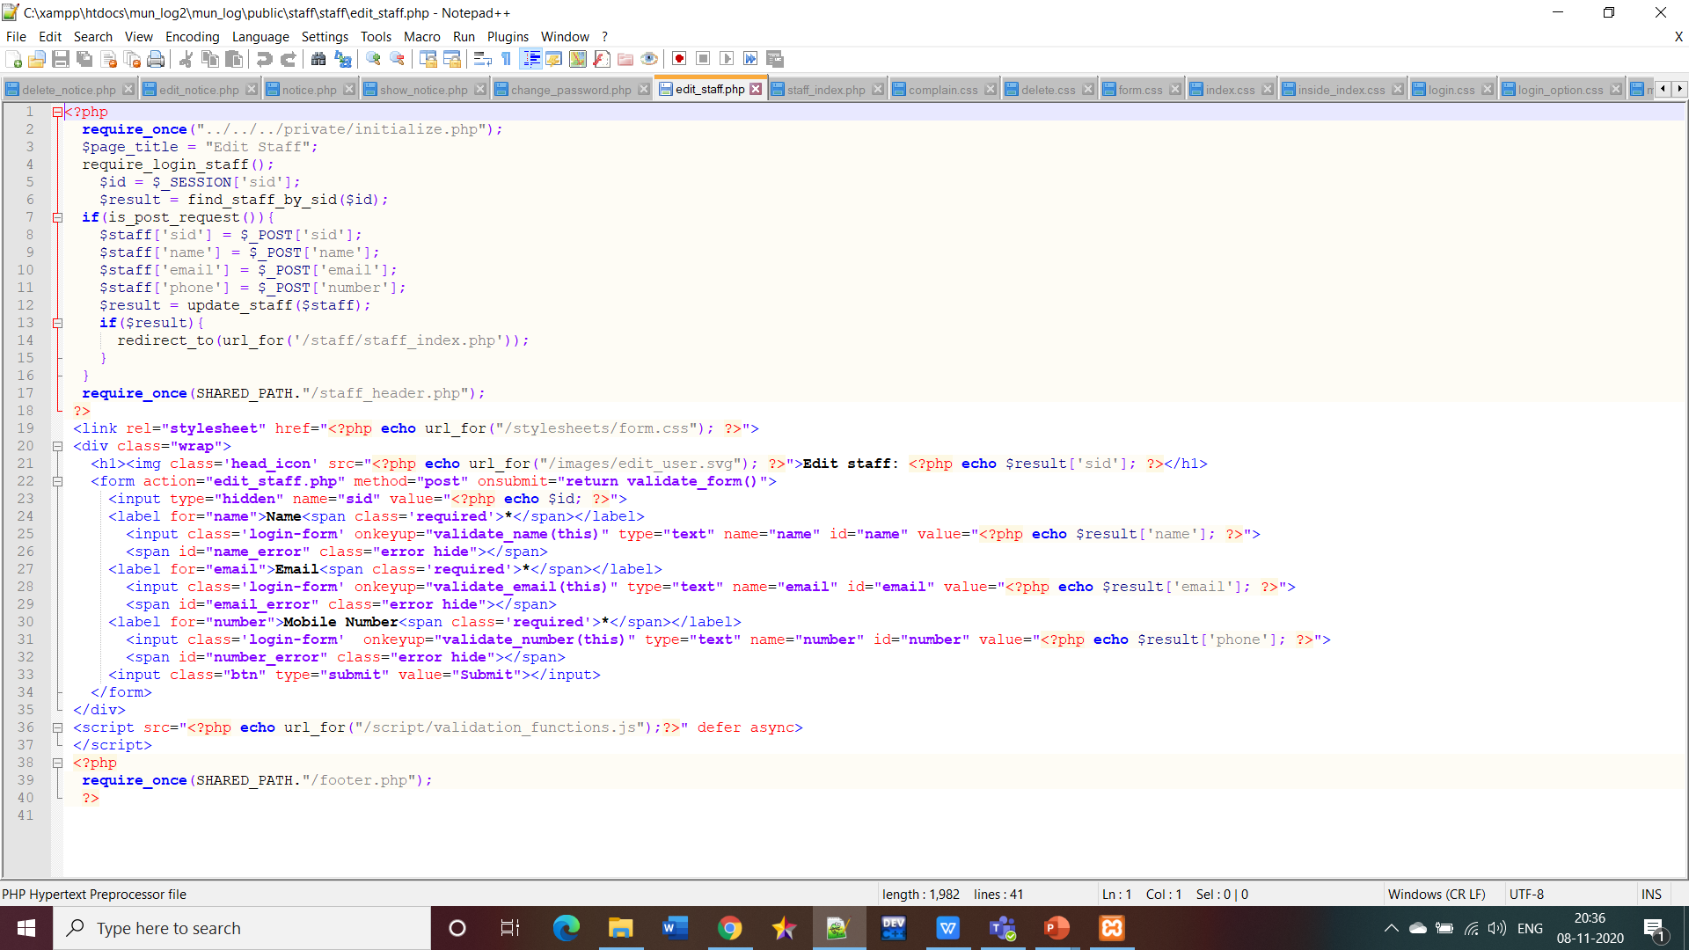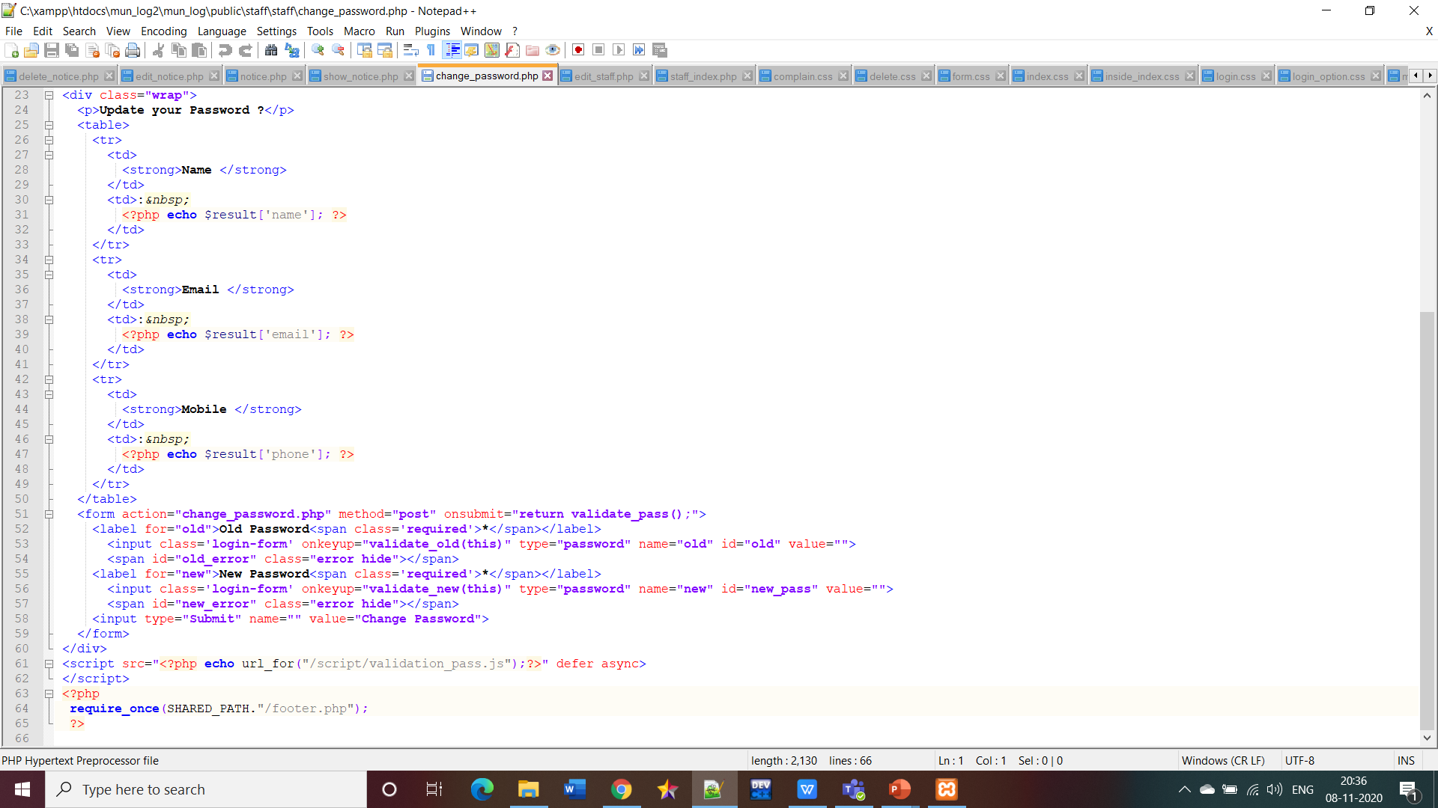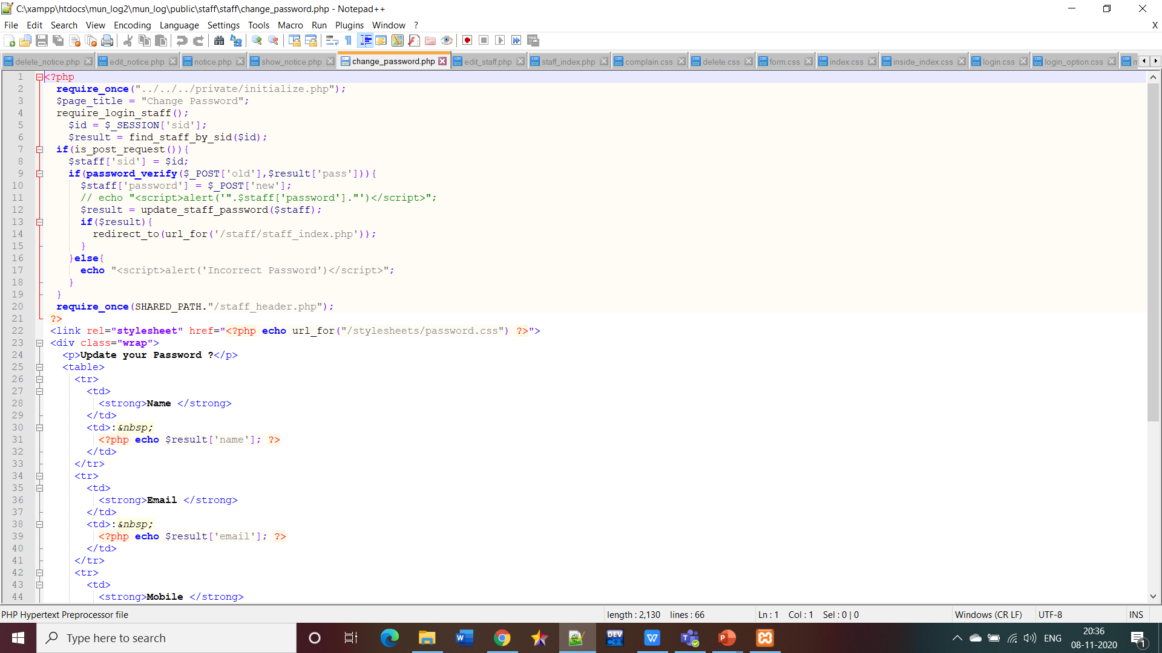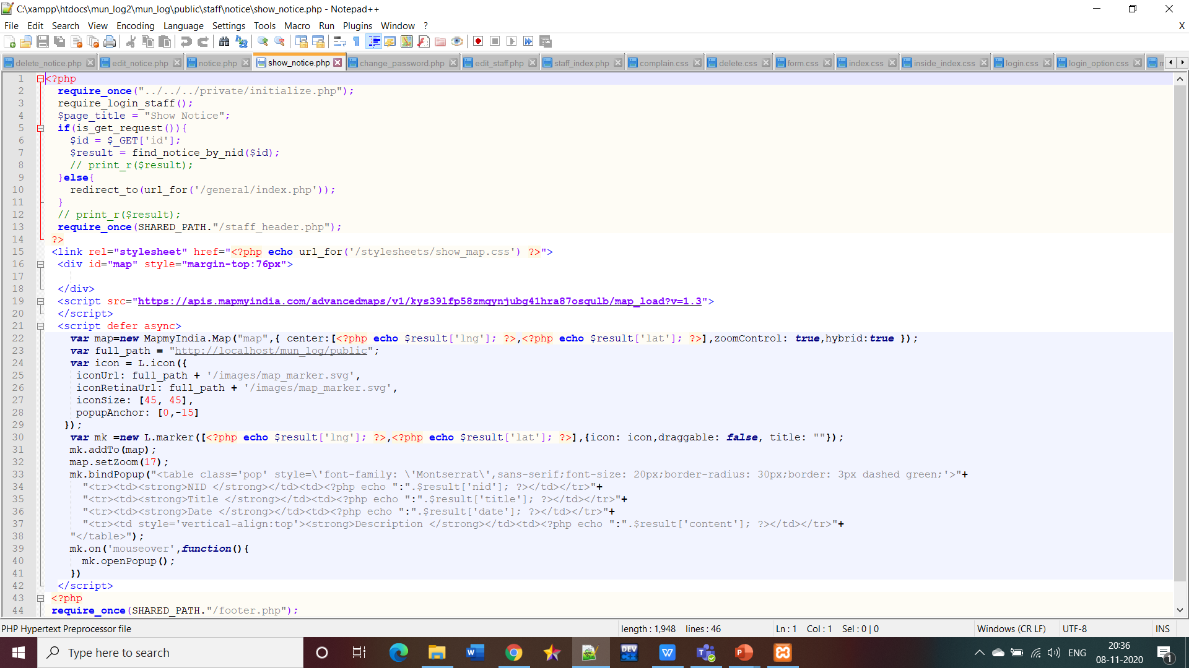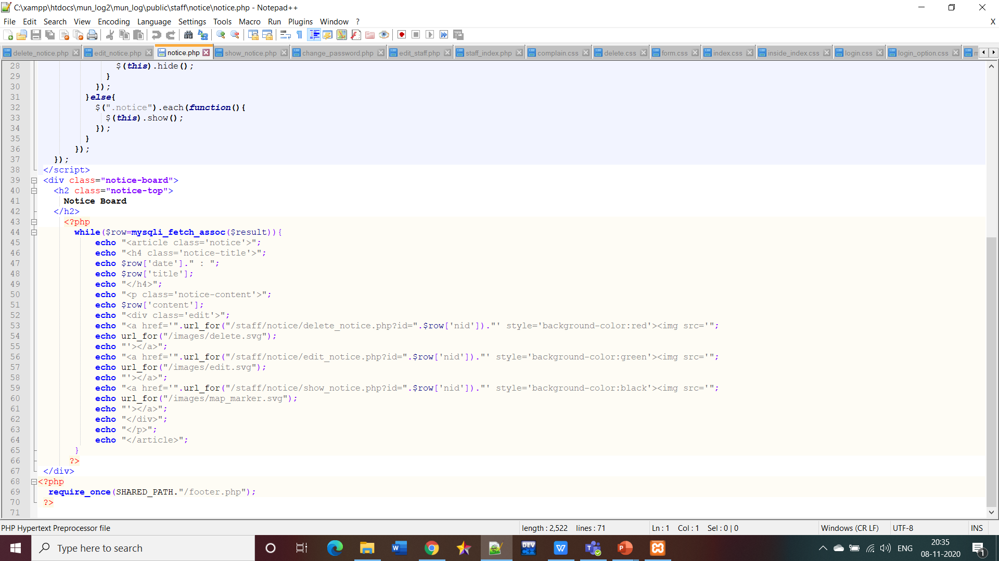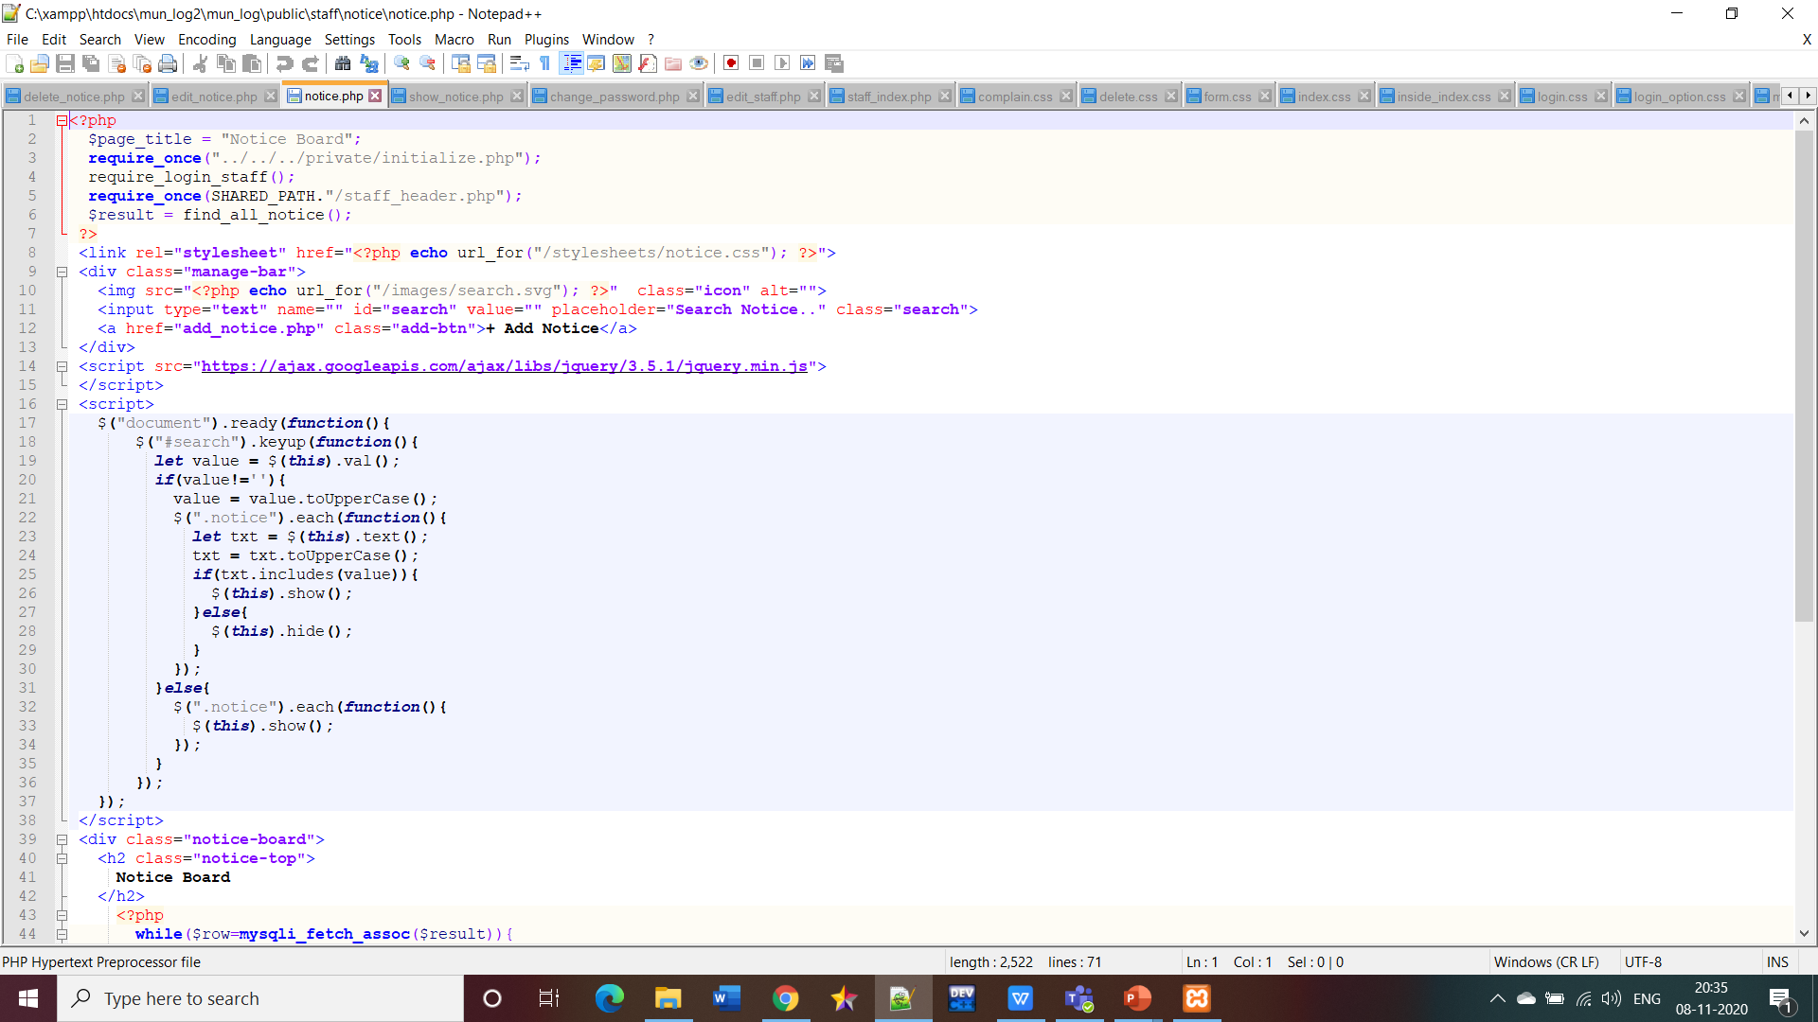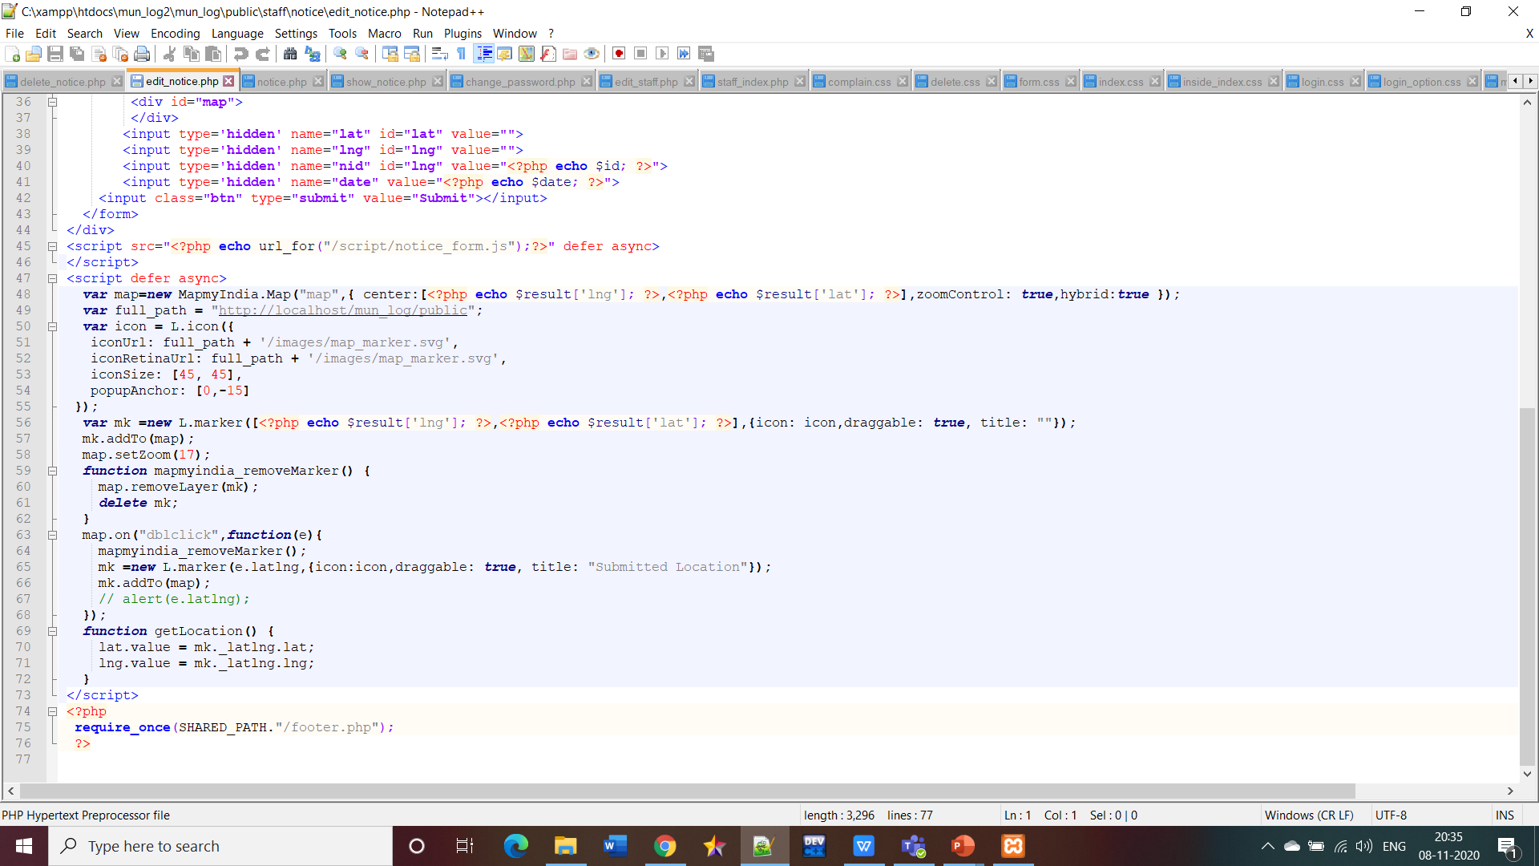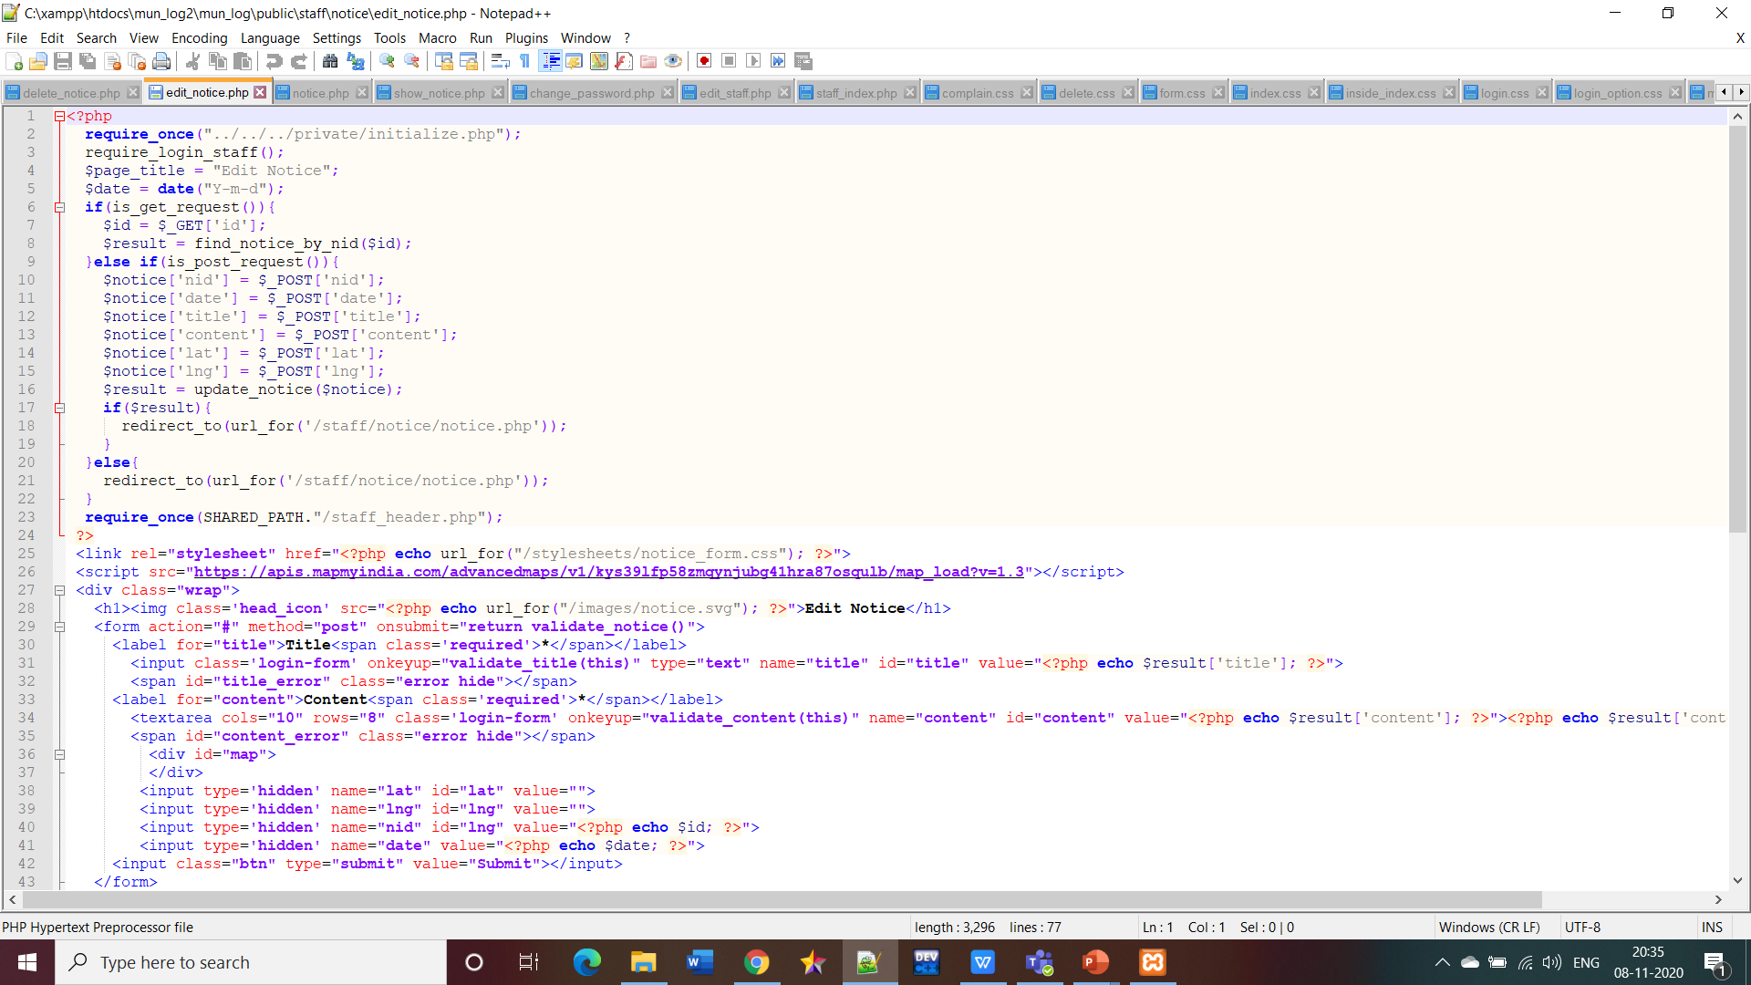

**Javascript files**

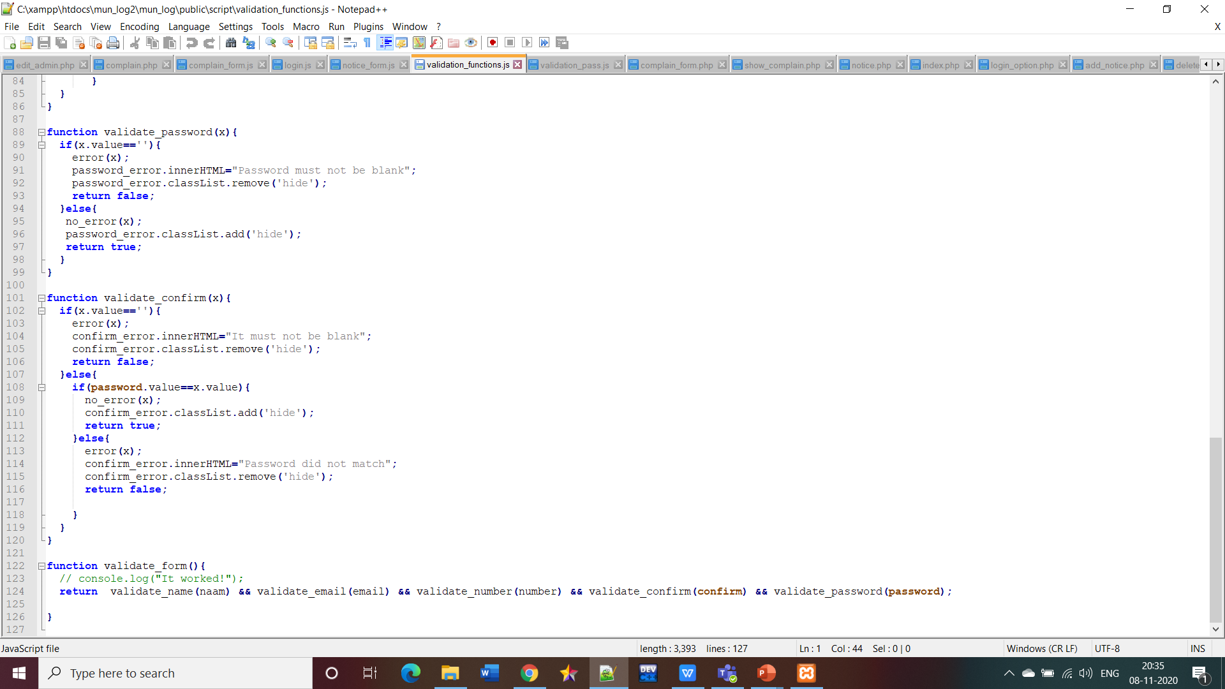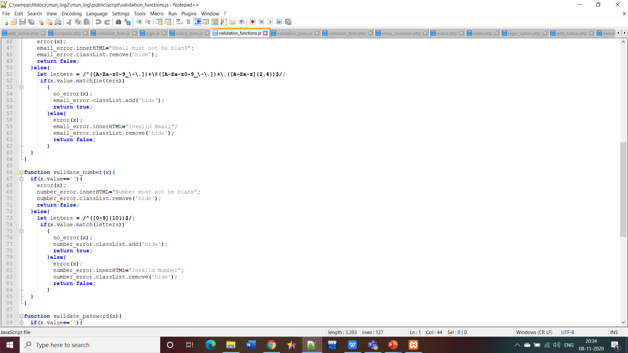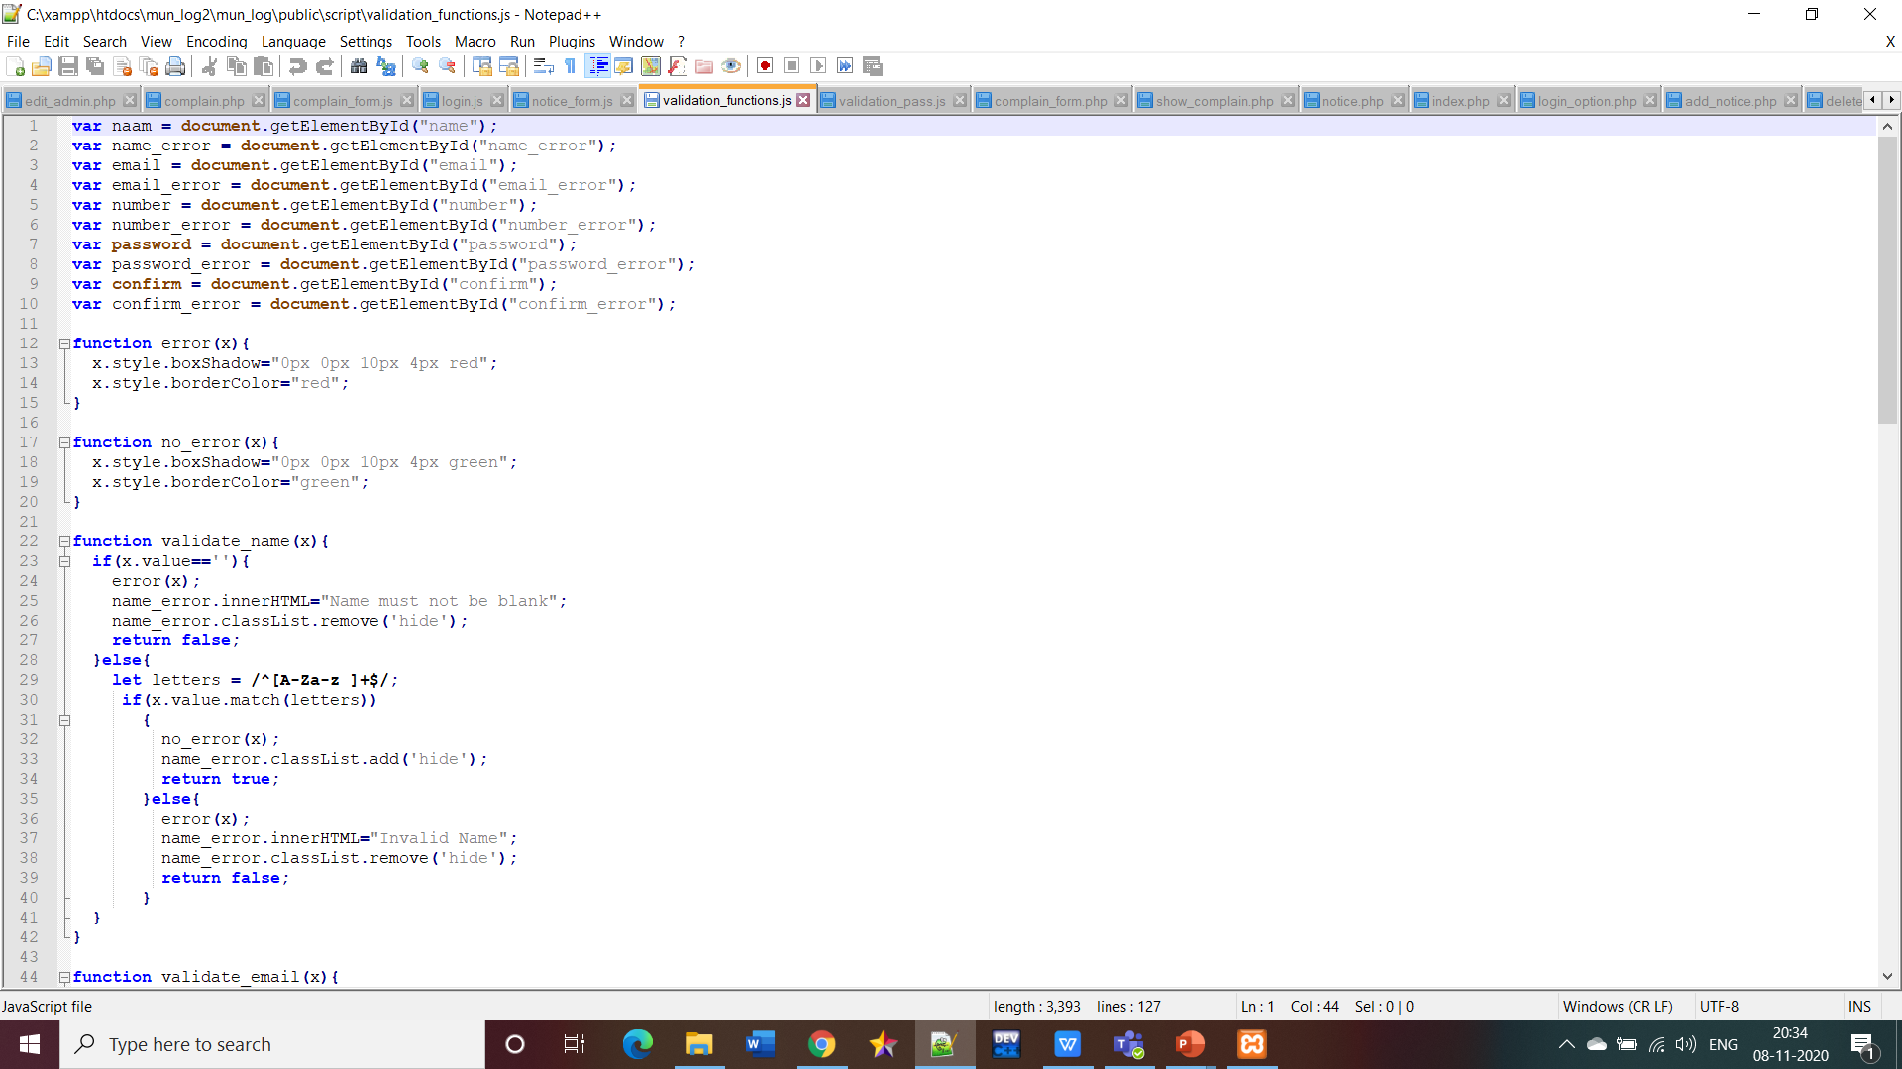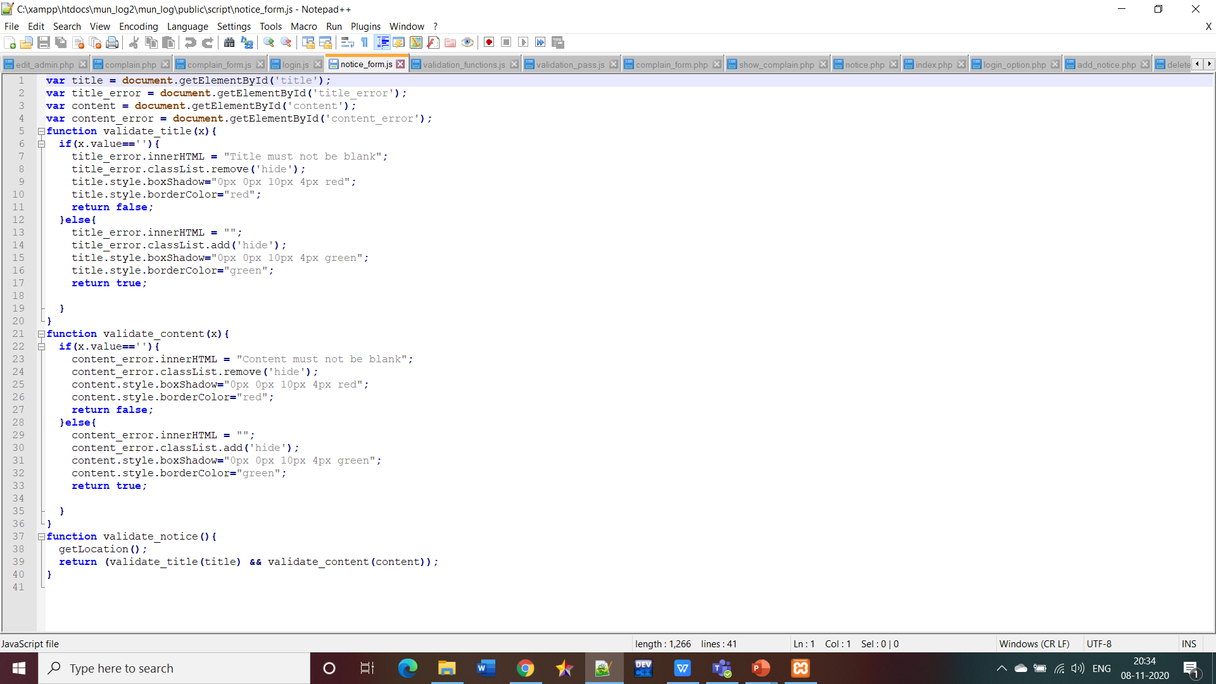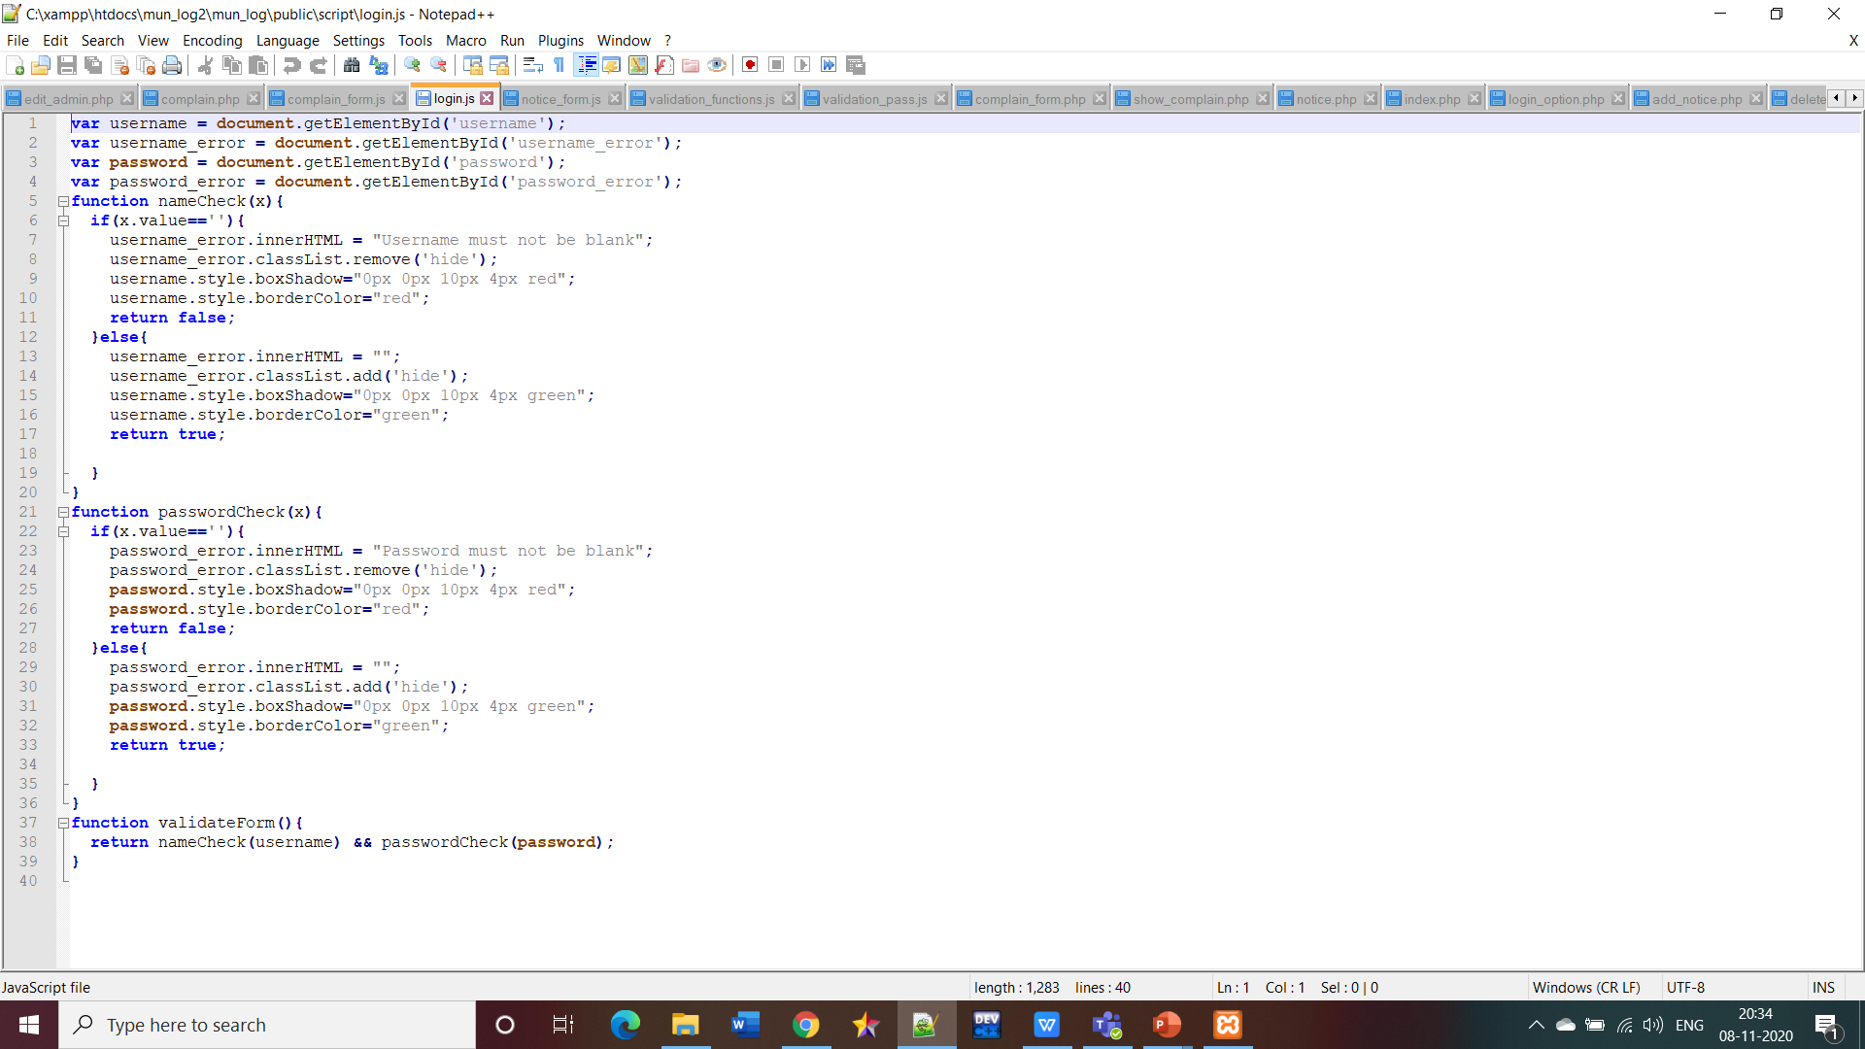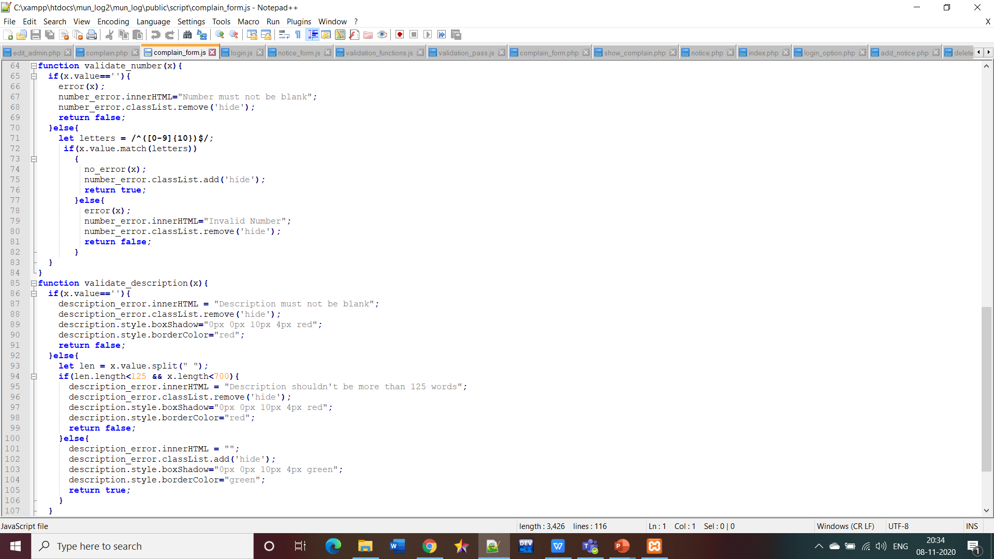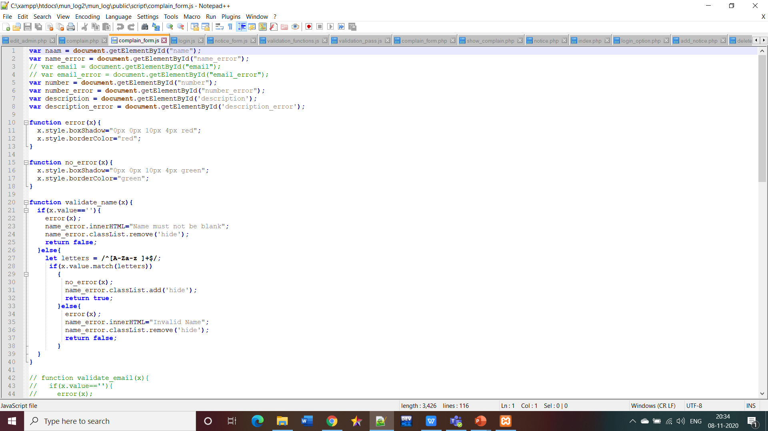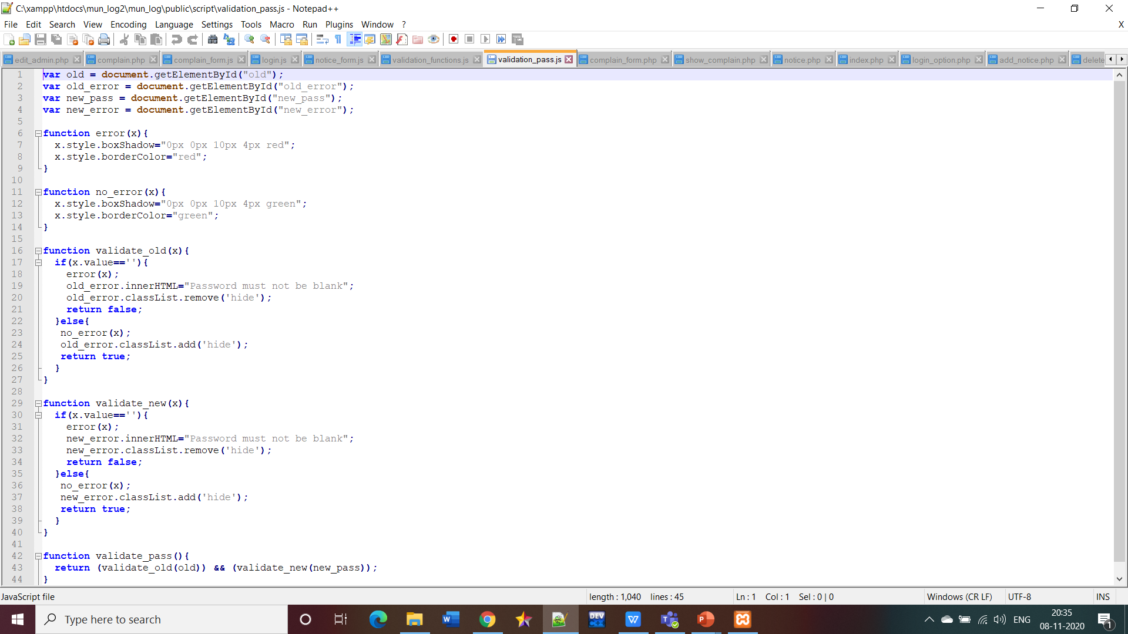

**CSS files**

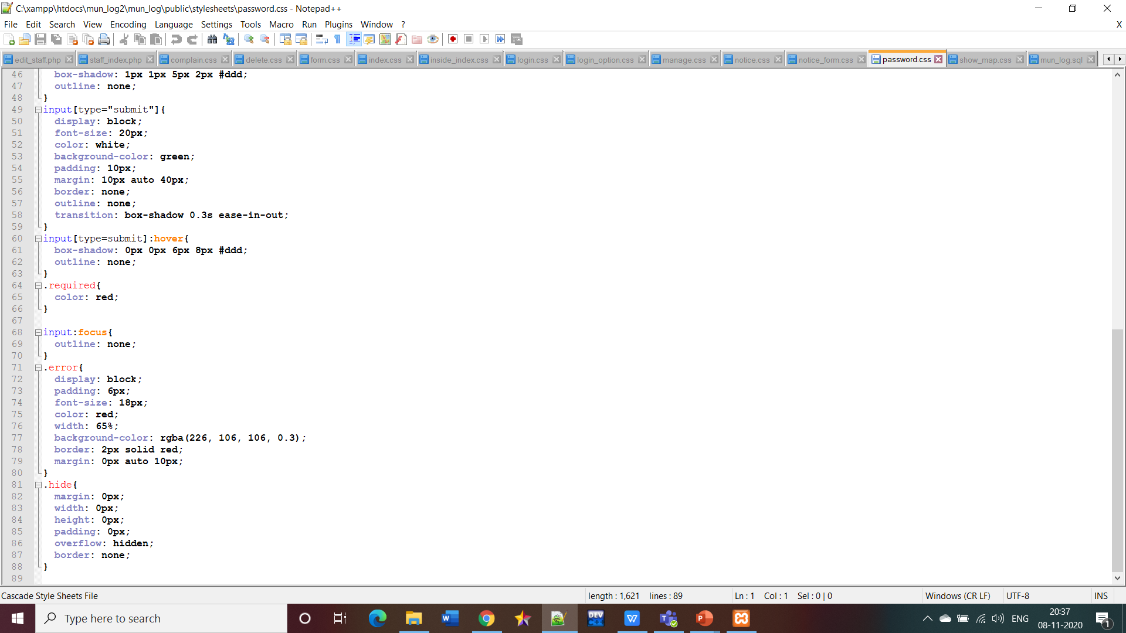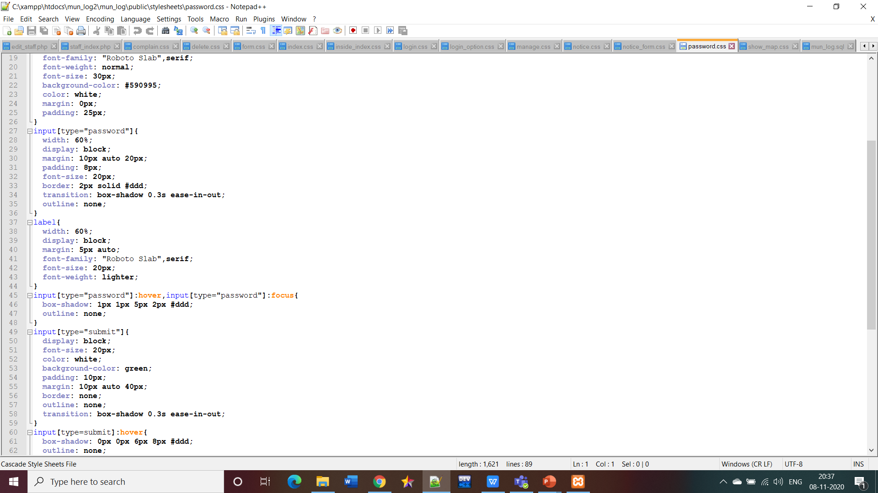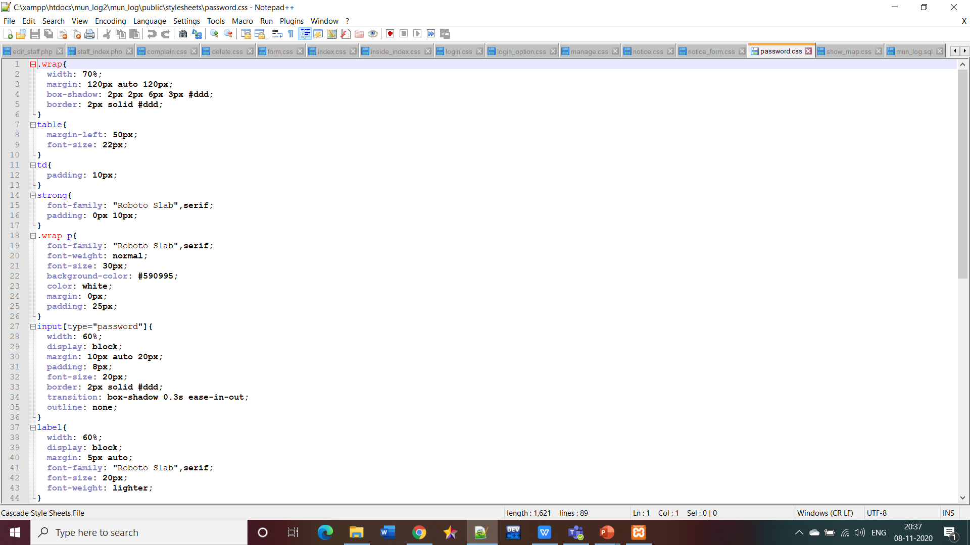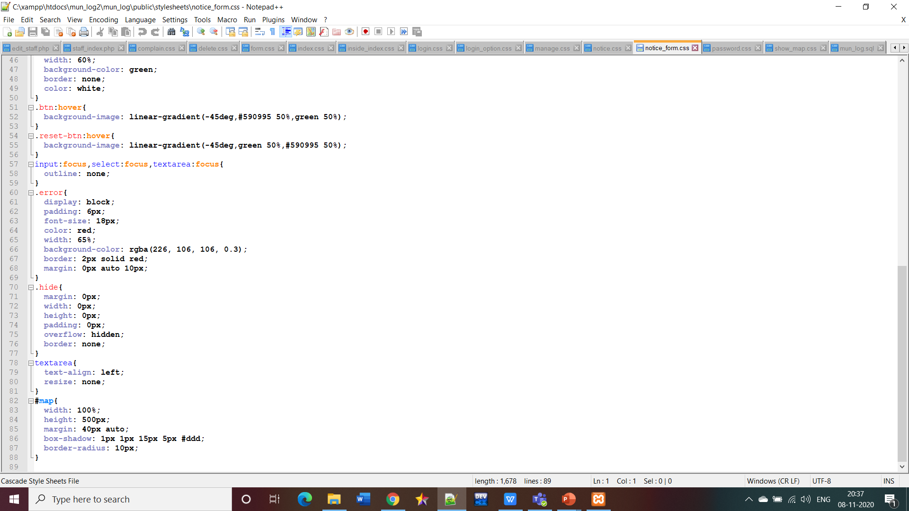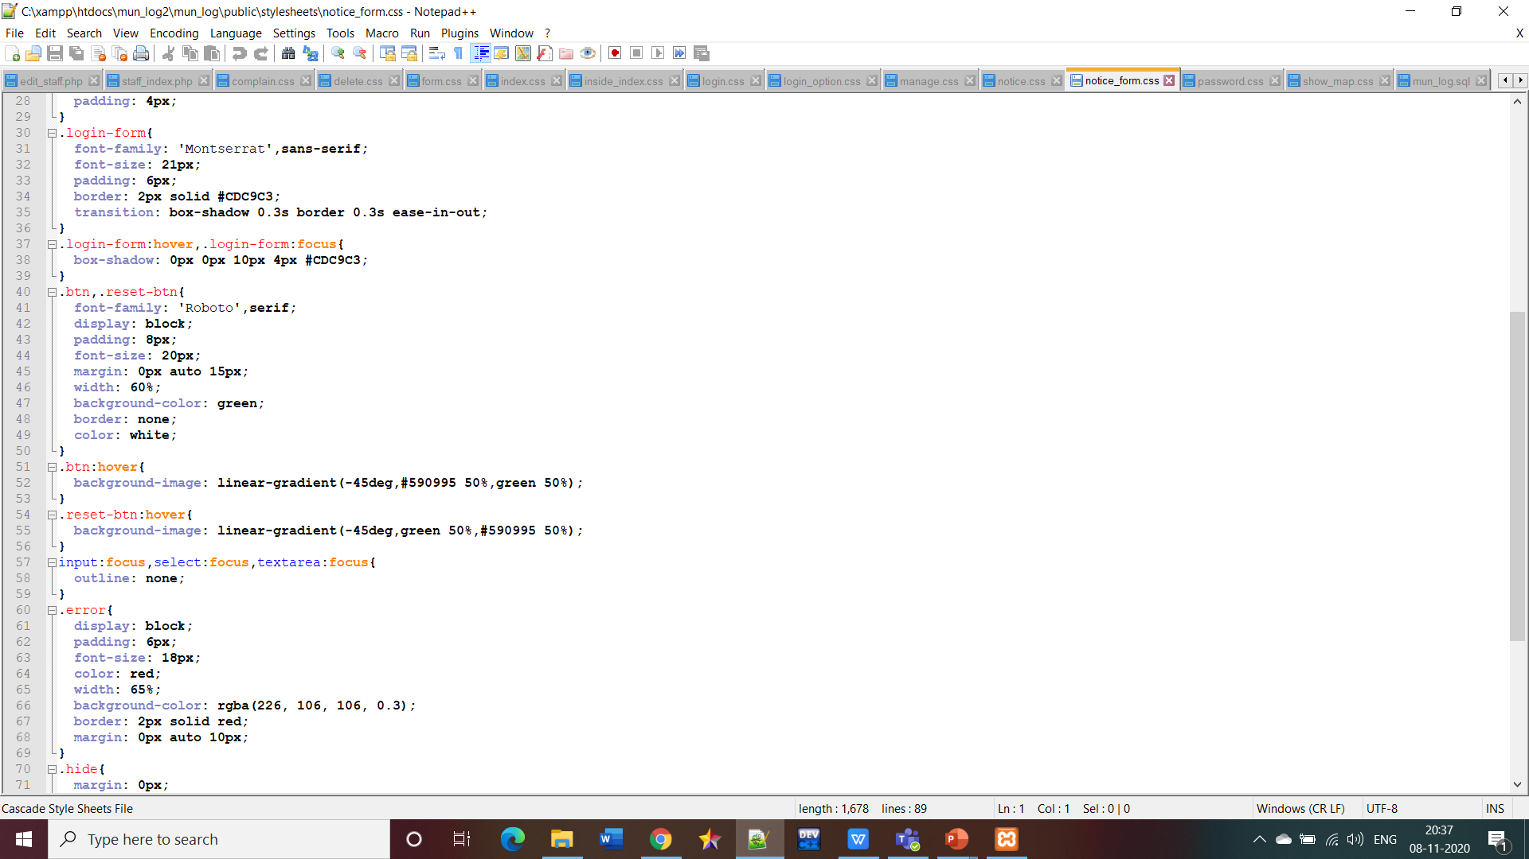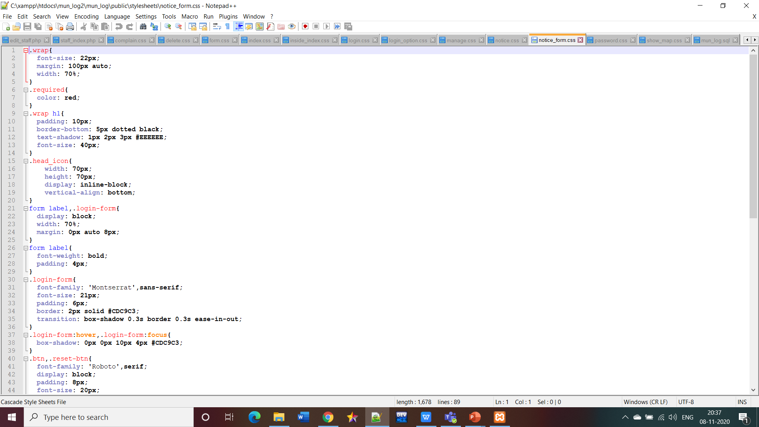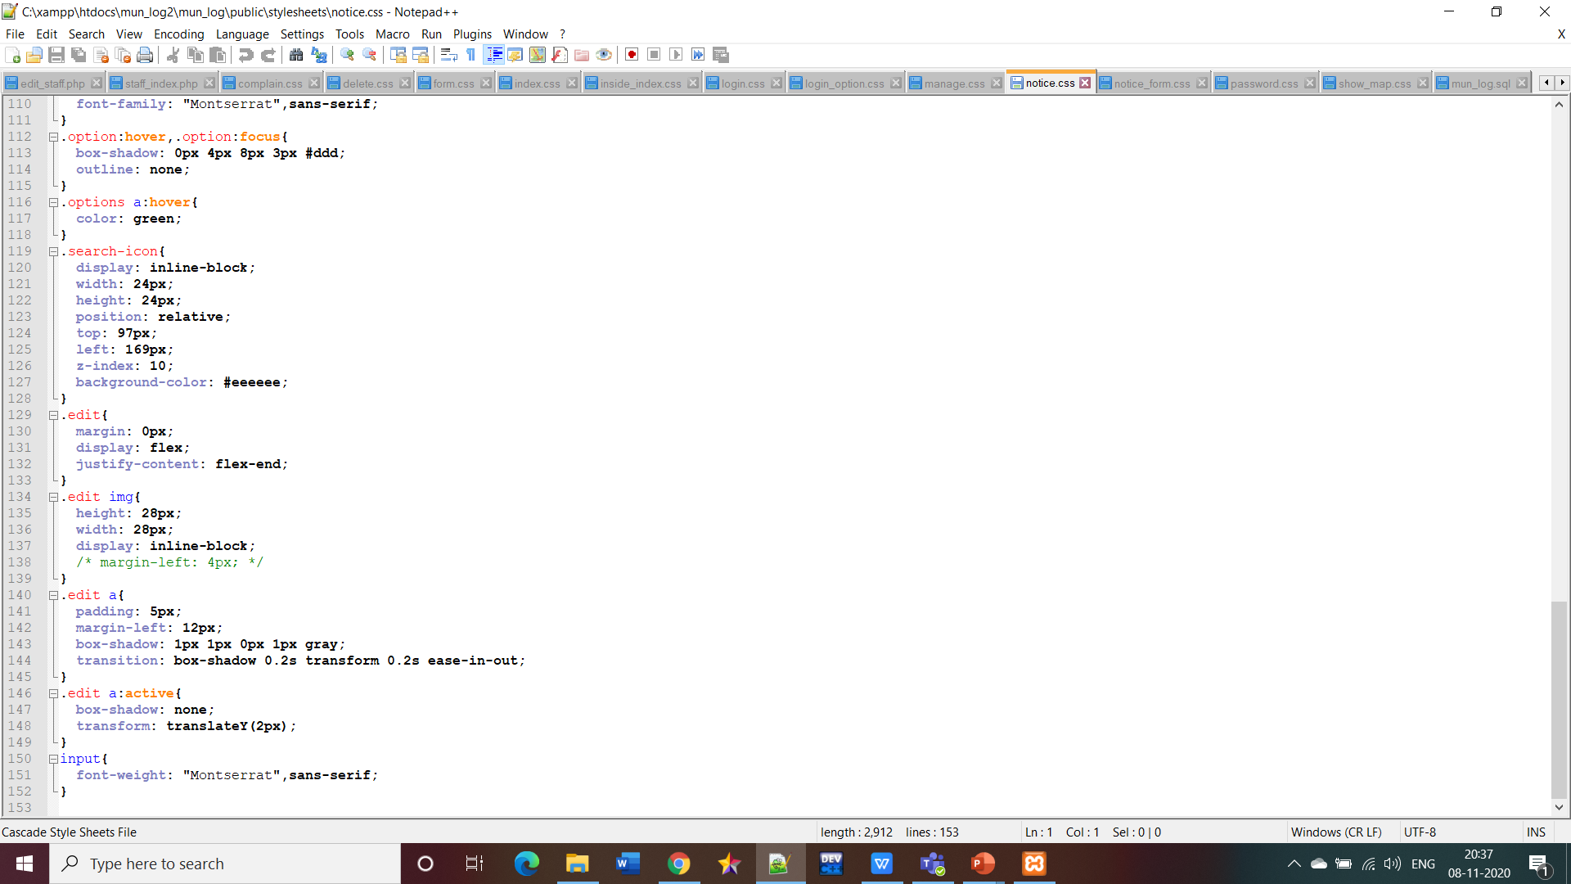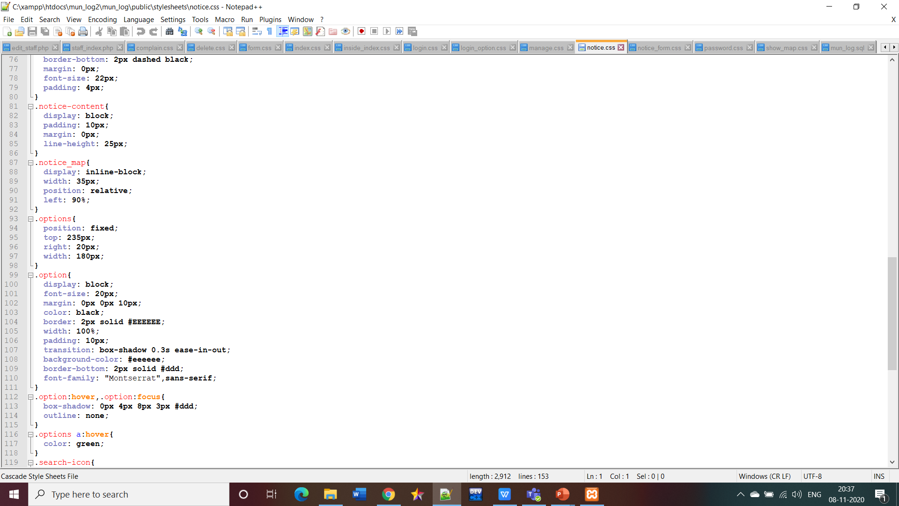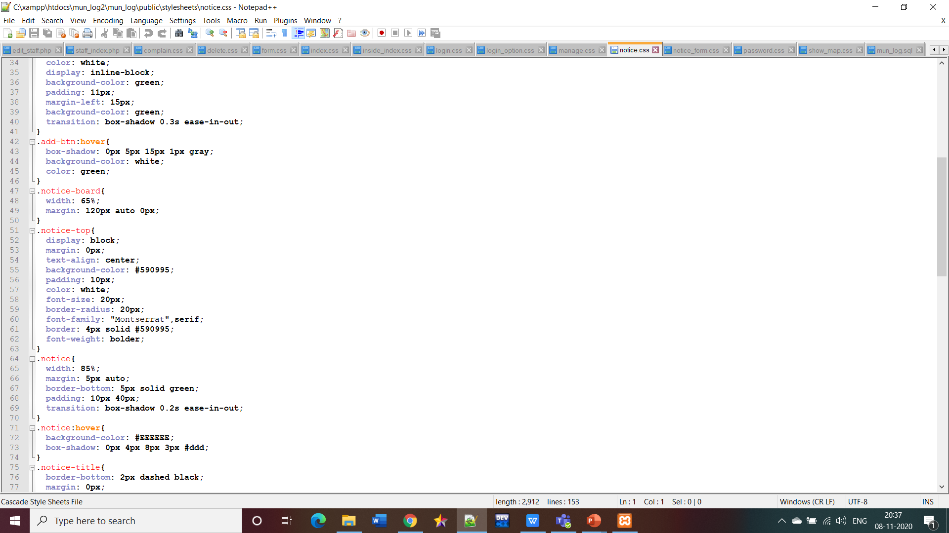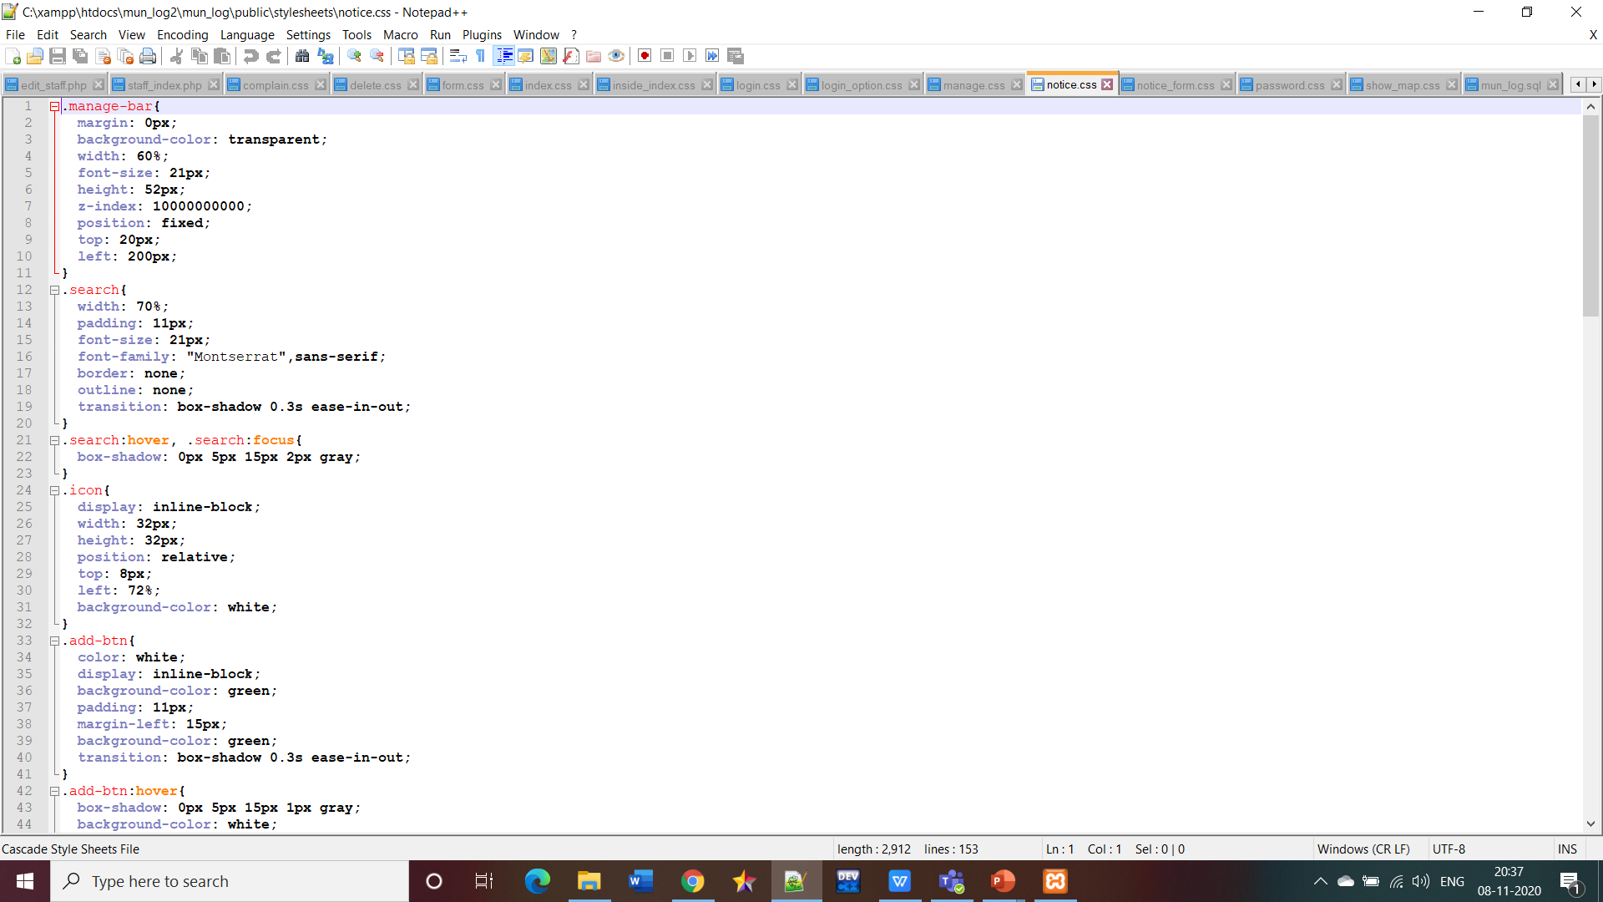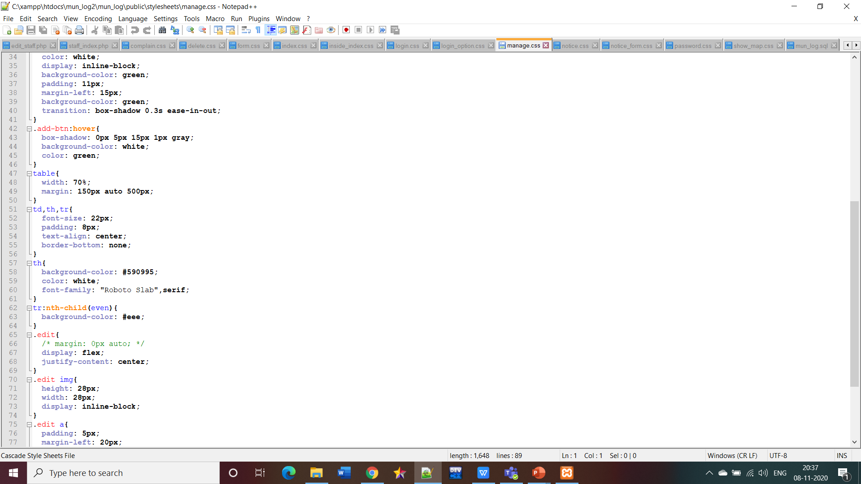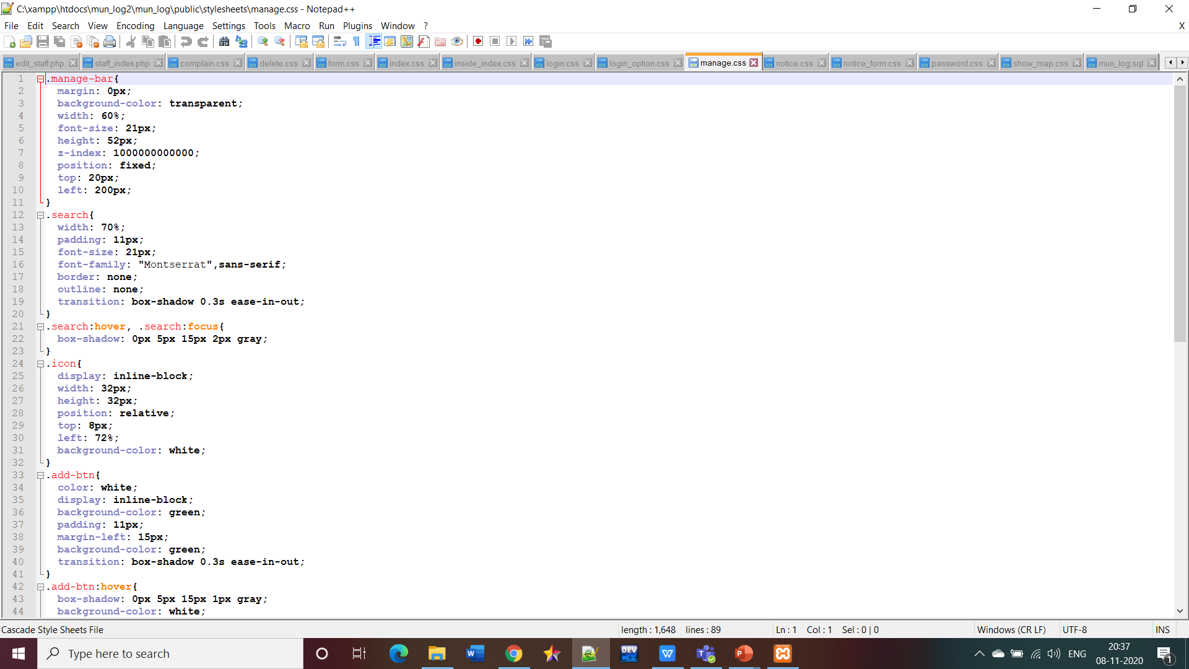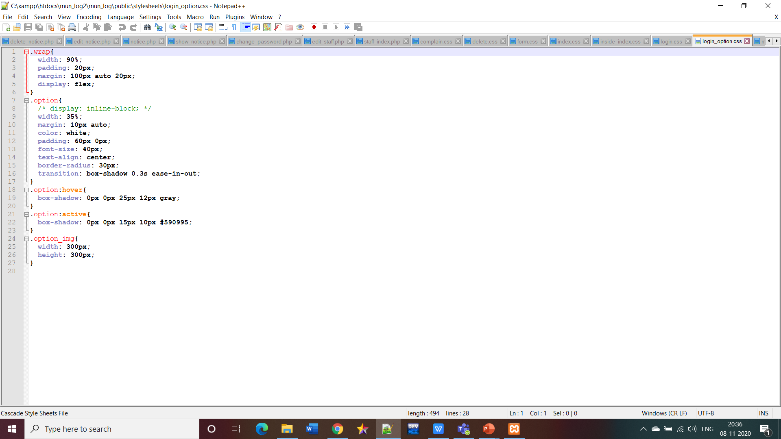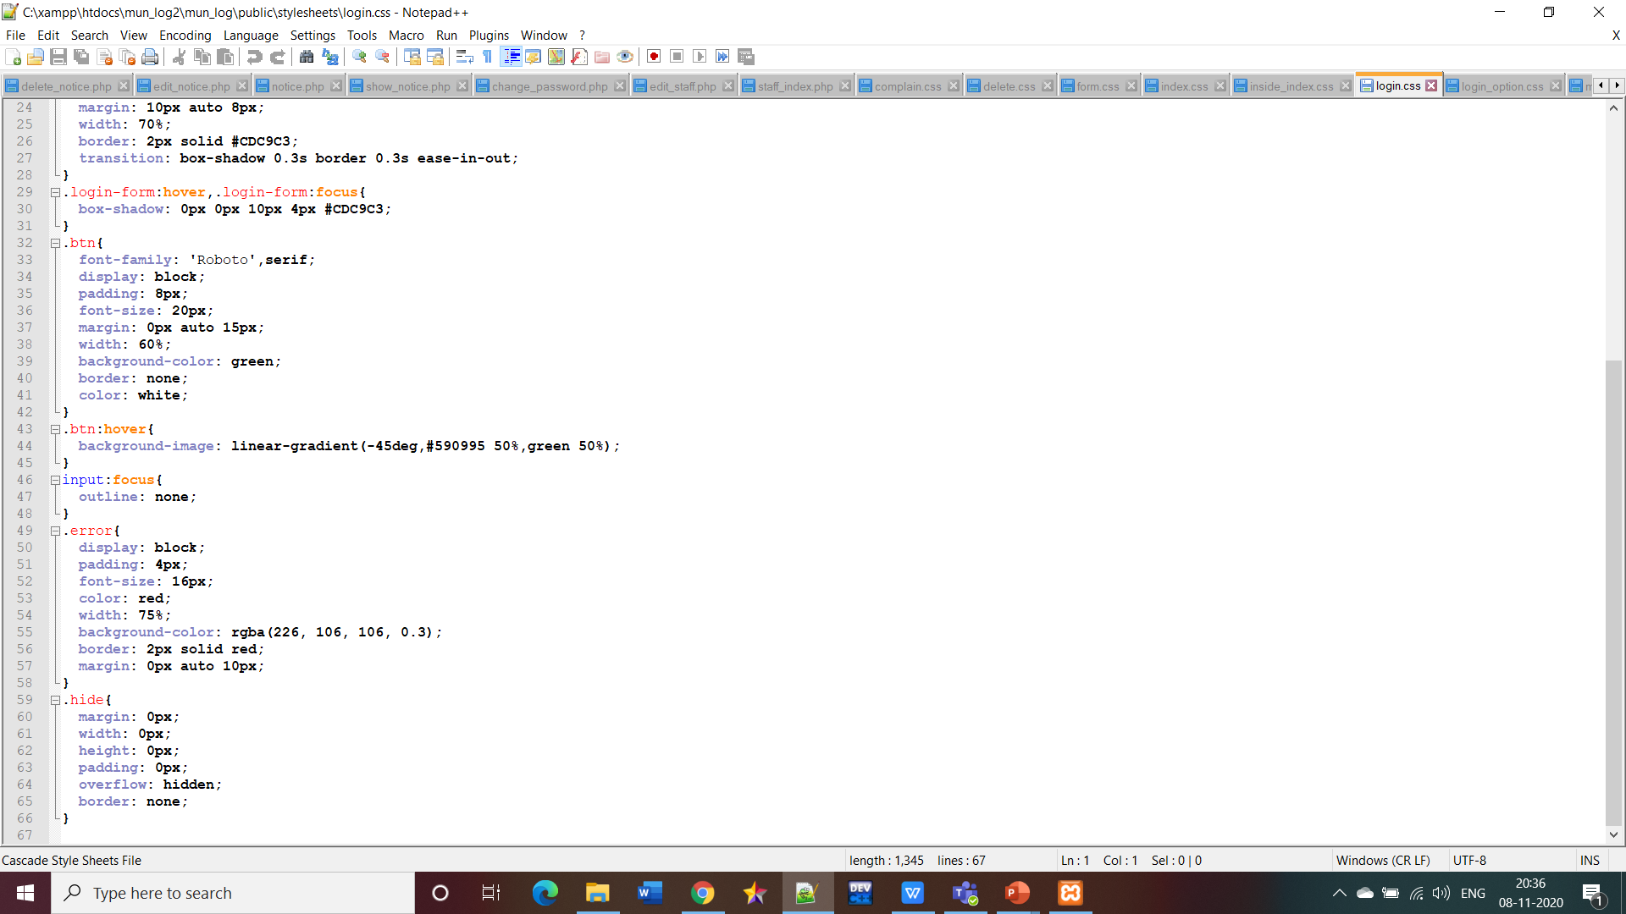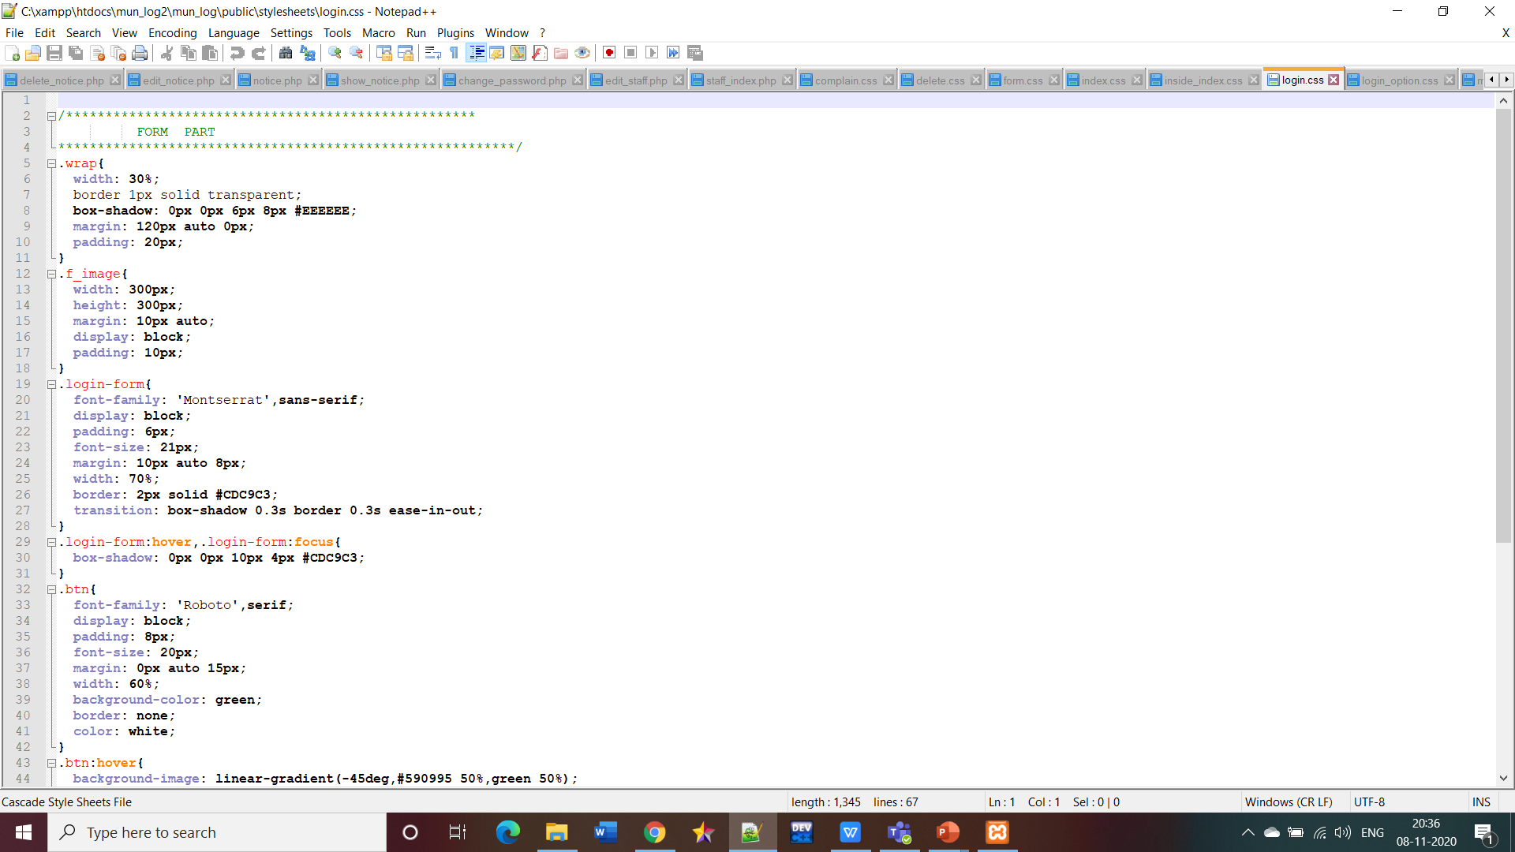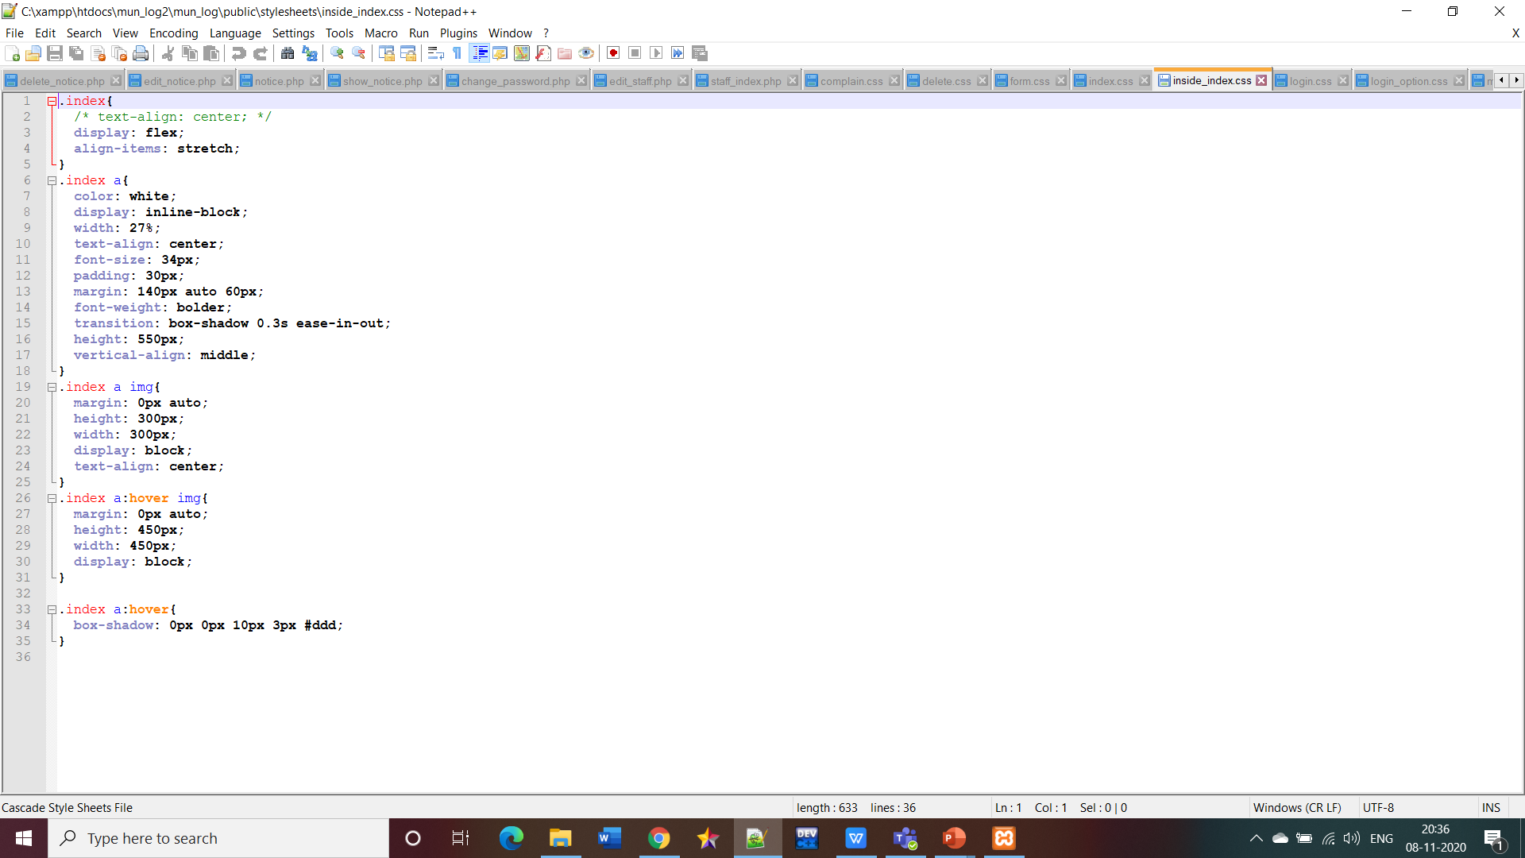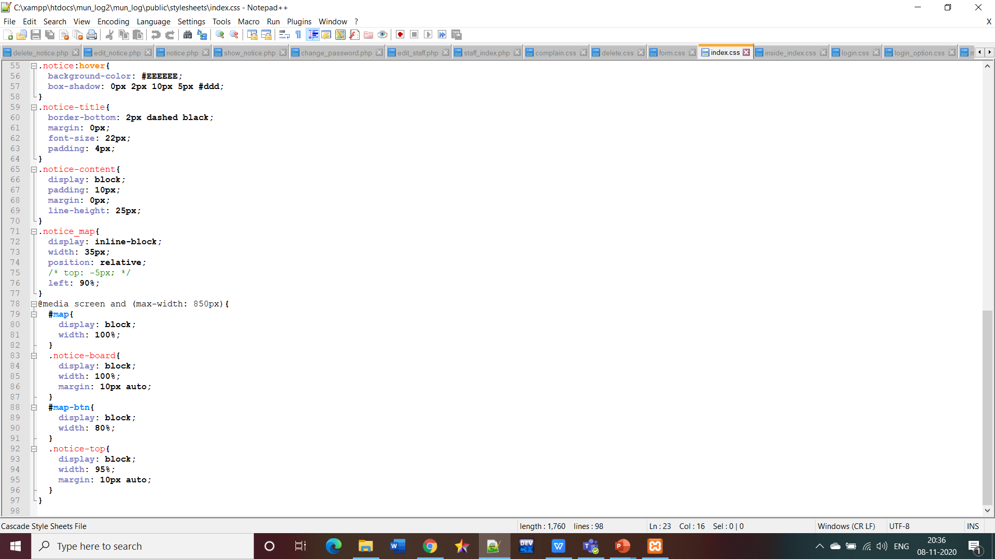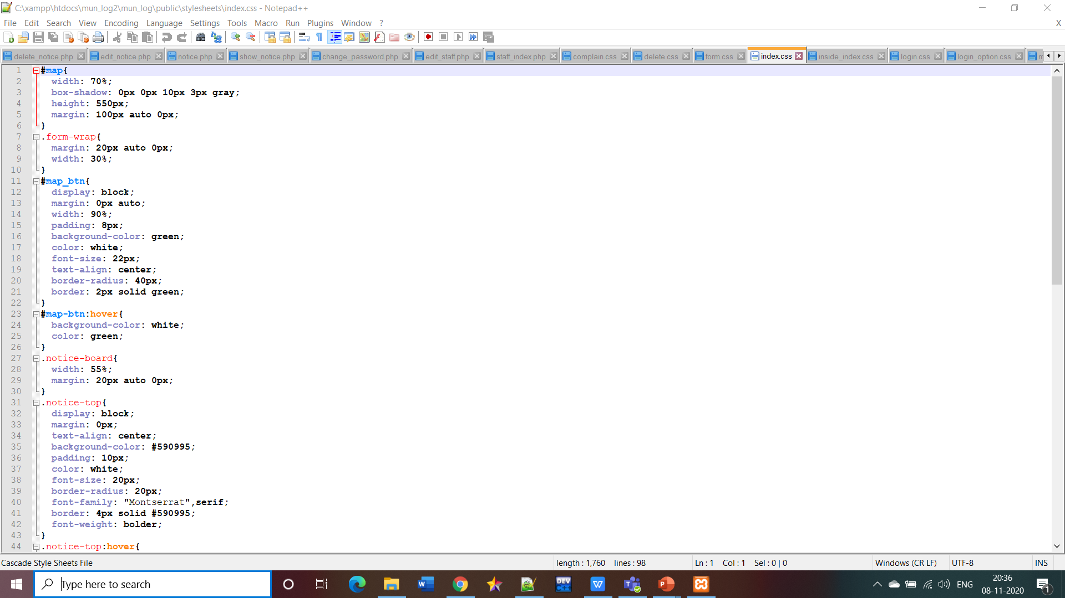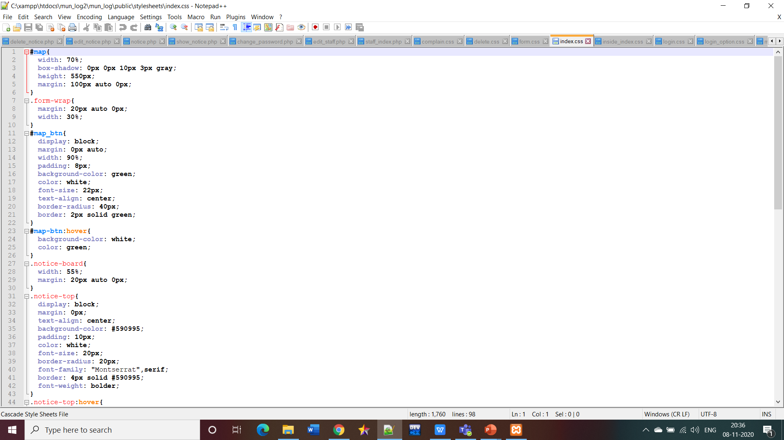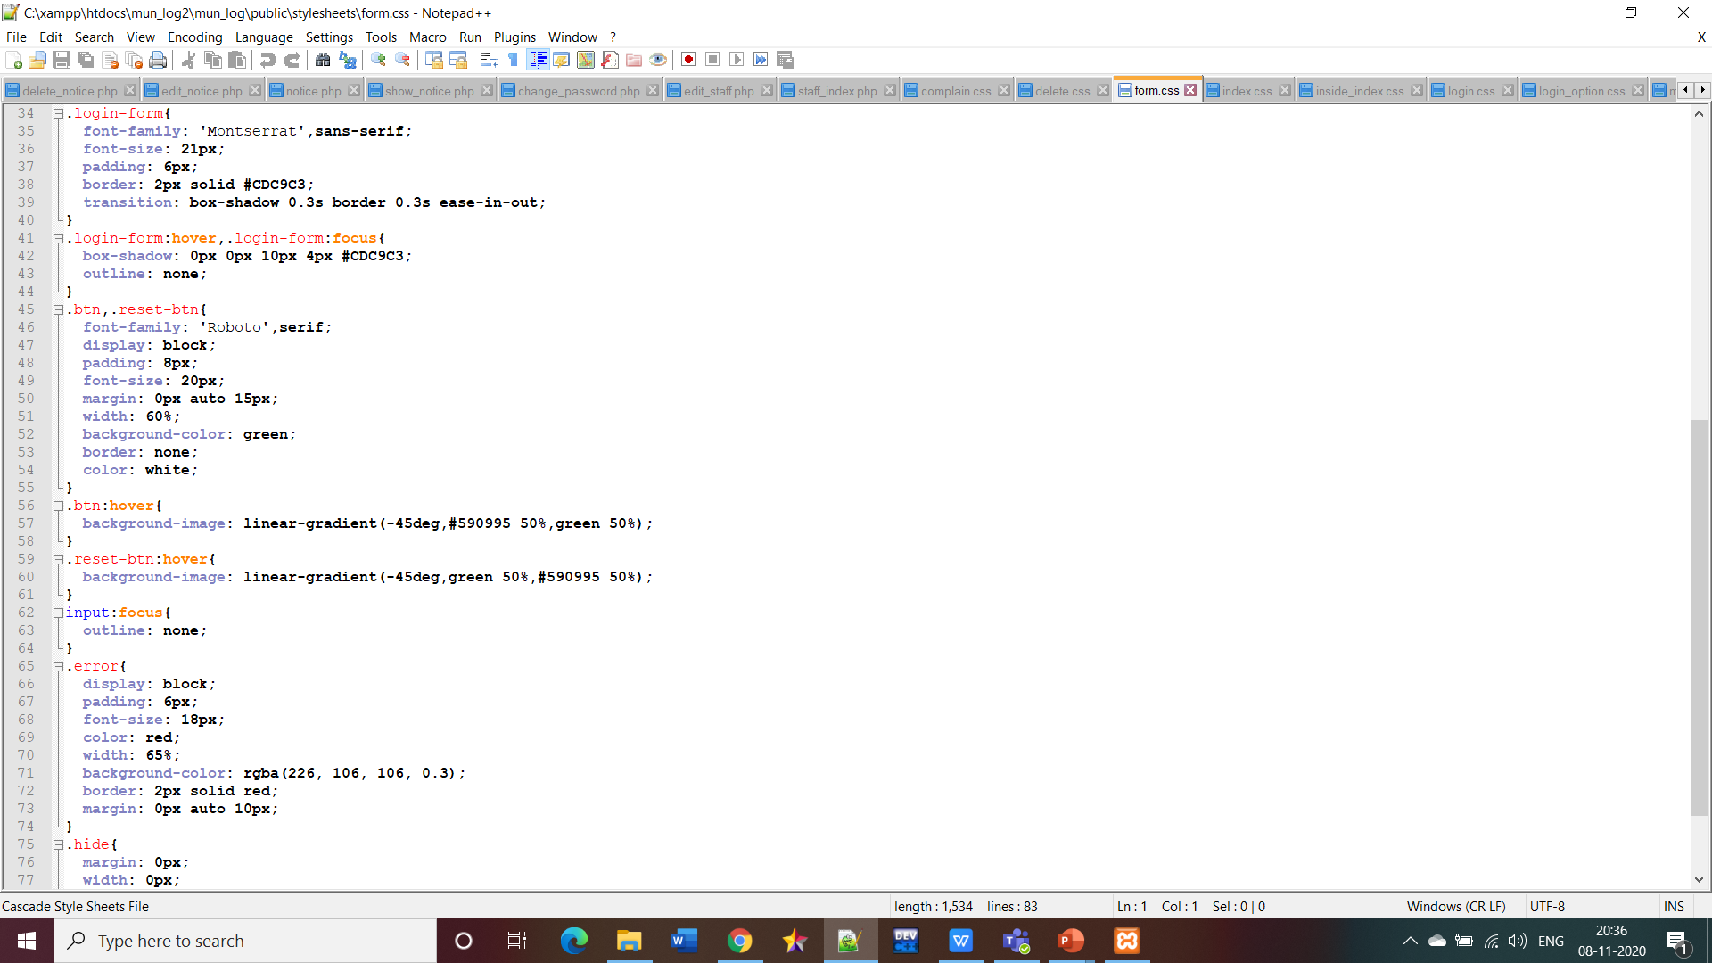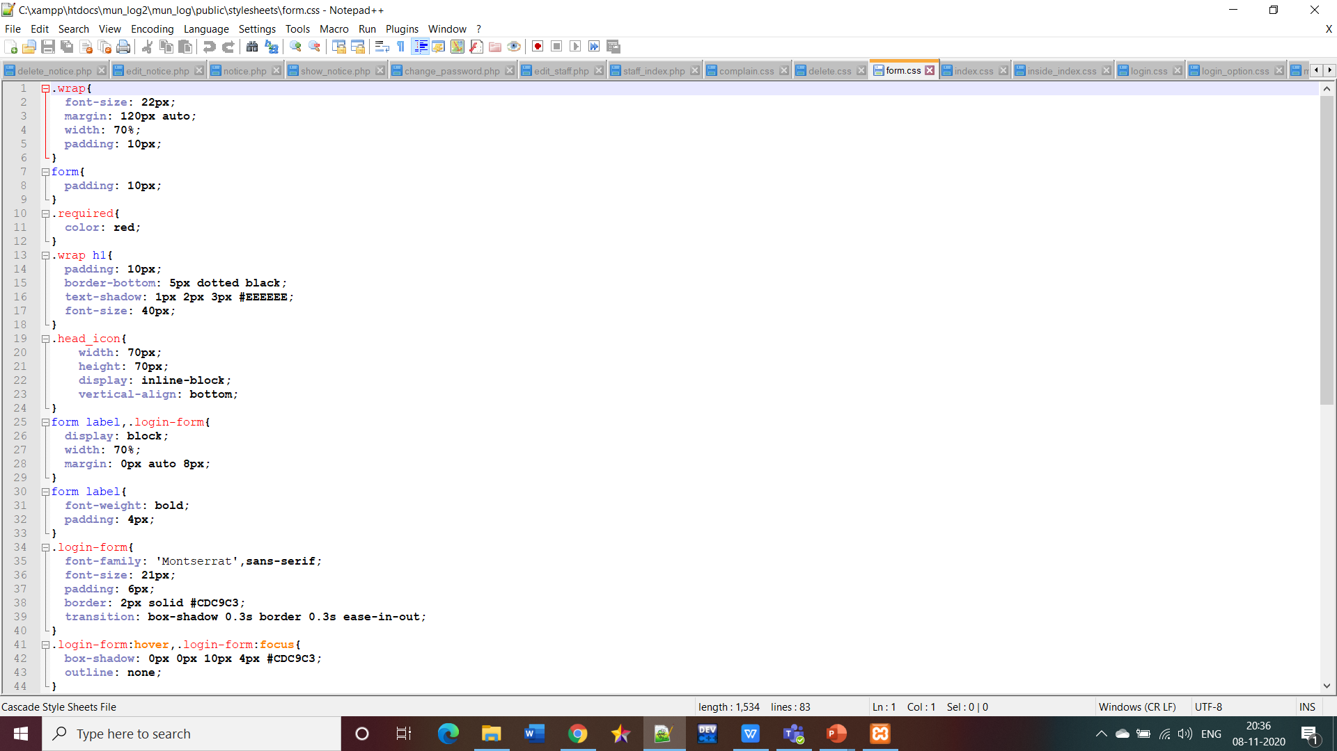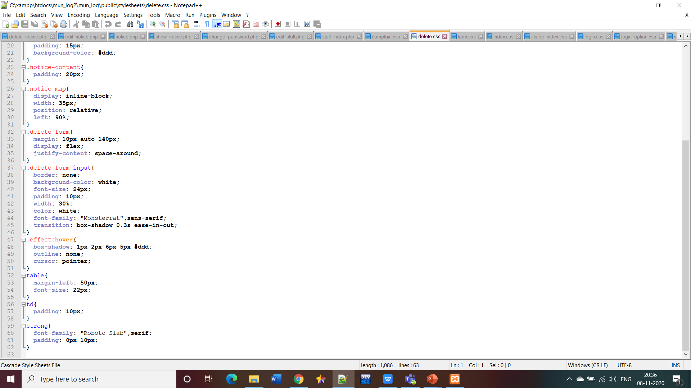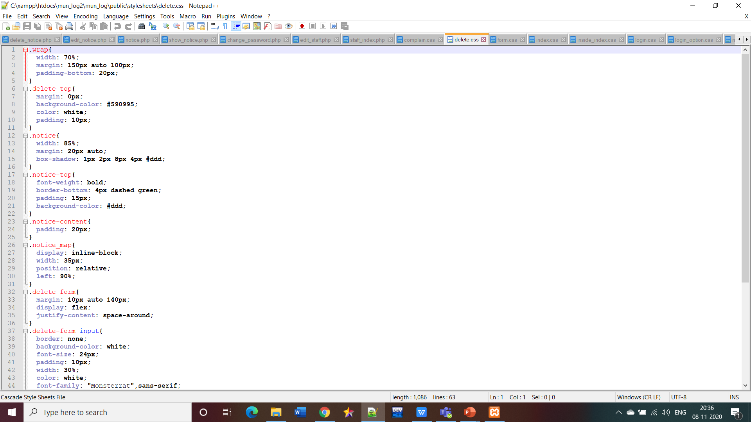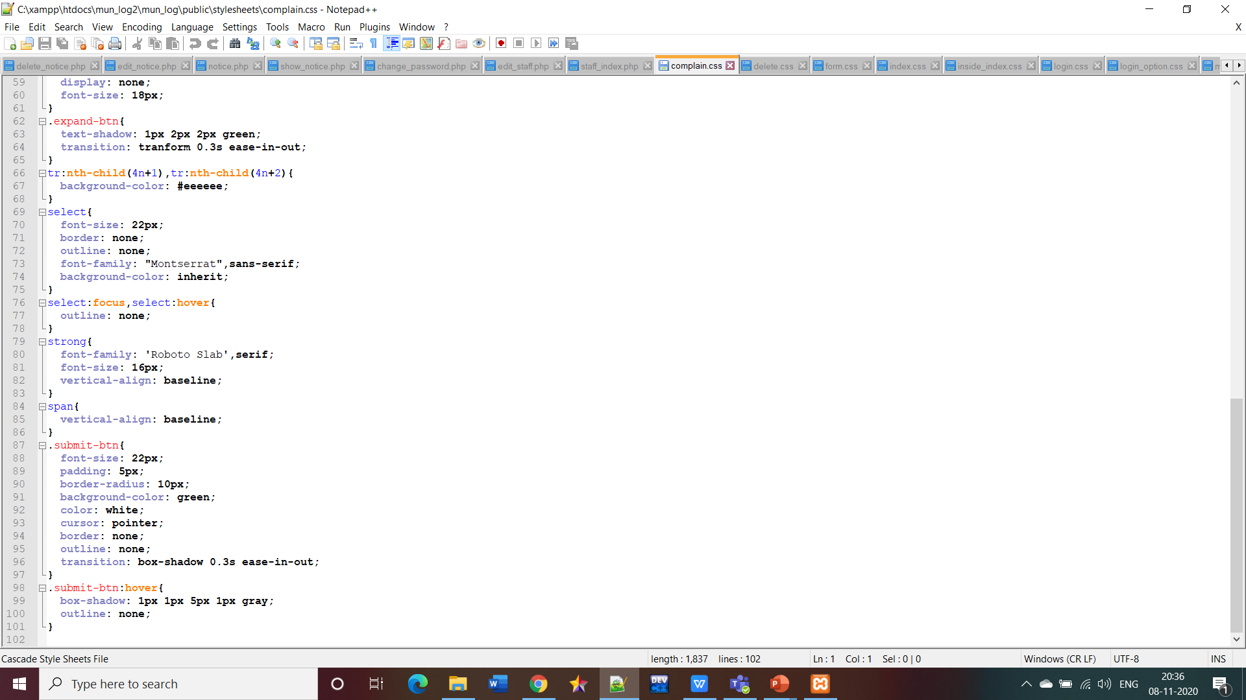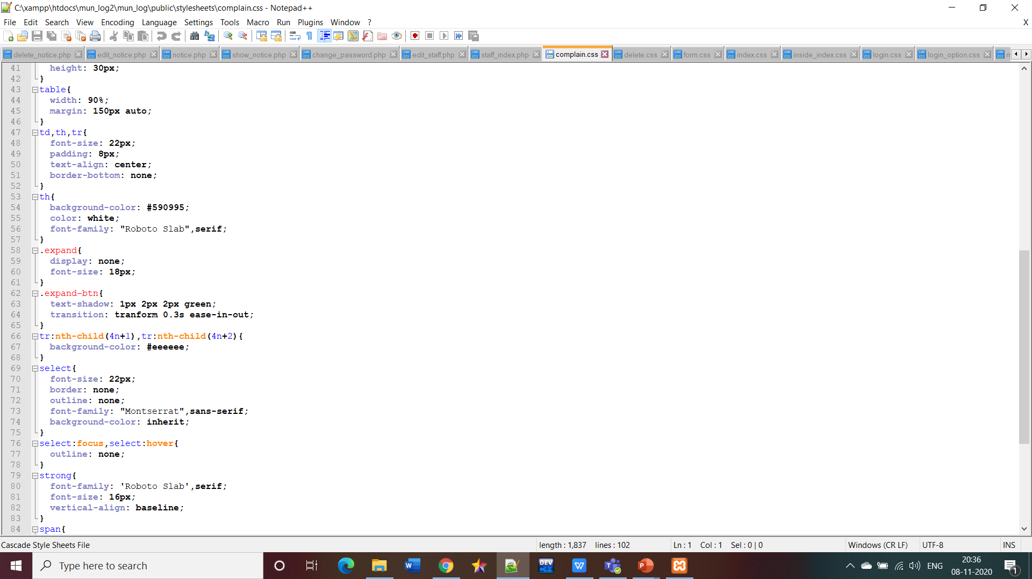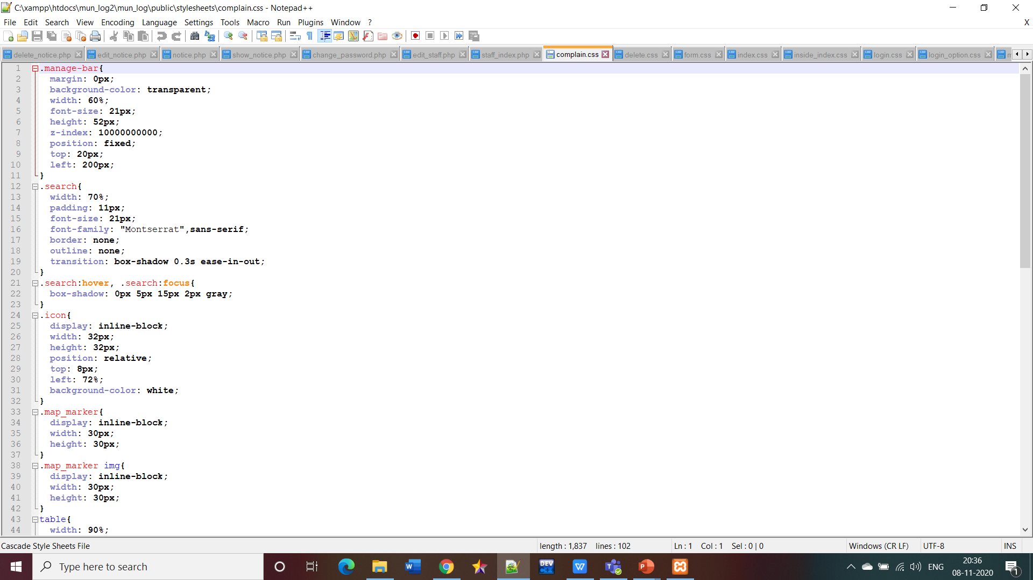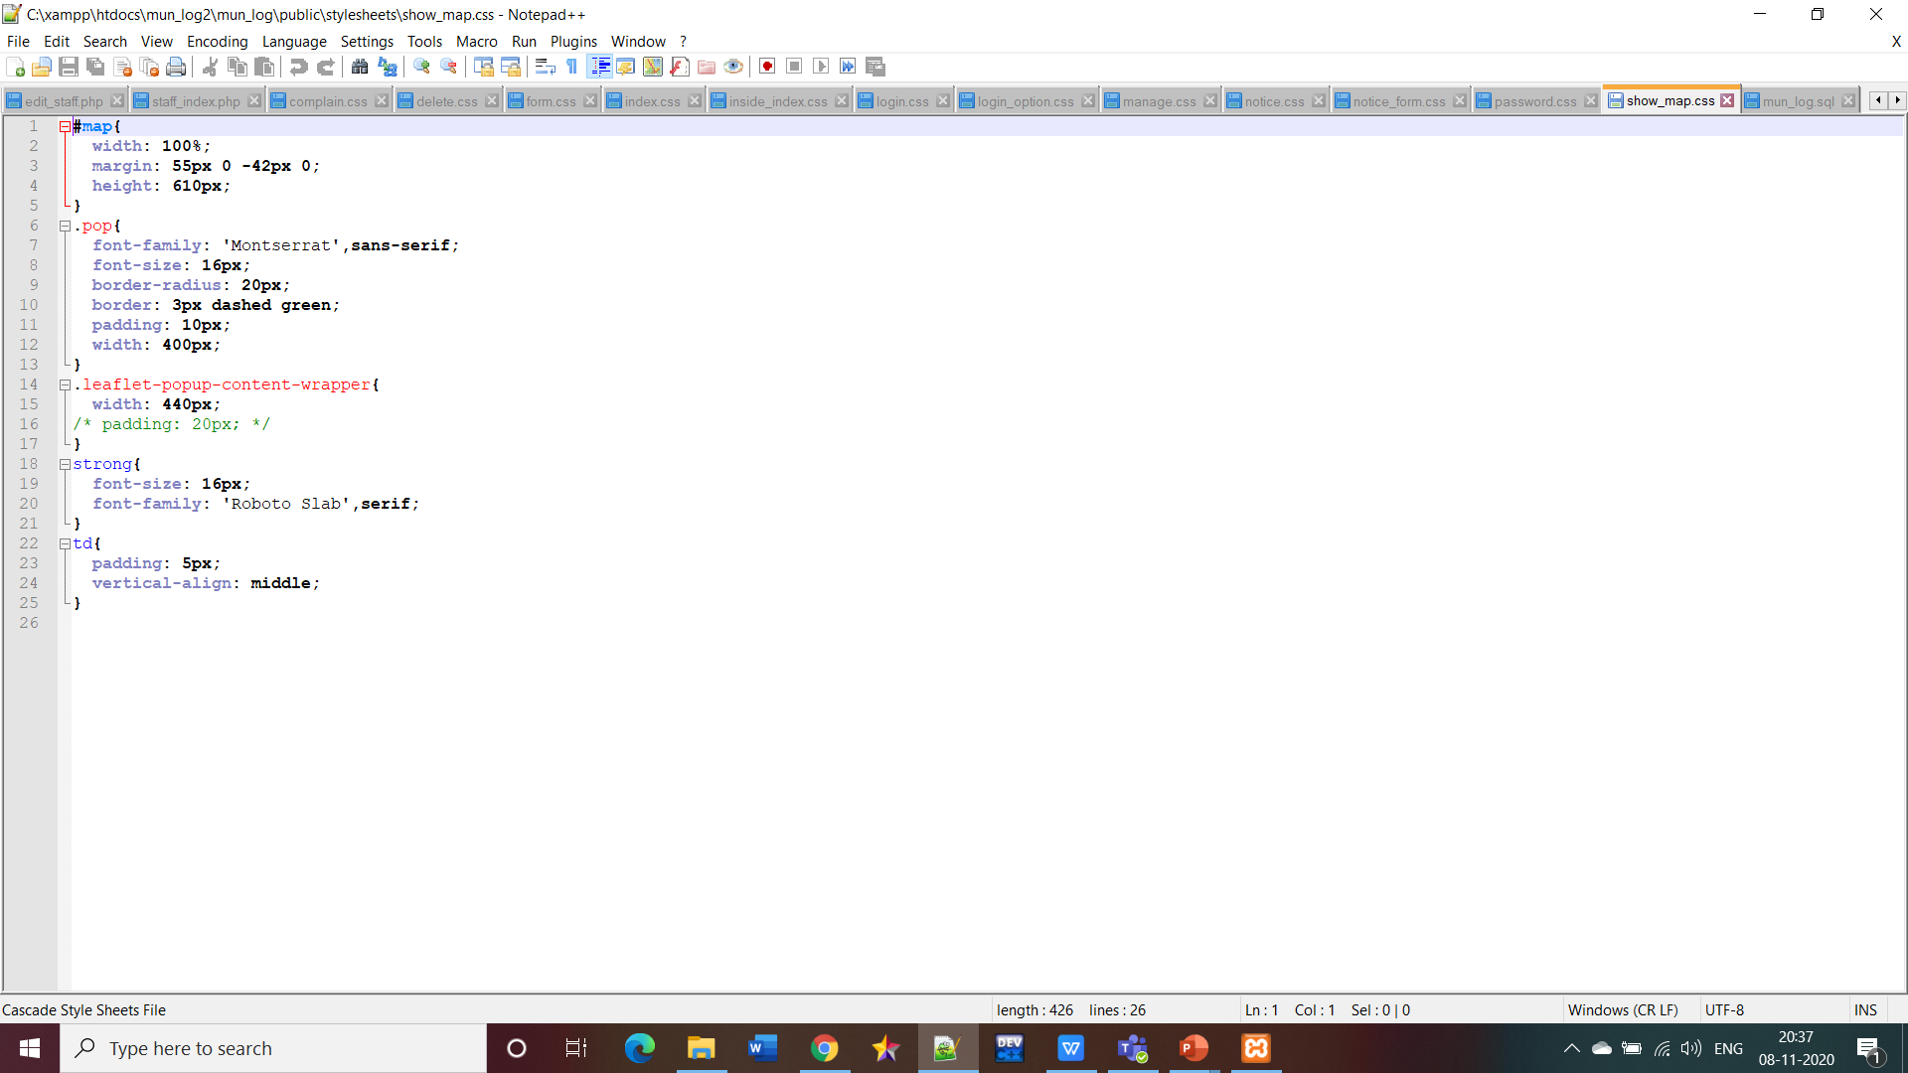

**SQL FILES**

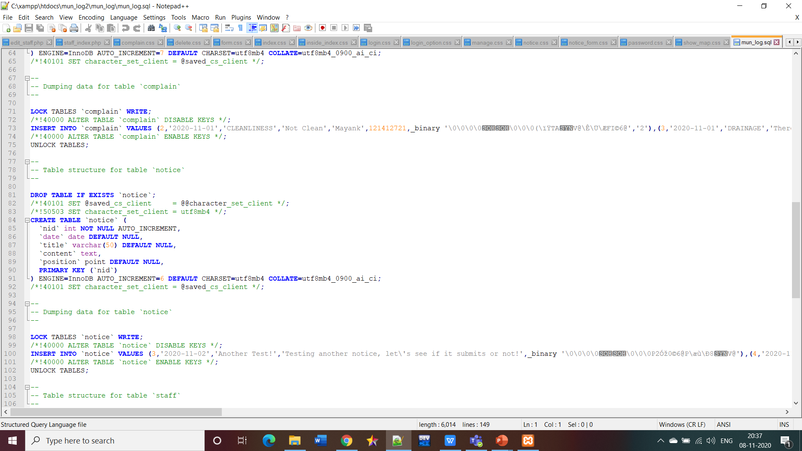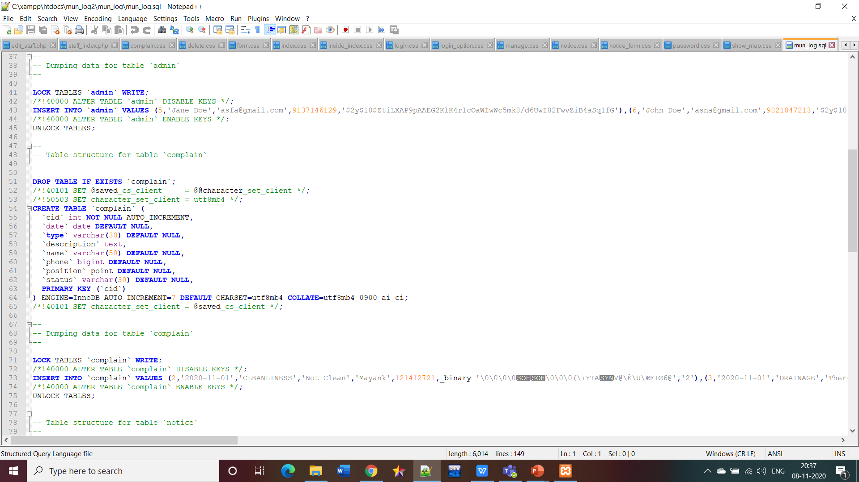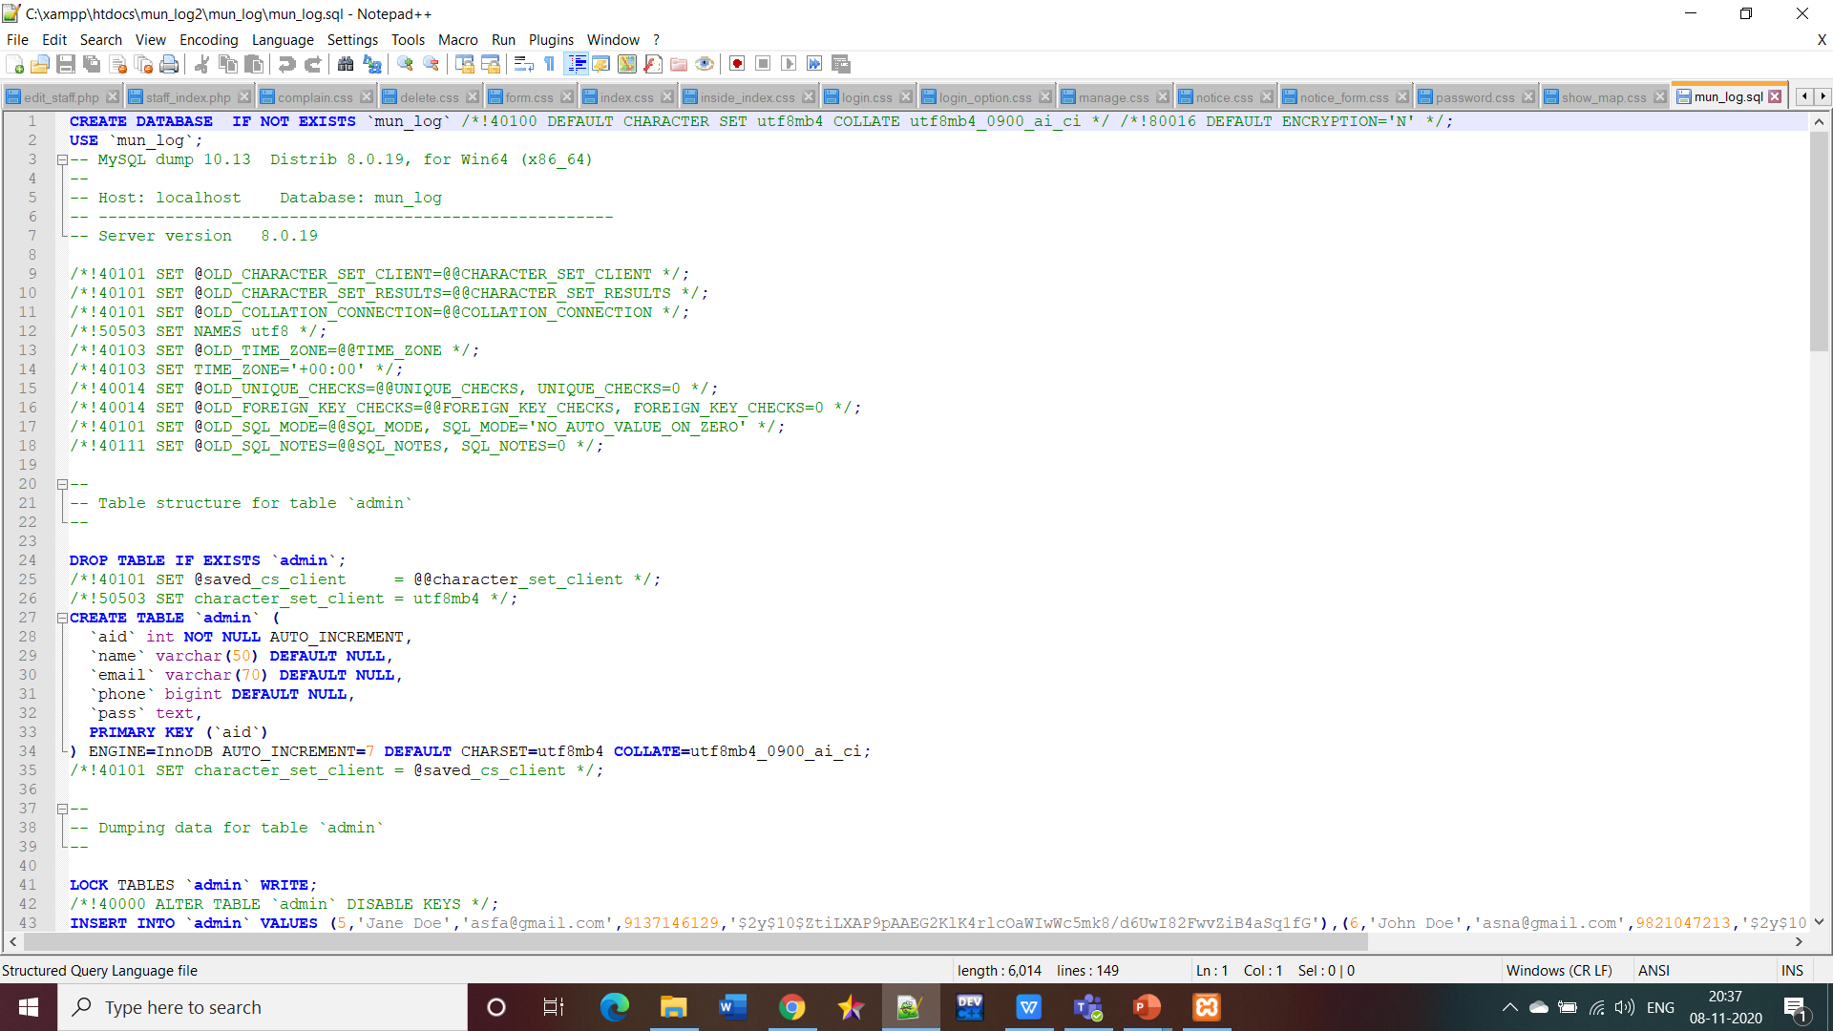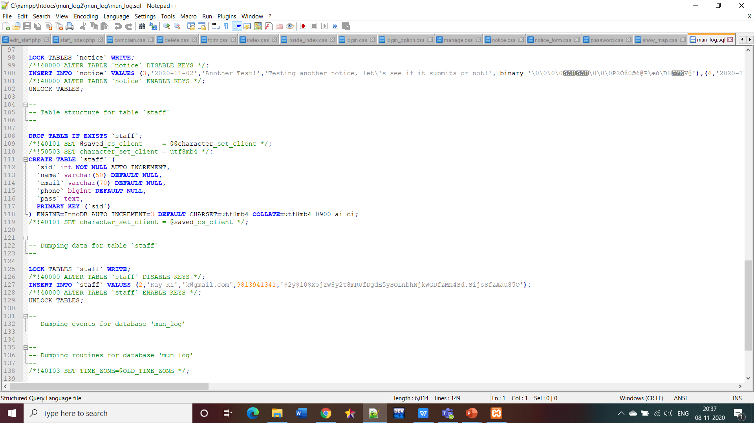

**SCREENSHOTS:**

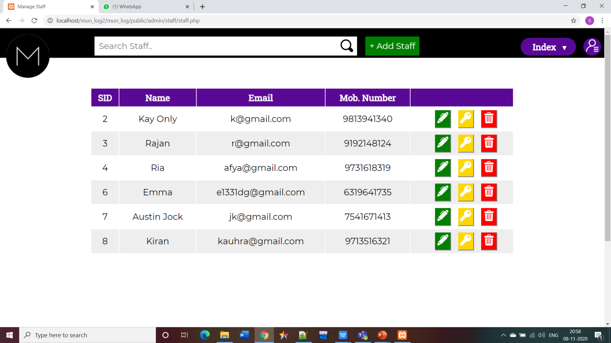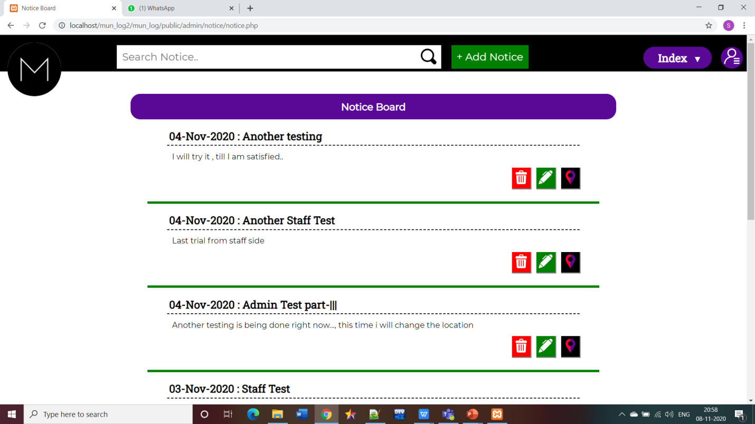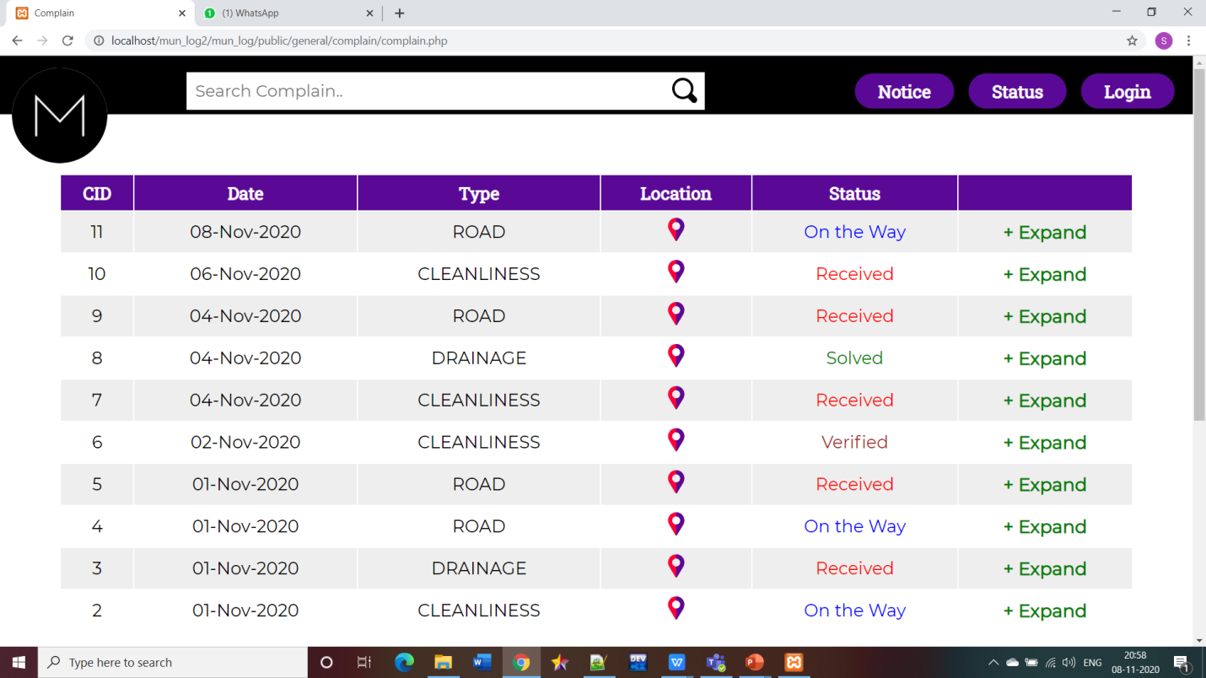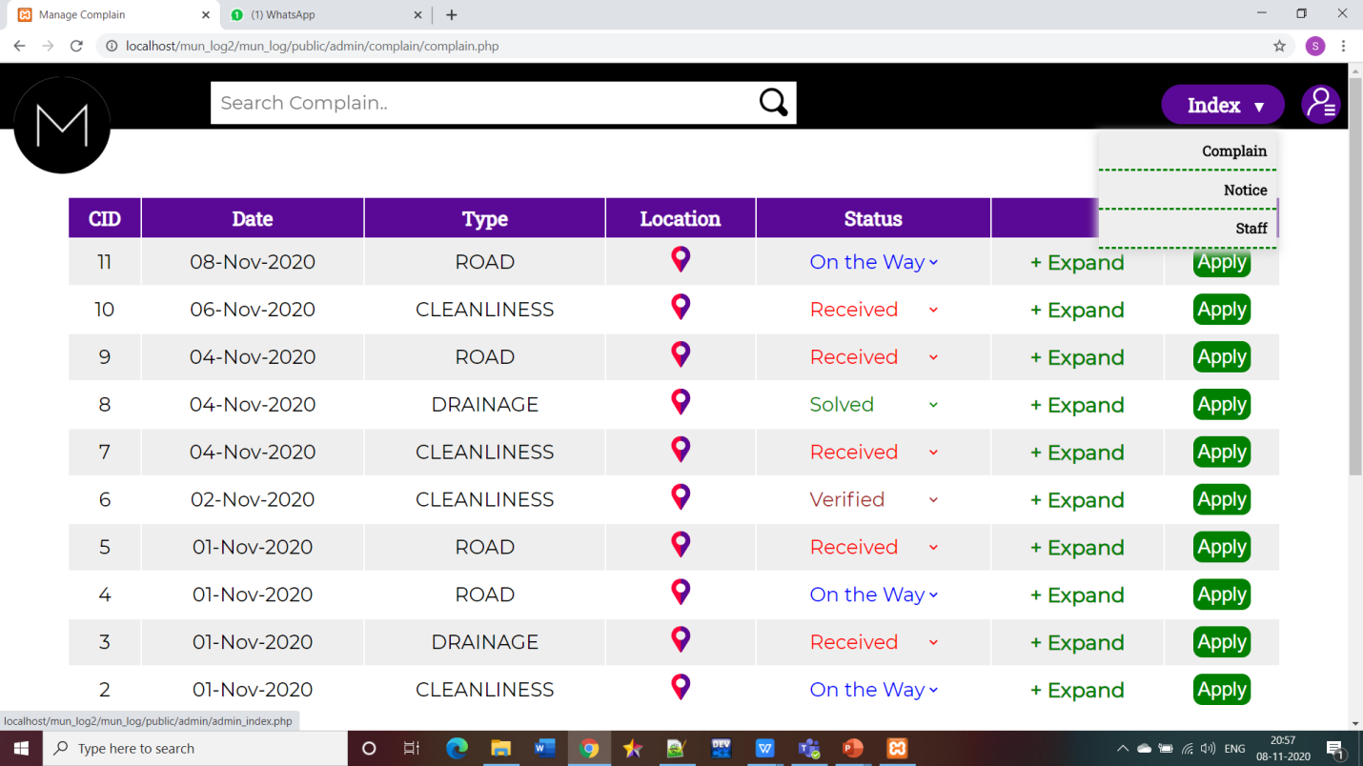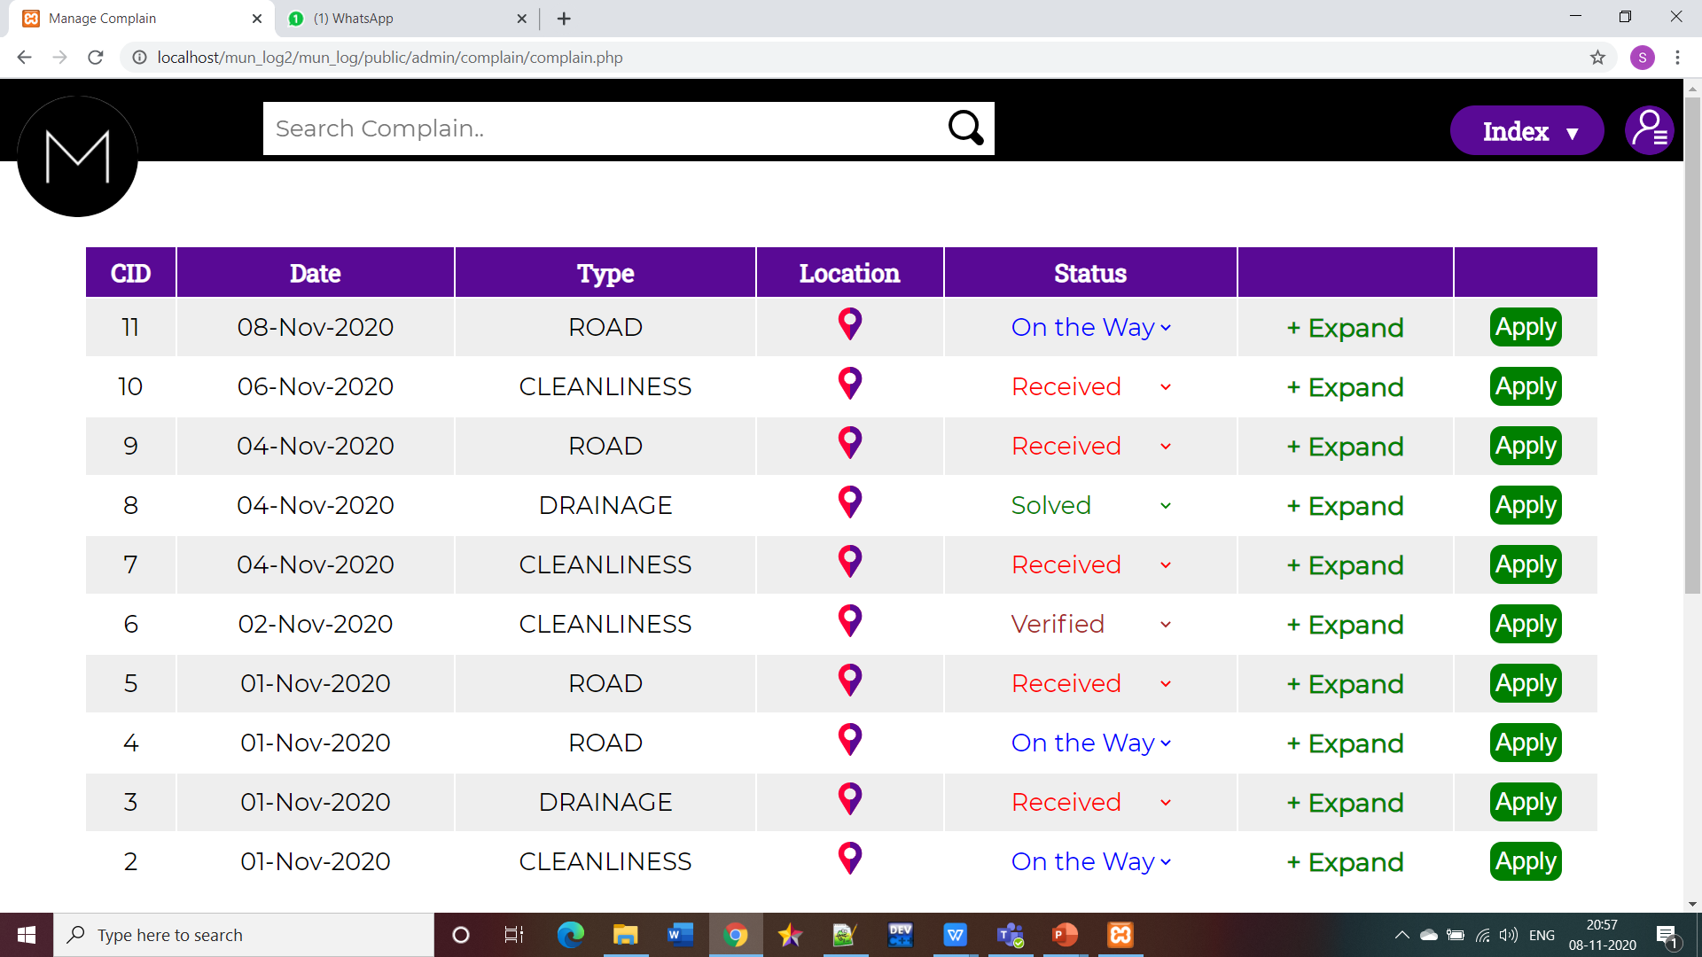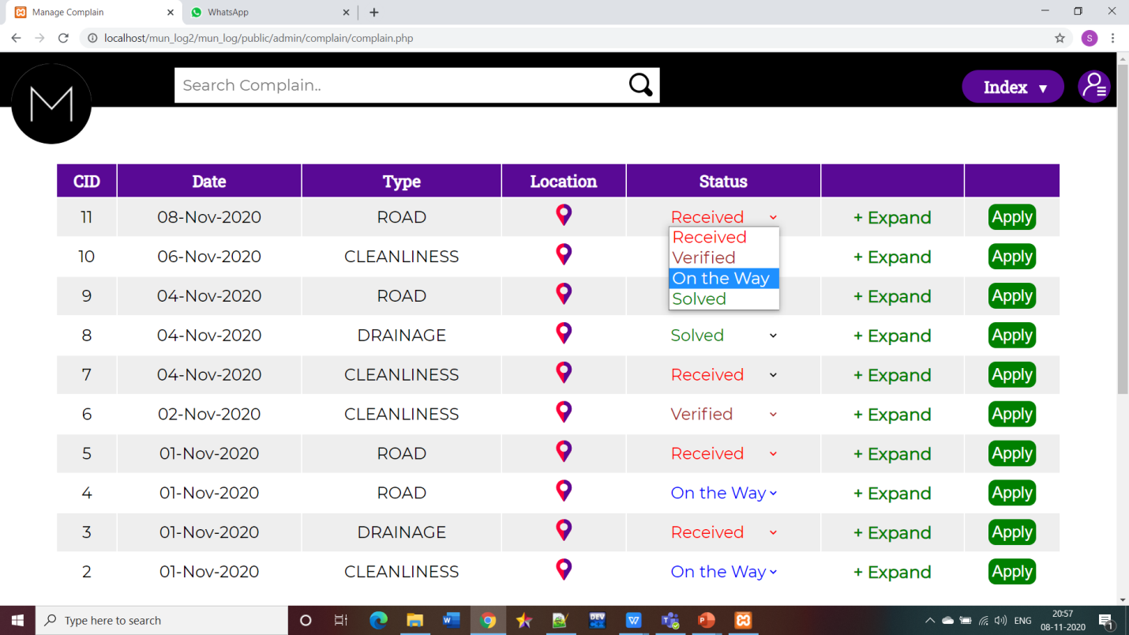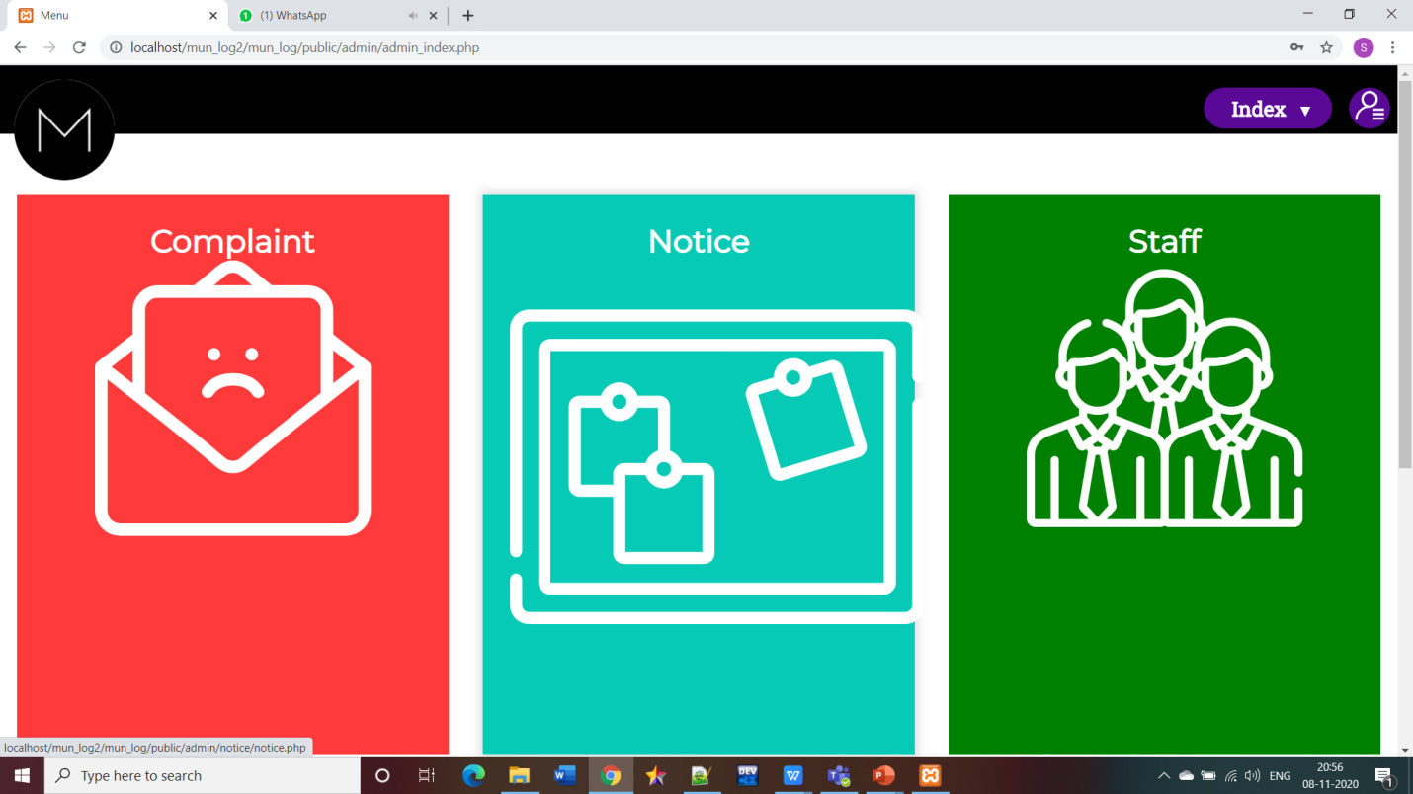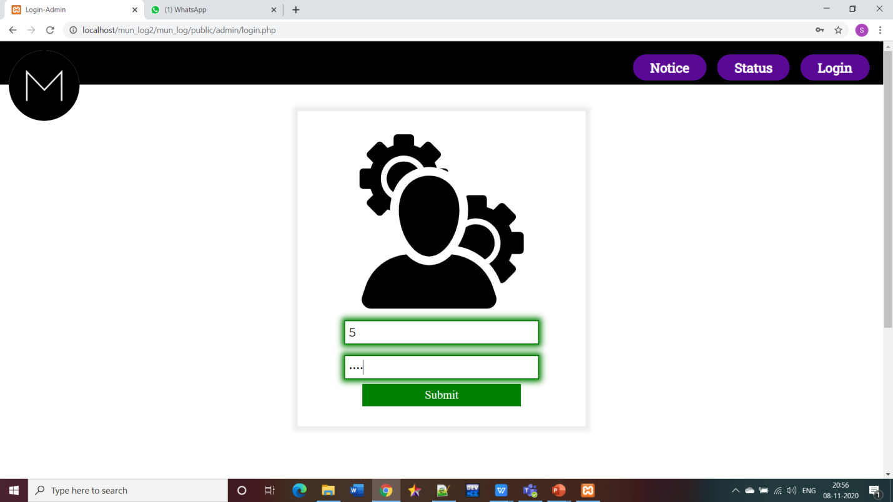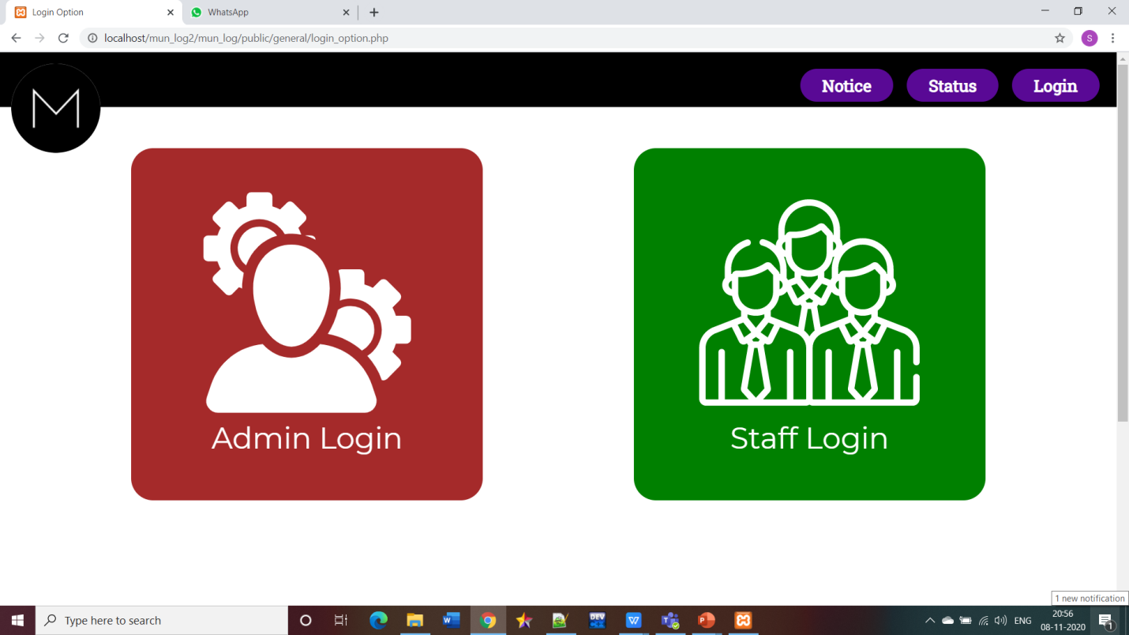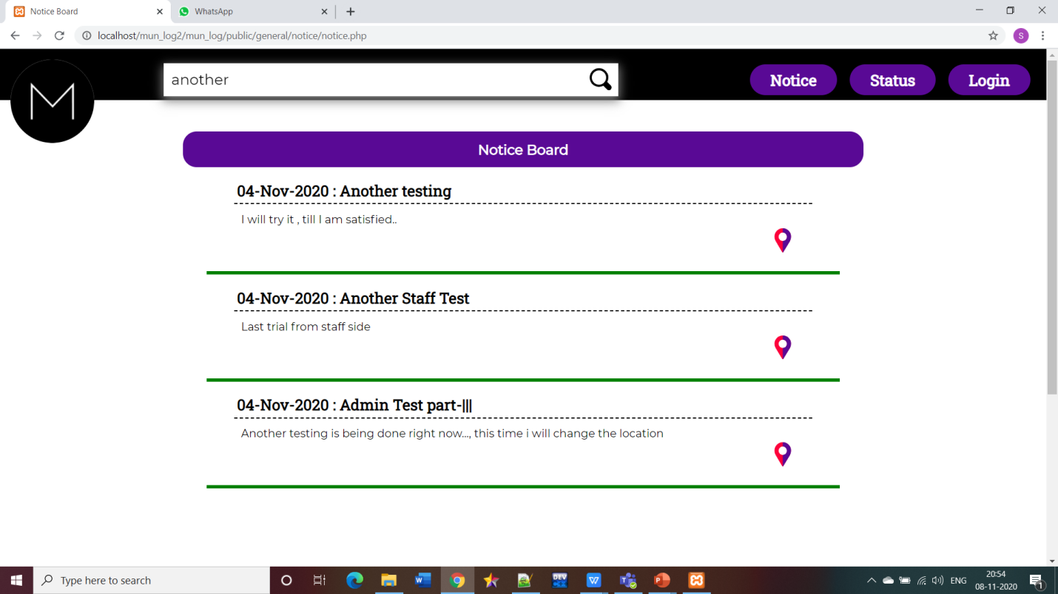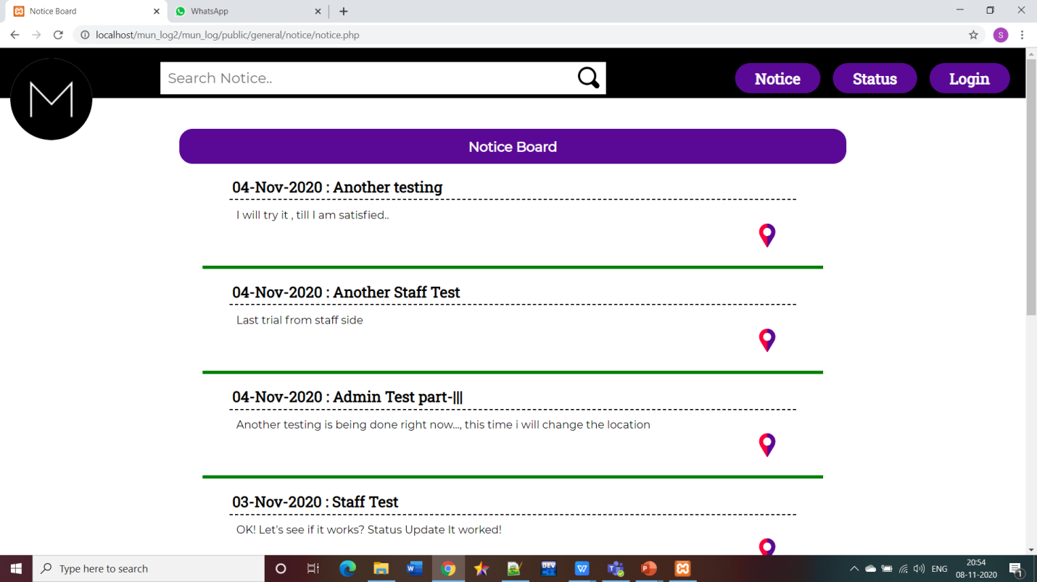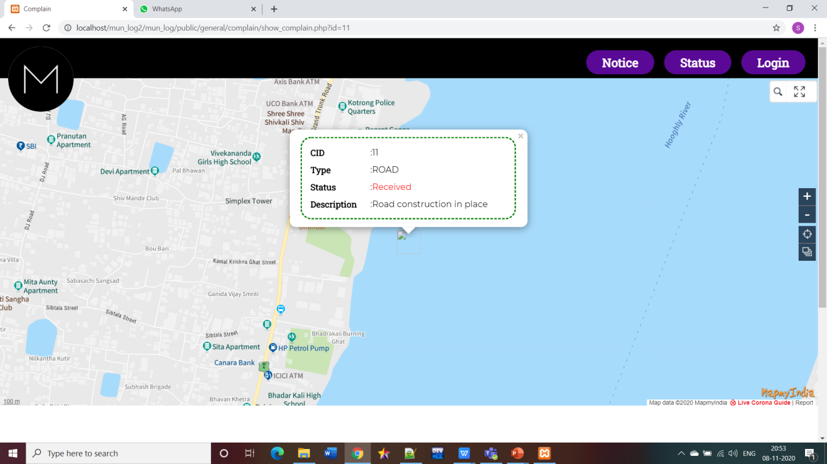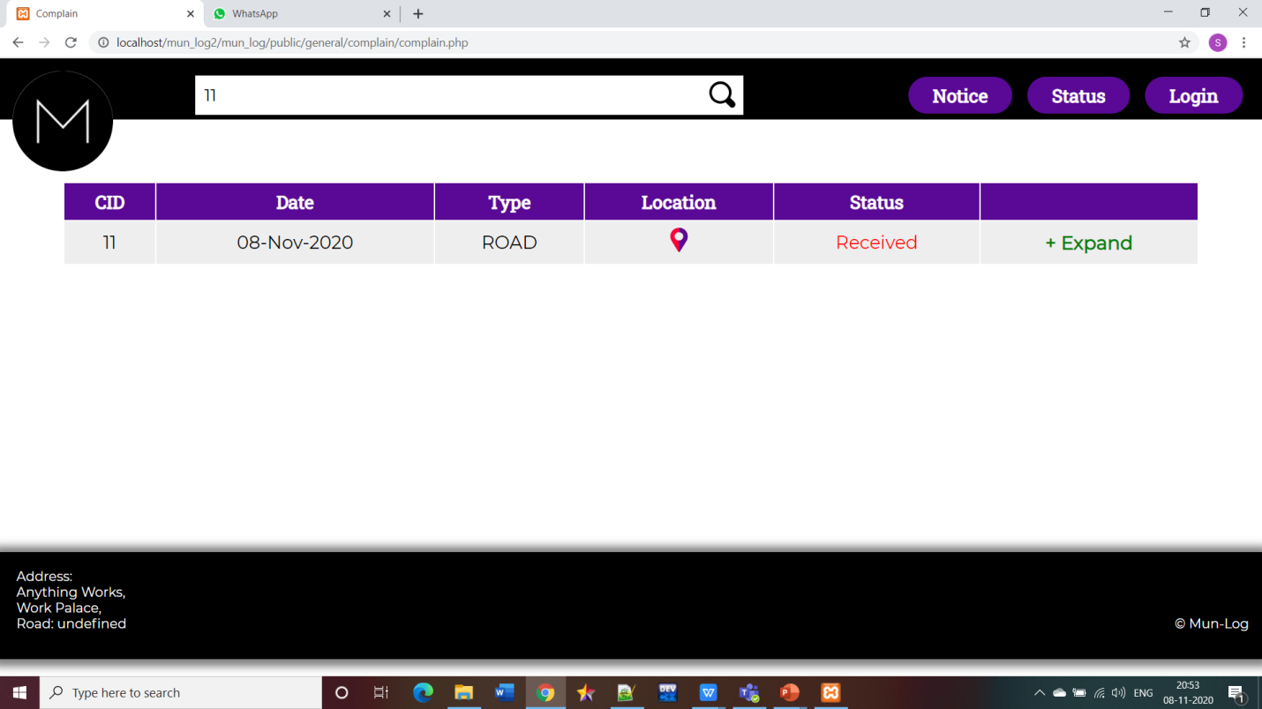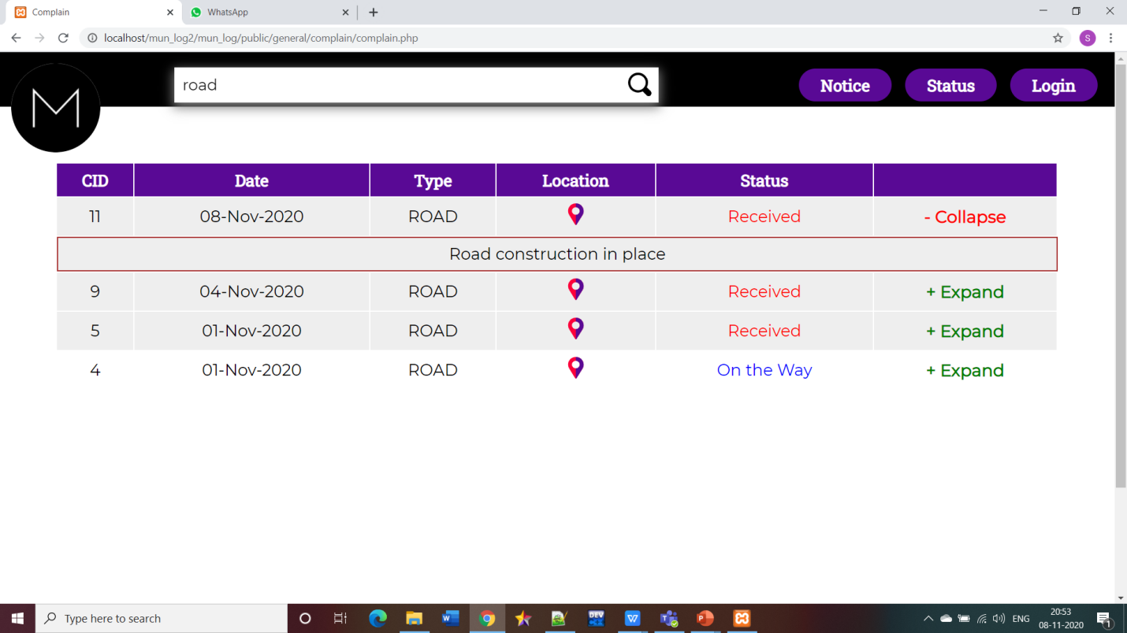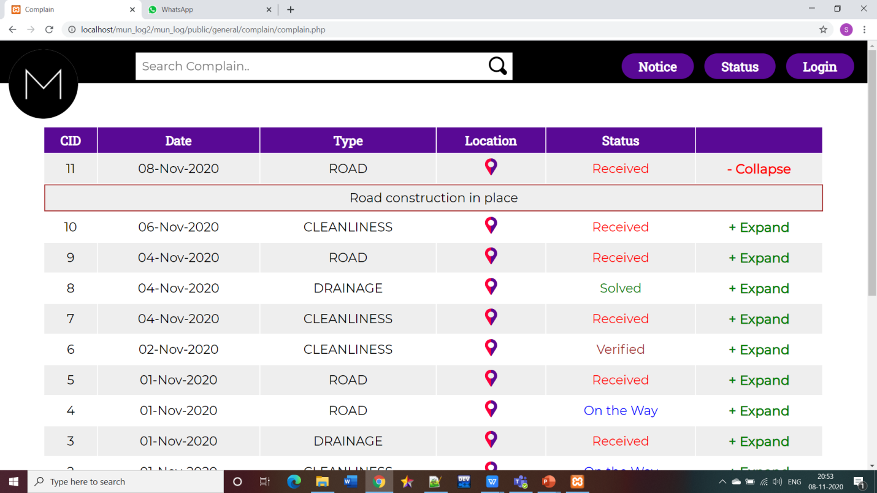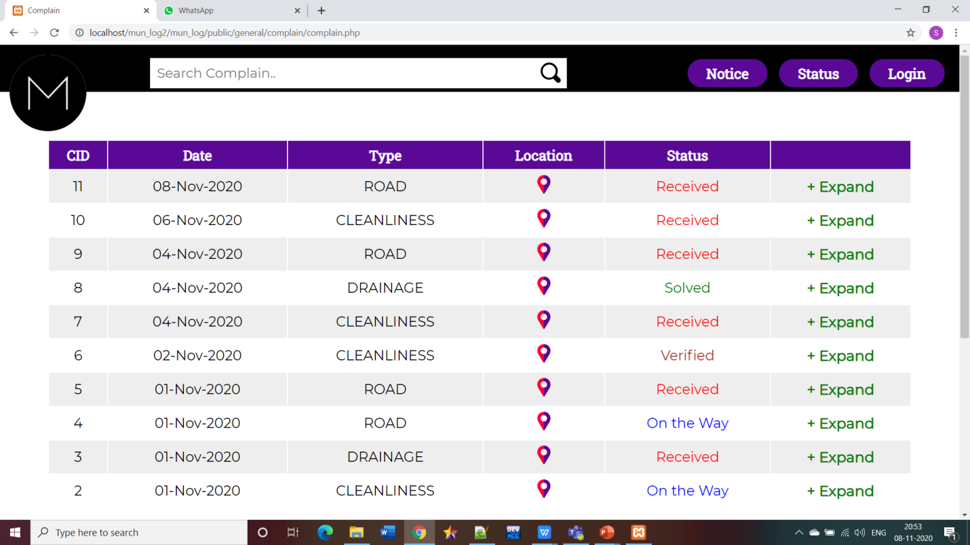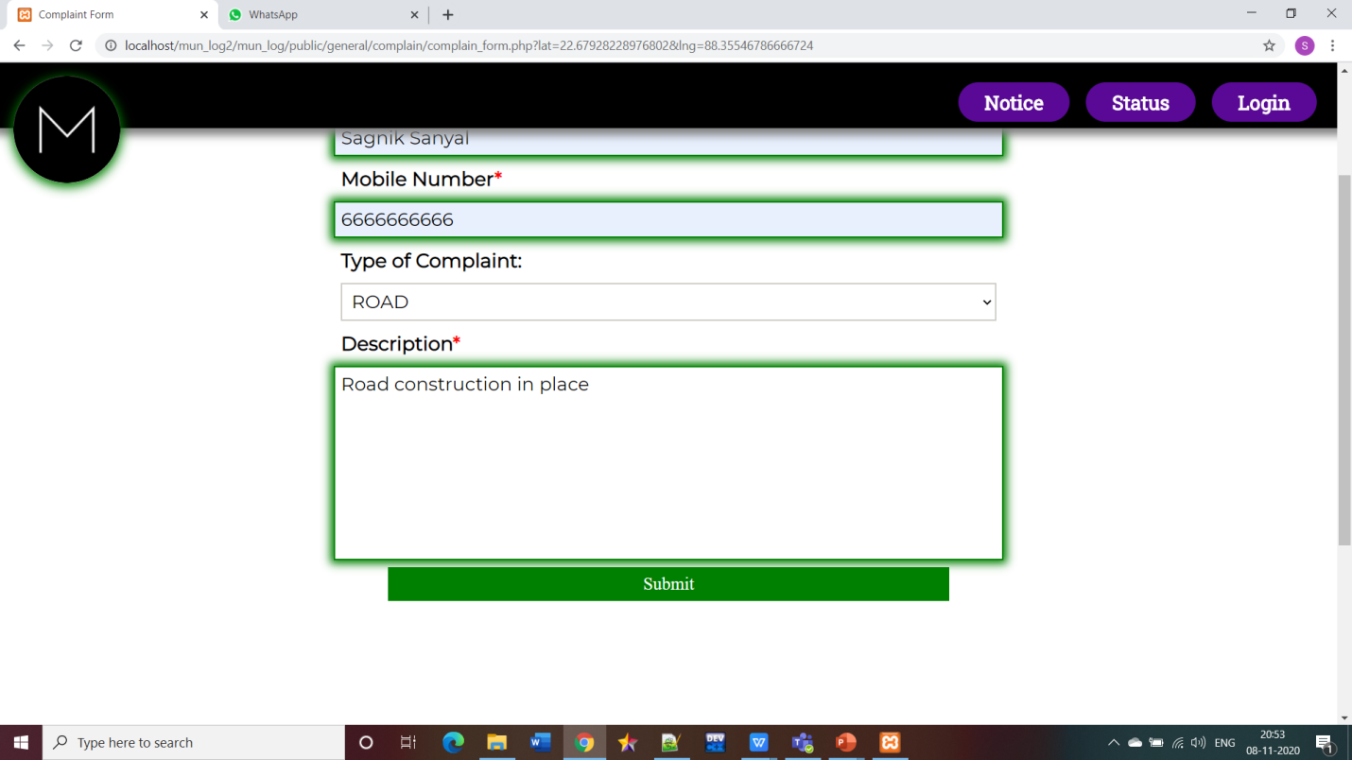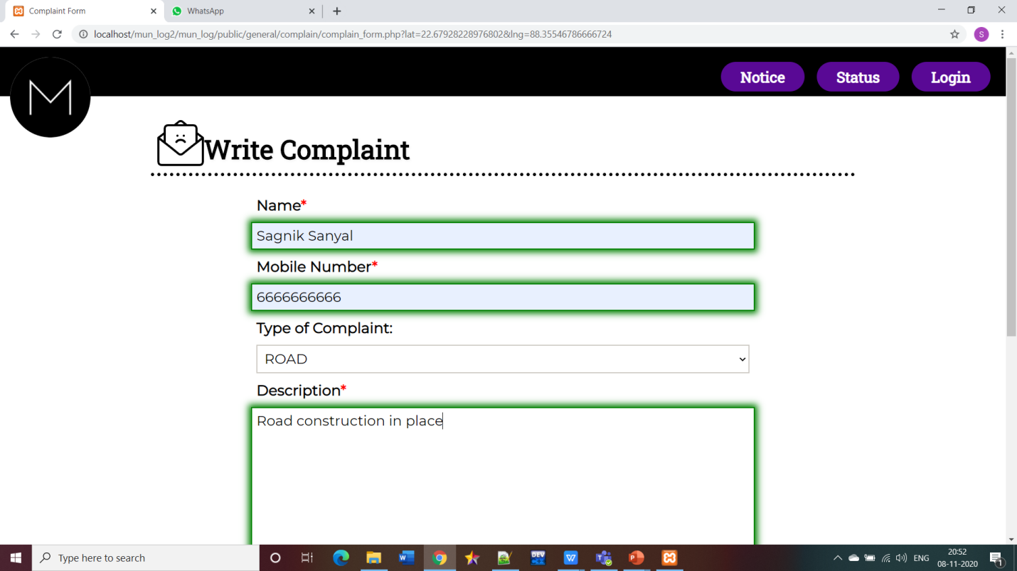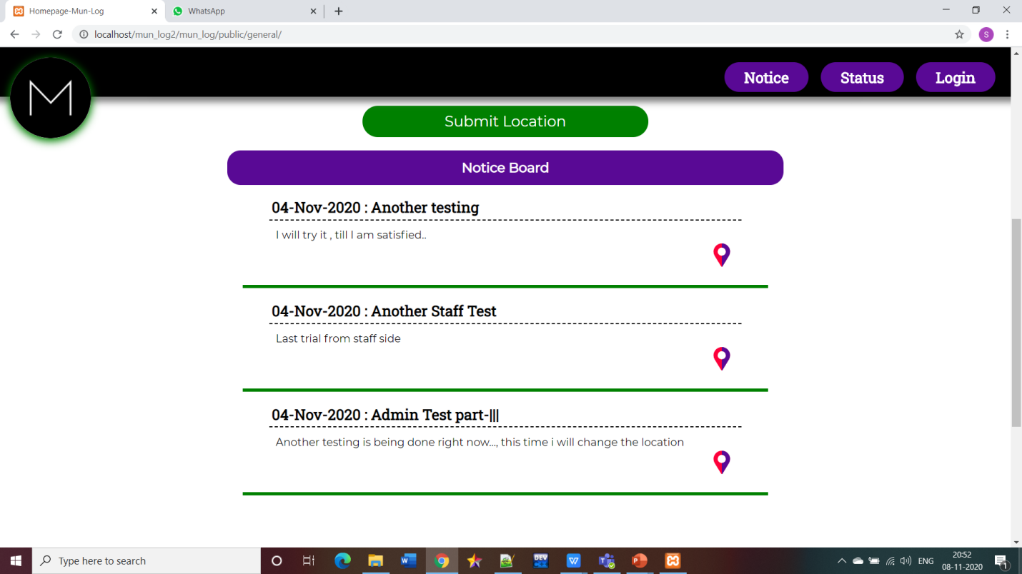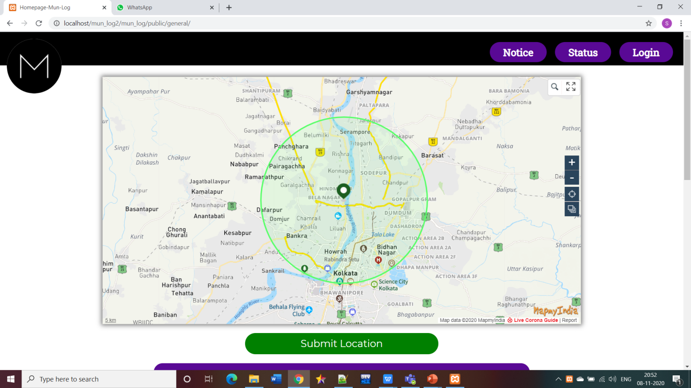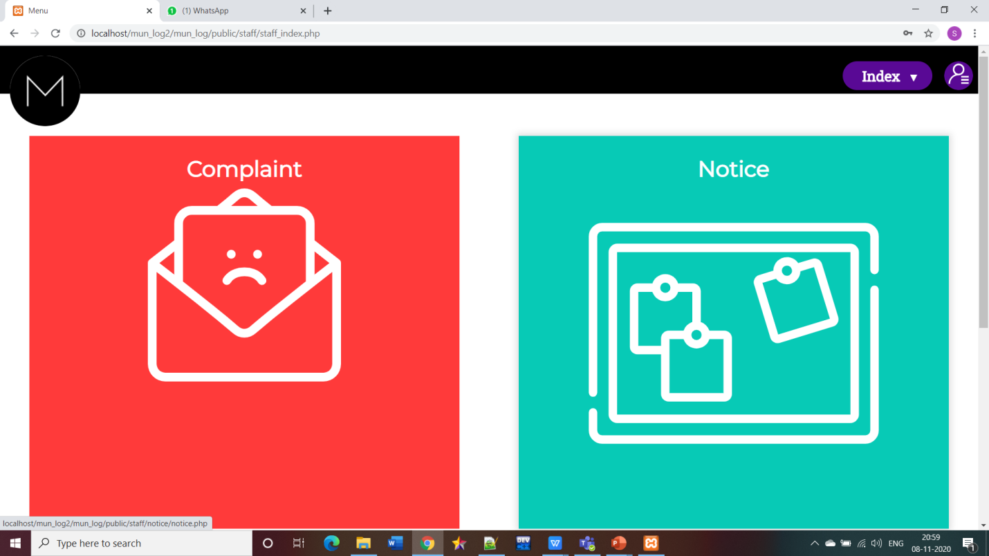

**CONCLUSION & FUTURE WORK:**

We successfully achieved our goal to make such website for the users that would be beneficial and the people. This will be a great relief for the people who don’t have time to go to the Municipal Corporation Office and register their complaint. Furthermore they can also get notification about the notices posted by Municipality. Through this project we learnt a lot about HTML, CSS, JAVASCRIPT, PHP, MYSQL and gained much more knowledge about Map Implementation.

In order to make a successful website one should always keep updating the features and functionality of the website time to time. With a clear vision we would try our best to make this website better in future. We will make our website more responsive and make it more animation oriented that will make our website more appealable to the customer/user. For verification of the user we will implement the system of OTP and will also link user’s Aadhaar Card to the website to prevent any malicious or mischievous activity.

**VIDEO and Code LINK:**

**Google Drive Link for Demonstrational Video and Code:**

**https://drive.google.com/drive/folders/1JXkBfTtXnLviCtPXRdju-fwlzwU0TBZ9?usp=sharing**